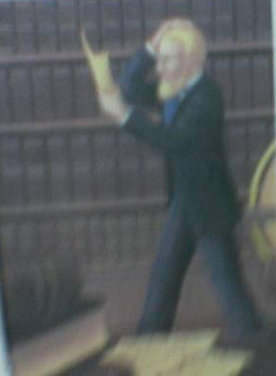
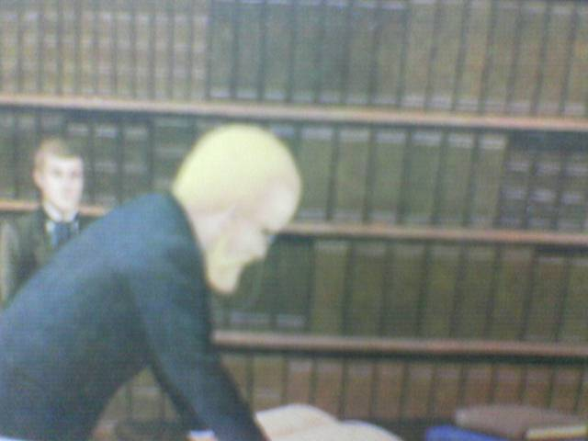
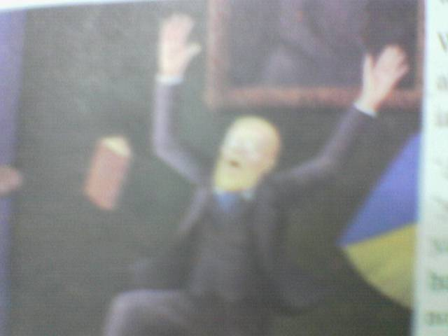
Journey to the centre of the earth
By: Jules Verne
Chapter Two
1- Who broke the secret code?
Axel broke the secret code.
2- What made Axel believe that the journey was dangerous?
He believed that the centre of the earth was very hot.
3- What was Sneffels?
It was an extinct volcano that hadn't erupted since 1229.
4- Why was Axel going to burn the parchment?
To stop his uncle from making the dangerous journey.
5- Why couldn't Axel burn the parchment?
Because his uncle entered the room.
6- How could Axel break the secret code?
By chance he saw some Latin words which he knew.
8- Why did the professor think that Sneffels was an extinct volcano?
It hadn't erupted since 1229.
9- Why did Axel decide to tell his uncle about the secret of the parchment?
Because he felt sorry for his uncle..
10- Who was going to burn the parchment?
Axel was going to burn the parchment

11- When did Lidenbrock say that Axel was a clever boy?
After Axel broke the secret code.
12- What did Axel decide to do with the parchment?
Axel decided to burn it.
13- Was Sneffels an active volcano?
No. It was an extinct volcano.
14- Why was Axel afraid to go to the centre of the earth?
Because it was very dangerous and he thought that the centre of the earth was very hot.
15- How was the professor before knowing the secret code?
He was very puzzled and angry. He decided not to eat or sleep until he broke the secret code of the parchment
16- When was Axel able to break the code?
When he was fanning himself in front of the window.
17-Why was Axel against the journey?
He believed that the centre of the earth was very hot
18-Why did the professor ask Axel to bring the atlas?
To show him the places Arne had written about on the map.

believed | يعتقد
very hot | ساخن جدا
extinct | خامد
hadn't erupted | لم يثور
burn | يحرق
entered | دخل
By chance | بالصدفة
felt sorry | شعر بالشفقة
a clever boy | ولد ذكي
dangerous | خطير
puzzled | متحير
not to eat or sleep | ان لا يأكل و لا يشرب
until | حتي
fanning | يهوي
in front of | أمام
show | يعرض
the places | الأماكن
on the map | علي الخريطة

