chapter one

vocabulary

late  professor  excited  cook  worried  start  go upstairs  voice | في وقت متأخر  أستاذ جامعي  مثار؛ منفعل  طباخ  قلق  يبدأ  يصعد للدور العلوي  صوت (إنسان) | shout  exclaim  fantastic  wonderful  keep  repeat  famous  century | يصيح  يصيح متعجبا  رائع؛ خيالي  عجيب؛ مدهش  يظل ؛ يستمر  يكرر  مشهور  قرن (100 سنة)
parchment  pick up  runes | ورق من الجلد  يلتقط  الحروف الأيسلندية | The Earth  parents  proud | كوكب الأرض  الوالدين  فخور
reply  impatiently  lecture  university  geologist  geology  scientist | يرد ؛ يجيب  بلا صبر  محاضرة  جامعة  عالم جيولوجيا  الجيولوجيا  عالم | assistant  look puzzled  angry  study  soup  kitchen  hungry | مساعد  يبدو متحيرا  غاضب  حجرة المكتب  شوربة  مطبخ  جوعان
call  get up  immediately  rush back  stare at  mixed up  secret code  handwriting | ينادي  يستيقظ  في الحال ؛ فورا  يندفع عائدا  يحملق في  مختلطة  شفرة سرية  خط اليد | own  continue  magnifying glass  point to  scientific  discoveries  discover  keep it secret | يمتلك  يستمر  عدسة  مكبرة  يشير إلى  علمي  اكتشافات  يكتشف  يحتفظ به سرا
find out  guess  Latin message  forwards  backwards | يكتشف  يخمن  رسالة لاتينية  للأمام  للخلف | make no sense  hit  fist  slammed the door  starve | ليس لها معنى  يضرب  قبضة اليد  أغلق الباب (بعنف)  يموت جوعا

- Who was professor Lidenbrock ?من كان البروفسير ليدن بروك
He was a famous scientist and geologist at the university of Humburg
كان عالم مشهور وجيولوجى بجامعة هامبرج
- Who was the narrator ( the teller ) of the story ? من راوى القصة
Axel

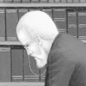
- Who was Axel ?من كان اكسل
He was the professor's nephew ابن اخيه

- 12. What did Axel do ? OR. What was Axel's job?
- He was the professor's assistant.

- When did the story happen ? متى حدثت القصة
In the 19th century فى القرن 19

- Who was Martha ? من كانت مرثا
She was the professor's cook طباخة البروفسير

- -Where did professor Lidenbrock and his nephew Axel live ? اين عاشوا
they lived in Humburg in Germany فى هامبرج بالمانيا

- Why did Axel live with his uncle ?لماذا عاش اكسل مع عمه
Because his parents died . لان والديه ماتو ا

- Why do scientists from all over the world come to Lidenbrock?
لماذا العلماء من جميع أنحاء العالم كانوا يأتون إلى ليدن بروك؟
- Because he was a famous scientist and he knew about the Earth more than any other scientist. لأنه عالم مشهور ويعرف عن الأرض أكثر من أي عالم أخر .

- Why was Professor Lidenbrock a famous scientist?
لماذا كان البروفسورعالم مشهور
- Because he knew more about the Earth than any other scientist.
لأنه كان يعرف عن الأرض أكثر من أي عالم أخر.
- Why was Axel proud to be his uncle's assistant?
لماذا كان اكسل فخور بأن يكون مساعد عمه؟
Because his uncle was famous and genius لأنه كان عالم مشهور و عبقرى .

- What was Axel Proud of?ماذا كان أكسل فخور بـ ؟
- Axel was proud to be his uncle's assistant .فخور أن يكون مساعد عمه

- What made the professor go back home early ?
ما الذى جعل البروفسير يعود للمنزل مبكرا
he was excited as he found an old book كان منفعلا لانه وجد كتاب قديم

- Why was Martha worried when the Professor came home?
لماذا كانت مارثا قلقة عندما أتى البروفسور؟
- Because she didn't prepare his dinner.لأنها لم تجهز الغداء .
12-What was the old book that the professor found ? ماذا كان الكتاب الذى وجده
it was a translation of a famous Icelandic book , كان ترجمة لكتاب ايسلاندى مشهور

3- Why was the book fantastic ? لماذا كان الكتاب رائع
Because it was more than six hundred years old

13-How old was the book ? كم كان عمر الكتاب
it was more than 600 years old اكثر من 600 سنه
.
14-Who wrote the book ? من كتب الكتاب
Snorri Sturlasson in the 12th century سنورى ستيرلاسون فى القرن 2 1

15-What did the professor find in the book ?ماذا وجد البروفسير فى الكتاب a piece of parchment قطعه جلدية

16.Where was the parchment kept?أين حفظت الرقاقة الجلدية ؟
The parchment was kept in an old book. حفظت الرقاقة في كتاب قديم.

17- Why couldn't the professor understand the parchment ?
لماذا لم يستطع فهم القطعة الجلدية
the letters were mixed up ,and it was written in a secret code
الحروف ملخبطه و. مكتوبه بشفرة سرية
18-What are Runes ? ما هى الرونيز
The letters of the old Icelandic alphabet الحروف الهجائية للغة الايسلاندية القديمه

19-How did the professor know that the parchment was written by the owner of the book ? كيف عرف البروفسير ان القطعة كتبها مالك الكتاب
the writing of the parchment was newer than the writing of the book
القطعة احدث من خط الكتاب خط
20-Who was the owner of the book ? من كان مالك الكتاب
Arne Saknussemm ارن ساكنسيم

21-Who was Arne Saknussemm ? من كان ارن ساكنسيم
a famous Icelandic scientist of the 16th century, he was the writer of the parchment عالم ايسلاندى مشهور من القرن 16 و كان كاتب القطعة الجلديه
18. How did the professor know the owner of the book?
- By using a magnifying glass , he could see the name of Arne Saknusseemm.

22- Who was Snori sturlasson? من كان سنورى ستيرلاسون
He was the auther of the book مؤلف الكتاب

23- why did the professor think the parchment was written in Latin لماذا اعتقد ان القطعه مكتوبه بالاتينيه
the scientists of the 16th century used to write about their discoveries in Latin علماء القرن 16 تعودوا ان يكتبوا عن اكتشافاتهم بالاتينيه
28-Why did the professor guess that the parchment was written in Runes?
Because he found it in an old Icelandic book

24 Why did Arne Saknussemm write his message in a secret code?
لماذا كتب أرني الرسالة بشفرة سرية؟
- Because he wanted to keep it secret. لأنه أراد أن يبقيها سرا.

25. What did the Professor use to make the letters on the parchment bigger? ماذا استخدم البروفسور ليجعل الحروف اكبر؟
- He used a magnifying glass.استخدم العدسة المكبرة .

26. Why did the Professor use a magnifying glass?
لماذا البروفسور استخدم عدسة مكبرة؟
To make the letters bigger يجعل الحروف اكبر

27-What could he see with the magnifying glass? ماذا راى بالعدسة المكبرة
The name of Arne Saknussemm. اسم ارن ساكنسيم

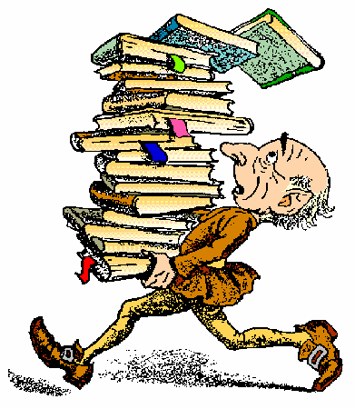

1-Runes were………………………………
the letters of the old Icelandic alphabet.
2- Although the professor knew Latin and Runes,……………...
He couldn t understand the parchment .
3- The book and the parchment were not written ……...
in the same handwriting .
4- At first the professor thought the parchment was written in……..
runes .
5- Professor Lidenbrock was so famous that ……….
other geologists came from all over the world to learn from him .
6-Unlike all other scientists, the professor thought that ……...
the center of the earth wasn t hot.
7. Axel went to live with his uncle when ----------(his parents died ).

8.The professor decided not to eat or sleep until ----(he could read the parchment) .
9. To make the letters bigger , the professor used ------( a magnifying glass )
10. At first, the professor thought that the parchment was written in…-( runes
11 When the professor saw the name of Arne Saknusesmm , he guessed the parchment was written in ----------- ( Latin )
12. The professor was a famous scientist , so -----( other scientists came to learn from him)
13. The professor guessed the parchment was written by someone who owned the book because….( the writing of the parchment was later than the writing of the book ).
14- Arne Saknussemm wrote the parchment in a secret code to ---(keep it secret
15. The book was written in---( the 12 century)
,16- the parchment was written in---(16 century)

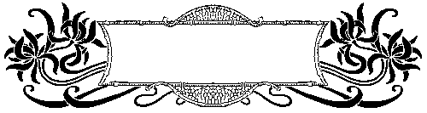
Excercises

A) Answer the following questions:
1- When was the book written?
2- What did the professor, at first, think about the writing on the parchment?
3- Why did the professor use a magnifying glass?
4- Why couldn't the professor understand the writing on the parchment?
5- How was the parchment written?
6- Where did Prof Lidenbrock work ?
7. Why couldn't Professor Lidenbrock read the writing on the parchment ? (الاسكندريه )
8. Which was older, the parchment or the book?
9.What was Professor Lidenbrock ? (الغربيه )
10- How did the professor know that the parchment was
written in a secret code ?

B) Compete the following sentences:
1 .Professor Lidenbrock used a magnifying glass to-------- (البحيره )
2. The professor said that he would neither eat nor sleep until he ----------- (الدقهليه )
3. When Axel's parents died , he ----------- (كفر الشيخ )
4. Although the professor knew runes and Latin , -------------- (الشرقيه )
5-Professor Lidenbrock couldn't understand the writing on the parchment because ………
6-Martha, the Professor's cook was worried because …………
7-To make the letters appear bigger, Professor Lidenbrock used…
8-Axel lived with his uncle because …………
9-Professor Lidenbrock used a magnifying glass to …………
7-Professor Lidenbrock guessed that the message was not written in Icelandic because...
8-Arne Saknussemm was the........................... of the book and the…......................... of the parchment.
9- Axel came to live with his uncle when ……………...
10- Professor Lidenbrock was so famous that ………….

The auther / writer of " Ajourney to the centre of the earth "
Jules Verne
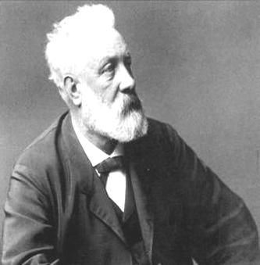
ر


مع تحيات
Abu Youssef

