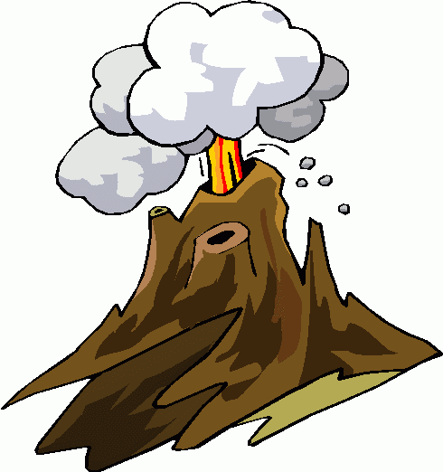

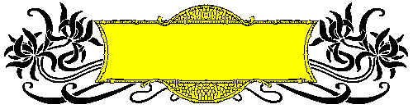
The reader


Ajourney to the centre of the earth
*
*

Chapter Two

chapter two

vocabulary

arrange  form  impossible  combination  become hot | يرتب  يكون ، يشكل  مستحيل  مجموعة  ينفعل | fan  in front of  back  breathe  suddenly | يهوي بمروحة  أمام  خلف  يتنفس  فجأة
crater  imagine  break the secret code  calm down  spread  manage to  frightened  really  brave | فوهة البركان  يتخيل  يفك الشفرة  السرية  يهدأ  ينشر  ينجح في  خائف  في الحقيقة  شجاع | jump up  seat  return  fire  burn  appear  fall asleep  couch  wake up | يقفز إلى أعلى  مقعد  يعود  نار، مدفأة  يحرق  يظهر  ينام  كنبة  يستيقظ
follow  footsteps  dangerous  change my mind  surly  put on  hat  decide | يتتبع  خطوات  خطير  أغير رأيي  بالتأكيد  يرتدي  قبعة  يقرر | shake his head  shadow  touch  reach  jump to his feet  fly  moment  surprised | يهز رأسه رافضا  ظل  يلمس  يصل إلى  يقفز واقفا  يطير  لحظة  مندهش
pack  box  danger  kindly  clever  greatly  atlas  bookshelf  huge | يحزم الأمتعة  صندوق  خطر  بعطف  ماهر  بدرجة كبيرة  أطلس  رف الكتب  ضخم | mountain  die of  heat  smile  extinct volcano  erupt  several  lead to  cast | جبل  يموت بسب  حرارة  يبتسم  بركان خامد  يثور (البركان)  عديد  يؤدي إلى  يلقي ، يرمي
come back | يعود ، يرجع | alive | على قيد الحياة

Questions with model answers

1-What did Axel do to understand the parchment? ماذا فعل اكسل ليفهم القطعة
He tried every combination of letters but he failed . جرب كل مجموعة حروف

2. Why did Axel try every combination of letters ? لماذا جرب كل التركيبات
- To understand the parchment. ليفهم القطعة الجلدية

2-Who broke the secret code ? من كسر الشفرة السرية
Axel broke the secret code اكسل
3-How did Axel break the secret code ? كيف كسر الشفرة السرية
He saw some Latin words on the back of the parchment by chance
رأى بعض الكلمات اللاتينية على ظهر القطعة بالصدفة
4-What was the secret code ? ما هى الشفرة السرية
To enter into the crater of Sneffels which the shadow of Scartaris touches before July .then you will reach the centre of the earth
لن تدخل من فوهة سنيفلز والتى يلامسها ظل سكارترز قبل يوليو وعندئذ ستصل الى مركز الارض
5-How did Axel feel when he knew the secret code ? why ?
بما شعر اكسل عندما عرف الشفرة السرية ولماذا
He felt surprised as Arne reached the centre of the earth
كان مندهشا لان ارن ساكنسيم وصل الى مركز الارض
6-Why didn't Axel want his uncle to know about the secret code ?
لماذا لم يرد ان يعرف عمه امر الشفرة السرية
He didn't want his uncle to make the journey to the centre of the earth
لم يرد ان يقوم عمه بالرحلة الى مركز الارض
7-Why did Axel oppose / عارضrefuse making the journey ?لماذا رقض الرحلة
7-Why was Axel against the journey? لماذا كان ضد الرحلة
He thought it would be very dangerous شعر انها ستكون خطيرة جدا

8-Why did Axel think the journey would be very dangerous ?
لماذا اعتقد ان الرحلة ستكون خطيرة جدا
The centre of the earth is very hot مركز الارض ساخن جدا
9-Why did Axel decide to burn the parchment? لماذا قرر حرق القطعة الجلدية
To stop his uncle from reading it ليمنع عمه من قراءتها

10-Why couldn't Axel burn the parchment ? لماذا لم يستطع حرق القطعة
His uncle entered suddenly دخل عمه فجأة
8. Did Axel burn the parchment? Why? هل احرق اكسل القطعة ؟ ولماذا ؟
-No, he didn t. because his uncle entered suddenly
لا لم يفعل لان عمه دخل فجأة
11-Why did Axel decide to tell his uncle about the secret code ?
لماذا قرر اكسل ان يخبر عمه بالشفرة السرية
He felt sorry for his uncle who didn't eat or sleep
شعر بالاسى من اجل عمه الذى لم ياكل ولم ينم
12-How did the professor feel after he knew the secret code ?
بما شعر البروفسير بعد ان عرف سر الشفرة
He jumped to his feet and gave a cry of joy. قفز عاليا وصاح صيحة فرح
13-What did the professor show Axel in the Atlas ?
ما الذى اراه البروفسير لاكسل فى الاطلس
The places that Arne had written about . الاماكن التى كتب عنها ارن ساكنسيم
14-What was Scartaris ? ما هو سكارتريز
It was a mountain in Iceland جبل فى ايسلاندا
15-What was Sneffels ? ما هو سنيفلز
It was a volcanic mountain nearly 2000 meters high
جبل بركانى ذو ارتفاع حوالى 2000 متر
16-What did the professor decide after he knew the secret code ?
ماذا قرر البروفسير بعد ان عرف سر الشفرة؟
He decided to make the journey to the center of the earth
.قرر ان يقوم بالرحلة الى مركز الارض
17. Why did the Professor think that Sneffels was an extinct?
لماذا أعتقد البروفسور أن سنفلز خامد؟
- Because it hadn't erupted since 1229.لأنه لم يثور منذ 1229.
18. How did Axel and the Professor feel about making a journey to the center of the Earth?
. كيف شعر أكسل والبروفسور تجاه القيام بالرحلة إلى مركز الأرض؟
18. Compare between the professor and Axel about making the journey.

- Axel was worried, but the professor was very excited.
شعر أكسل بالقلق لكن البروفسور كان مثار جدا.

.

1 . Sneffels was an extinct volcano that…………..
hasn t erupted since 1229.
2. Scartaris was………….. .
a huge mountain in Iceland
3.Although Sneffels had several craters,…………. ..
only one led to the center of the earth.
4. Everyone knows that the centre of the earth ………………..
- is very hot .
5. After finding out the secret message of the parchment, professor Lidenbrock decided ……………..
- to make the journey to the center of the earth

1- Answer the following questions :
1- Who could break the secret code of the parchment ?
How ?
2- What was the secret message on the parchment ?
3- What did Axel do to understand the parchment ?
4- Why was Axel against the journey ?
5- What was sneffels ? Where was it ?
6- Why was Axel afraid to go down into sneffels ?
7- What happened when Axel held the parchment up in
front of the window ?
8- Why was Axel going to burn the parchment ?
9- How did Axel break the secret code of the parchment?
10- Why didn't Axel want to tell his uncle that he knew the secret code ?
11- What did Axel decide to do with the parchment ?
12- Why couldn't Axel burn the parchment ?
13- What did the professor show Axel in the atlas ?
14- Why was Axel surprised when he read the secret message ?
15- How was Lidenbrock before knowing the secret code ?
2- Complete the following sentences :
1- Sneffels volcano ………………………....since 1229 .
2- The professor told Axel that he was clever because …..
3- Sneffels was not dangerous because …………………..
4- Axel thought it would be impossible to travel to the
centre of the Earth because ……………………………
5- Axel was frightened to go into Sneffels because ……..
6- Sneffels has several craters but only one ……………..
7- Sneffels was a volcano in Iceland which had not erupted for ……………

