❶Choose the correct word:-
1–An (engine – engineering – engineer) is a person who plans and build machines.
2 –For (entertain – entertainment – entertaining) we watch television.
3 – (Scientist – scientific – science ) is one of the subjects that are taught in English .
4 – Ahmed studies (engineering – engine – engineer) at university . He wants to an engineer
5 –We do a lot of trade with (nation – international – nationality) companies.
6 – People can exchange ( network – internet – information – marks ) through the internet .
7 –The internet is a worldwide network of (machines – companies – projects computers)
8 – Mr. Khaled gave me a good (mark –exchange – communicate) for my composition
9 – If you know English, you can (rescue – learn – exchange) with a lot of people..
10 –There is a good railway (internet – network – telephone – company) in Egypt .
11 – (Why – Because – If – Where) you phoned yesterday, I was eating lunch .
12 –Courageous means (clever – beautiful – brave – dangerous) .
13 –You should breathe in (hot air – smoke – clean air – water) .
14–An old man was ( trapped–grabbed–pulled) inside the burning house. He couldn’t get out
15 –Our army acted (lazily – safely –courageously) in the war and could win the battle معركة
16 –She lost an arm and a leg in the accident, but she didn’t lose ( hope – safety – money )
17-A storm (broke – came – went gave) out last night. It destroyed the crops.
18–He (gave – received – grabbed – trapped) a gold medal for his bravery.
19–The telephone is (between – through – by – with) the window .
20 –Fatma thought his life ( came – went – cut – began ) to an end when he fell off his horse
21–A swimming ( teacher – coach – man – student ) taught her how to swim .
22 -Yara likes read magazines in English in her (first – second – spare) time.
23–Medicine is one of the subjects that are (exchanged – found – taught) in English.
24 -Ahmed is studying ( art – engineering – medicine ) He is going to be an engineer .
25 –Our company does a lot of (entertainment – information – trade ) with foreign companies
26 – People all over the world can find and ( type – need – exchange ) information
The internet is like a (small – tiny – huge) information bank .
27 – When Yara finishes (primary – prep – nursery) school , she go to secondary .
28 –English is an important (subject – entertainment – job ) for all students .
29 –The internet is worldwide network of (videos – telephones – computers) .
30 –The Toshka valley is in (videos – telephone – computers) .
31 –Ahmed was born ( in – on with – to ) I March 1998 .
32– (He – Him – He’s – His) favorite food is rice.
34 –Ahmed is I meter (young – old –tall – short) .
33 –His hobbies (be – am – is – are ) reading and swimming .
34 –My father visits Aswan once ( a – an – any – the ) month .
❷Write what you would say in the following situations :-
1–You leave someone at night .…………………………………………………..
2 –Yara met Fatma for the first time at Rehab‘s house . . What will Yara say to introduce her friend? .………………………………………………...…………..
3 -You leave your family to go bed at night . .…………………………………..
4–It is late at night . You go to bed . You ‘ll say to your mother . .………………………………………………………………………………….
5–You want to introduce Yara to your family .
.………………………………………………………………………………….
❸Choose the correct answer :-
1 – People who (live – lives – lived – living) in the desert are known as nomads.
2 – What do you (went – go – going – goes) and report what we have found.
3 – What do you (thought – are thinking – thinks – think) this strange thing is?
4 – He speaks Arabic and so (did – dose – do – have done) I .
5 – Please don’t make so much noise, I (study–have studied –is stud –am studying
6 – Students usually (work – works – worked – working) hard before ex- am .
7 – I didn’t use to wear glasses but nowadays I ( does – did – don’t – do ) .
8 – My father never (work – had worked – working) hard before ex – am .
9 – My father used to drive his car but now he (does – doesn’t – don’t ) .
10 – Let’s (has – have – to have – had ) a nice at restaurant .
11 – When do shops (close – closes – closed – closing) here ?
12 – The police (is – was – are – has been ) looking for the thief .
13 – Listen!a bird (sing – is singing – has been – was singing ) .
14 – He (answer – answered – is answered – has answered) the lest at the .
15 – What (you do – are you doing – are you done – you are doing ) the lest at the

❹Read and correct.
1-We didn’t at home yesterday. 2-They don’t go the club last week.
3-Do you watch the last match? 4-When were you go to Alex?
5-Ahmed watches T.V two days ago. 6-Once, Ahmed makes a mistake.
7-The ancient Egyptian builds the Pyramids. 8-Ahmed is in first year last year.
❺ Rewrite the following.
1-Mr.Khaled explained unit two.(Was) …………………………………
2-Did Ahmed buy that T-Shirt? (Was) ………………………………?
3-They visited me two days ago.(when .How long) …………………………………?
…………………………………………………?
4-We went to Mahallet Bisher and so did Ahmed (not) ……………………………………………………………
5- Mr.Khaled and we like English (not) ……………………………………………………………
6-We like English and Mr.Khaled like English, too. (not) ……………………………………………………………
❻Make question:.
1- Ahmed went to Cairo with Mohamed by bus Last week.
(Who-Where-With whom- How –When-What)
…………………………………………………………………….…………?
………………………………………………….…………………………?
❼Write a paragraph of six sentence about :
When? | How? | Who with? | What you saw. | How long? | How you felt?
Last week | bus | My class | Workers-machines | Five days | happy
"A visit to a factory"
❽Read and correct.
1-Amira was burning rubbish when her clothes catch fire.(……… …..……..)
2-While Mr.Khaled was eating , we visit him.(…………..……………….….……)
3-Ahmed get into the train while Mohamed was sitting.(…….........................……)
4-What are you ding when I arrive?(………………….)(… …………………)
5-While Ahmed eating, Mohamed watch T.V.(…….…..)(…… ……………….)
6-When Ahmed came, I am studying.(…… ……..)
❾Read then answer the question.
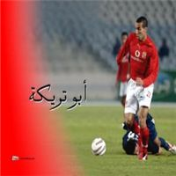
Abou treika was born on 7th of November 1978 in the city of Giza.
Like most football players, he lived a simple life playing football in the
streets and honing his skills. When he turned 12, his friend, Magdi Abed,
suggested he take the fitness test at Tersana Club. The second biggest
club in Giza after Al-Zamalek. Indeed, Abou treika did pass all the tests
and joined the club. "I joined the club through personal effort and without
favouritism". With Tersana, Abou treika demonstrated a proficiency which
led to his promotion to the First Squad at the tender age of 17. He helped his
team whose was playing in the second division, to promote to the Egyptian
League, being their top scorer in two successive seasons. His first
appearance close to the spotlight was in 2000-2001 Egyptian League,
Abou treika scored 6 goals and made many assistants to his teammates, forming a link with the Syrian striker Mohannad Al-Boshi leading him to score 11 goals, most of them was with the help of Abou treika's accurate passes. As a result, Abou treika was offered a place in the Egyptian national Olympic team, and the Egyptian national military team, but he didn't take his full chance, because Egyptian coaches concentrated their attention only on the players playing in famous clubs. In 2001-2002, Abou treika continued his playmaking skills and scored 7 important goals helping his team to stay in the Egyptian League. In 2002-2003, Abou treika started to show his ability to score as well as making goals, he scored 11 goals for his team, and this is a very good rate for a midfielder player playing in a relatively weak team in the Egyptian League. The Egyptian newspapers started then to spot the light on this player's promising talent.
A-Answer the following questions.
1-Who m was helped by Abou treika's to score11goals? ...................................................................................................................................
2-What is Tersana? .................................................................................................
3-How many goals did he score in 2002-2003? .....................................................
4- When was Abou treika born? ............................................................................
B-Choose the best answer.
5- The second biggest club in Giza after Al-Zamalek is (Tersana-Ahly- Ismaily)
6-Treika didn't take his full chance, because Egyptian coaches concentrated their attention only
on the players playing in (dirty- Zamalek- famous clubs.)
❶Correct the verbs in brackets :-
1 – Salwa ( visit ) her a week a go . 1 - ……………………………….
2 – They ( go ) to Tanta last week . 2 - ……………………………….
3 –It (be ) hot yesterday and we (open ) the windows . 3 - ……………………….
4 –Ahmed (travel ) to port said last month . 4 - ………………………………..
5 – Our players (can ) win yesterday’s game . 5 - ……………………………….
6 –There years ago , I (be ) still in a primary school 6 - …………………………
7 –Usama (leave ) for Aswan last week . 7 - ………………………………..
8 –We ( write ) lesson ten two days ago . 8 - ……………………………….
9 – Ahmed ( say ) he had a cold . 9 - ……………………………….
10 –Yara (have ) a cold last week 10 - ………………………………
❶Correct the verbs between brackets :-
1 –While I ( to cross ) the street, I ( meet ) a man with on leg .
2 –Ahmed (see) me yesterday , as I ( walk ) along the street .
3 –While the train (move ) I ( jump) out .
4 –Mervet ( sleep ) when the teacher ( come )
5 –As they (to work ) , a man ( to knock ) at the door .
6 – I (see) my friend as I (to drive ) to the station yesterday .
7 –While I (work) , the telephone ( ring) .
❸Choose the correct word :-
1–Yara was very thirsty, so she drank three ( plates – packets – vases – glasses ) of water .
2 –While Yara was eating a ( glass – bottle – sandwich – cup ) her sister arrived .
3–Ahmed is proud of the ( pot – medal – sick) which he received for the hundred meters .
4–When Ahmed arrived at the ( house – station – hotel – shop ) the train wasn’t there .
5 –I didn’t have enough money to buy that camera . It was very ( expensive – cheap – small –
6–Fatma wants to be a tour guide, so English is an important subject for ( me – you – her him)
7–Enas was screaming. A man jumped into the canal and pulled (her – them – me ) to safety
8–Ahmed ( was slipping – slips – slipped – slipping ) on the wet grass and broke his arm .
9–Your camera is too old . I’ve got a new ( ones – one – any – some ) .
10–Hasson was badly hurt , (so – when – and – but ) he was not dead .
11–Bahaa can put ( off – out – on ) a small fire with a blanket .
12–Heba could see smoke coming out of the roof , but there weren’t (a-one – any ) flames.
13–Shymaa and Heba were playing football when it ( started –starts – will start ) to rain .
14–Yara ( am cooking – was cooking –have cooked ) lunch when you phoned yesterday .
15–Rasha was writing a letter to a pen friend when I (visit – visited – am visiting ) her
❹Rewrite the following sentences using the words in brackets :-
1 – Ahmed was watching television when his father entered . (Use “while “ )
2 – While Ahmed was climbing the tree , he fell down . ( Use “when “ )
3 – Ahmed is reading the paper at the moment . ( Use “ An hour ago “ )
4 – As Sabreen was crossing the street , it began to rain . ( Use “ when “ )
5 – Ahmed ( do ) his homework while he ( listen ) to music yesterday . ( correct the verbs )
❺Complete the missing parts in the following dialogue :-
Noha and Safaa are talking about what safaa did yesterday .
Noha : Hello Safaa . How are you ? Safaa : Fine, thanks .
Noha : What time ………… “1” ……………… ?
Safaa : I got up at six o’clock yesterday .
Noha : …………………… “2” …………………?
Safaa : I studied my lessons in the afternoon .
Nohaa : ………………….. “3” …………………..?

1-فاعل + would rather + to +مصدر بدون I'd rather go home now.
2- فاعل + would rather + فاعل +ماضى بسيط I'd rather Ahmed went early.
Ahmed'd rather I didn’t travel by bus. Eman'd rather he didn’t eat her.
3- فاعل + would like + to +المصدر  Ahmed'd like to drink tea.
4-Do you mind if +الفاعل +مضارع بسيط ? Do you mind if I take your pen?
5-Would you rather +مصدر الفعل+or…? Would you rather drink tea or coffee?
6-فاعل +make+ objectمفعول +to مصدر بدونIt makes me feel thirsty.
7-There +was- is +مفعول +(Verb +ing ). There is a boy playing with Fares.
8- Is it ok if+فاعل +مضارع بسيط?  Is it ok if I take your pen?
9-May-Could+فاعل +مصدر الفعل? May I take your pen?

❻Choose the correct answer.

1-Ahmed would rather (eat-eats-ate) fish with rice.
2-Ahmed would rather Mohamed (buys- buy- bought) that toy.
3-Ahmed would like (to- with-if) drink orange juice.
4-(Do – Does -is)you mind(to –if- of) I go with you.
5-Mr.Khaled makes Ahmed (study-studies- to study)Well.
6-Would you rather travel by bus( or –and-with)by taxi?
7-There was a man(look-to look looking) after the sheep.
8- (Is it –could- May)ok if I go by your car?
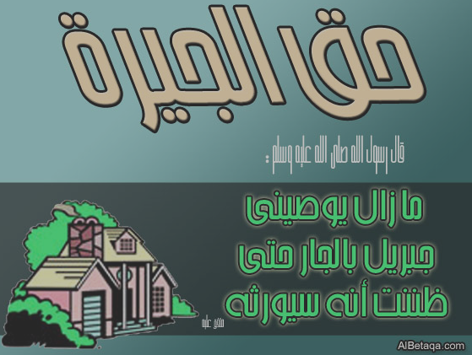
❼Read and correct.
1- I'd rather eating this sandwich.
2-Do you mind if Ahmed coming with us?
3- I'd rather Mohamed take me with him.
4-Are you rather live in a house or live in flat?
5- I'd like to darnk tea.
6-She lent a book from the library yesterday.
7- There is a girl watch T.V now.
8-Is it ok if I saw your new mobile?
❽Read and match.
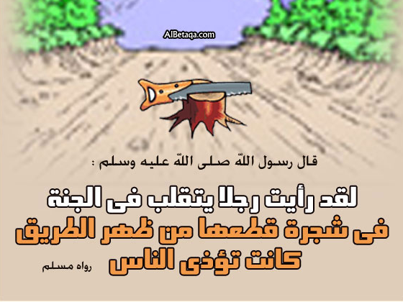
1-brrow forget
2-polite close
3-remember lend
4-open cheap
5-expensive rude
6-diffeclut easy
❾Read and match.
1-Be careful A- for the bus.

2-My mobile isn’t cheap B- traveling by plane
3- Ahmed'd rather C- to travel by train.
4-Ahmed is waiting D- have tea now.
5- Ahmed'd like E- it is expensive.
❿ Rewrite using the words brackets.
1-May I take your book?(mind) ………………………………………..…………..
2-Is it ok to ride your bike?(May) ………………………………………..……...…
3-Do you mind if we start our work now?(May) ……………………………..……
4-May I go and help him?(Is it) …………………..……………………...…..….…
5-Can I make a phone call, please?(Do) …………..……………………………..…
6-Can we buy some foods?(Is it) …………………………………………..………

