
Unit
one

from Egypt |  | من مصر | polite |  | مهذب
The best |  | الافضل | careful |  | حريص
learn |  | يتعلم | at break |  | في الفسحة
subject |  | مادة دراسية | give a tour of |  | ياخذ في جولة
Arabic |  | عربي | a sports school |  | مدرسة رياضية
English |  | انجليزي | sports clothes |  | ملابس رياضية
maths |  | رياضيات | student |  | طالب
science |  | علوم | good at…..n /v+ing |  | جيد في
social studies |  | دراسات اجتماعية | rules |  | قواعد
P. E |  | تربية بدنية | exercise |  | تمرين
places |  | اماكن | important |  | هام
playground |  | ملعب | timetable |  | جدول مواعيد
laboratory |  | معمل | location |  | موقع
gym |  | جيم | do a quiz | يجري مسابقة – اختبار قصير
classroom |  | فصل | ability |  | قدرة
toilets |  | حمامات | necessity |  | ضرورة
changing room |  | حجرة تغيير الملابس | website |  | موقع انترنت
music room |  | حجرة الموسيقي | get ready for |  | يستعد ...لـ
library |  | مكتبة | engineer |  | مهندس
office |  | مكتب | travel - ed |  | يسافر
gate |  | بوابة | discuss |  | يناقش
corridor |  | طرقة | arrive -d |  | يصل
stairs |  | سلالم | ask |  | يسأل
Let’s….inf |  | هيا بنا..... | need |  | يحتاج
where |  | أين | talk to) in…) |  | يتحدث الي( في...)
upstairs |  | دور علوي | pack |  | يحزم خقائبه
downstairs |  | دور ارضي | walk ) up x down) |  | يمشي
on the ground floor |  | في الدور الارضي | compare |  | يقارن
on the floor first |  | في الدور الاول | practise |  | يمارس
in the middle |  | في الوسط | stand up |  | يقف
at the bottom .... |  | أسفل ........... | do –did - done |  | يفعل
at the top ....... |  | أعلى ......... | put up - put |  | يضع
at the end..... |  | نهاية ......... | put on |  | يرتدي
opposite …… |  | أمام ............. | think - thought |  | يعتقد
next to ............ |  | بجوار ......... | fall - fell - fallen |  | يقع
outside ≠ inside | بالخارج x بالداخل |  | hurt -hurt |  | يؤلم - يؤذى
between…..and……… |  | بين....و........ | say - said |  | يقول
Reading text
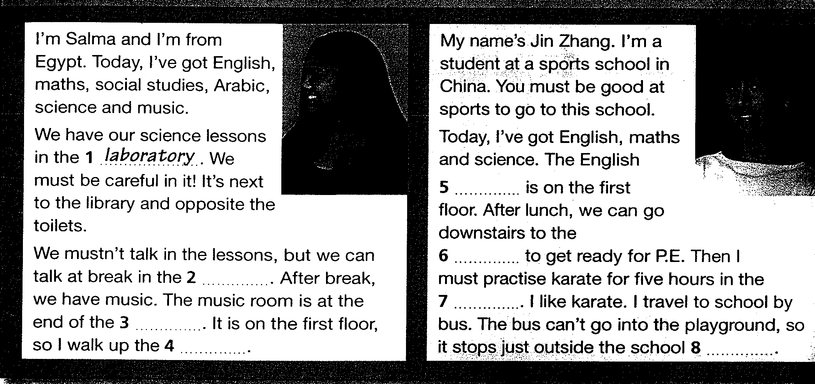

- Complete the text with eight of the words

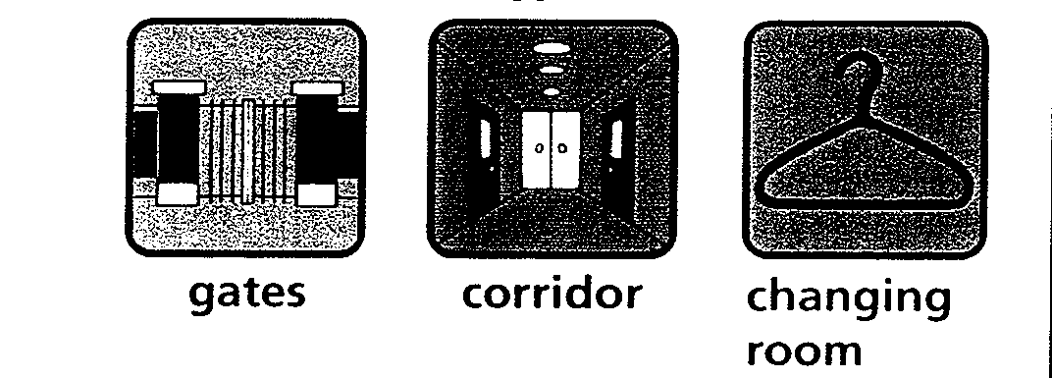
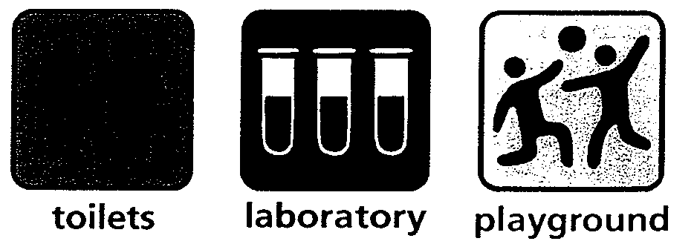
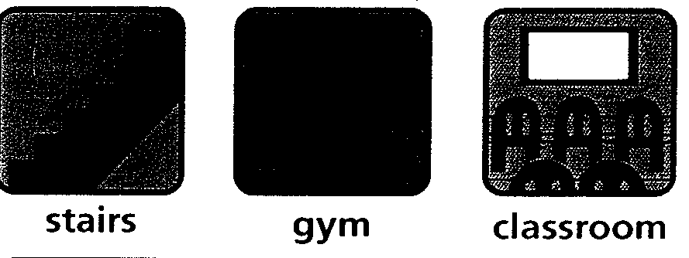

- Answer the questions

- What does Salma do at break?
- ..............................................................................
- What is Jin good at?
- ..............................................................................
- How long does he practise sport every day?
- ..............................................................................

2- Read the listening text and complete the dialogue

- Teacher : Hello, Salma. This is Amal. She‘s a new girl in our class. can you show her where to go for her lessons?
- Salma : Of course! I ‘ll give you a tour of our school.
- Amal : Thank you.
- Salma : Let‘s start on the ground floor. This is the office here at the bottom of the stairs on the right. The toilets are next to it. And that‘ s the door to the playground at the end of the corridor. We go there at break.

Complete the following dialogue:
- Teacher : Hello, Ali. This is Ahmed. He‘s a new boy in our class. can you
(1)……….............……. him where to go for his lessons?
- Ali : of course! I ‘ll (2) ….............……….you a tour of our school.
- Ahmed : Thank you.
- Ali : Let‘s start on the ground floor. This is the office here at the bottom of the stairs on the(3)….………................. The toilets are next to it. And that‘ s the door to the playground at the end of the(4)..……...........…….

ملاحظات هامة
The best time to…+مصدر ……..isافضل وقت لـ ....هو......

- The best time to study is in the morning.
- افضل وقت للمذاكرة هو في الصباح
- The best time to arrive at school is before lessons start.
- افضل وقت للوصول الي المدرسة هو قبل ان تبدا الحصص.
- The best time to pack your bag for school is the night before school
- افضل وقت لتعبئة ( حزم) حقيبتك للمدرسة هو اليلة قبل المدرسة
- The most polite way to ask a question is to put your hand up.
- اافضل طريقة مهذبة لطرح سؤال هو ان ترفع يدك لاعلي
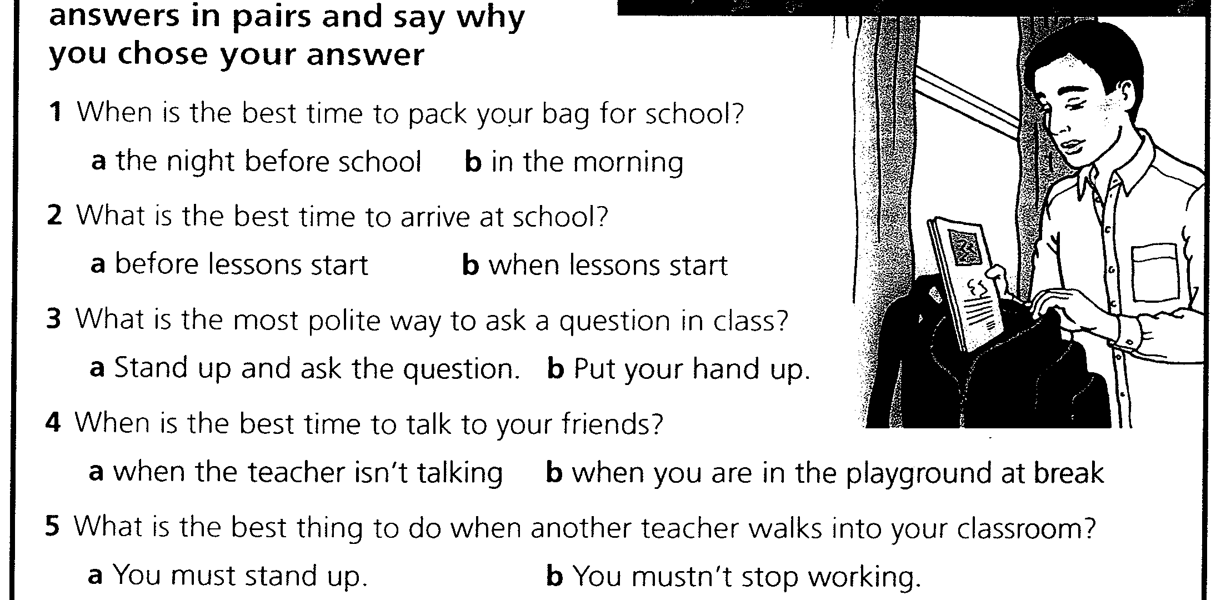

السؤال عن المكان Asking the way

- Where is…… مكان + ........... اين.........؟ عند السؤال عن المكان نقول :
- Where is the library? ؟… اين المكتبة
وصف المكان Giving locations

at the top of the stairs | أعلى السلم | on the right | علي اليمين
at the bottom of the stairs | أسفل السلم | on the left | علي الشمال
at the end of the corridor | نهاية الطرقة | on the ground / first floor |  | في الدور الارضي / الأول
in the middle | في الوسط | opposite (the lab) | أمام المعمل
upstairs | في الدور العلوي | next to (the library) | بجوار المكتبة
downstairs | في الدور السفلي | behind | خلف
above | فوق | between….and….. | بين..... و......
عند وصف المكان نقول : upstairs) ) It is…….

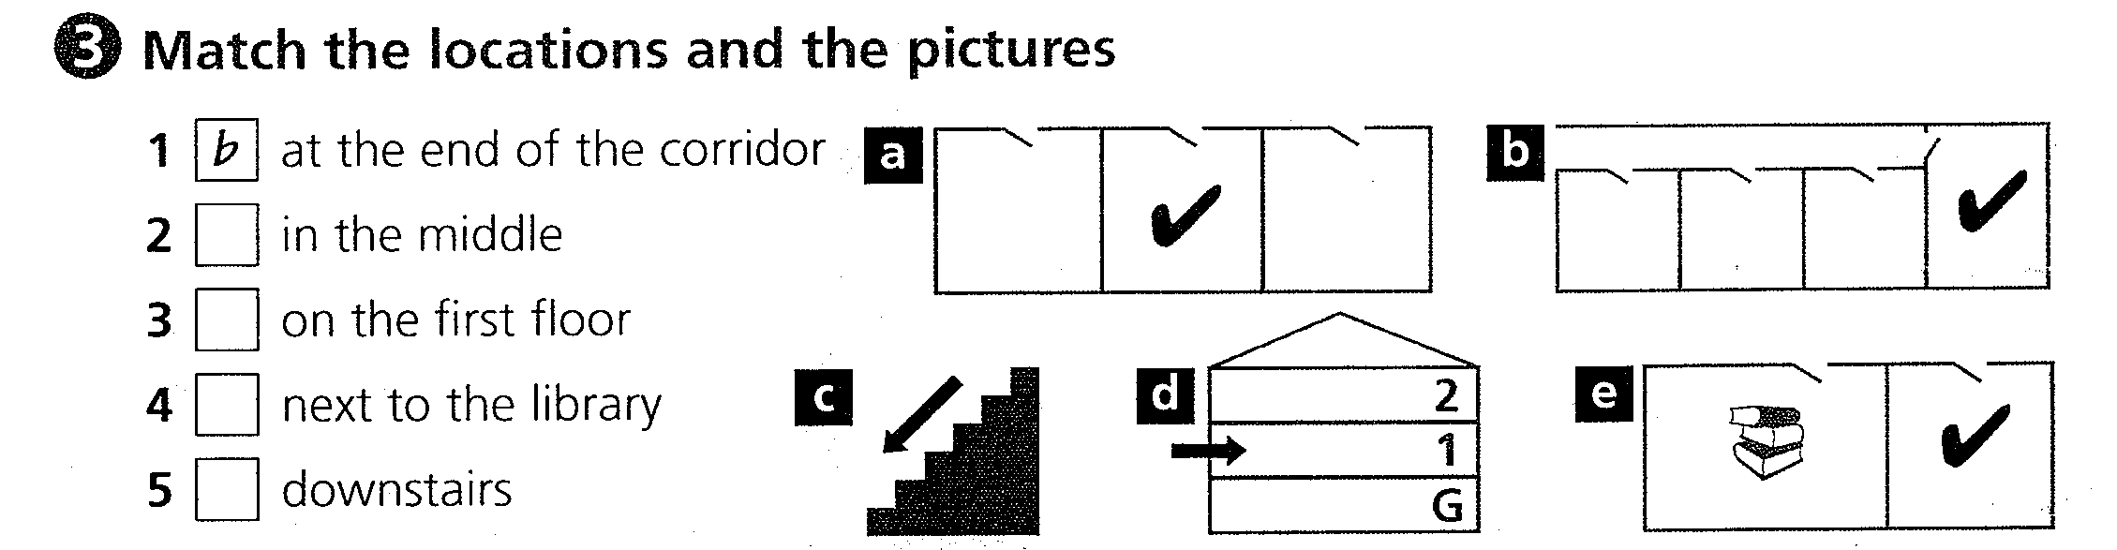

- Complete the following dialogue:

-Omar : Where is the science lab?
Ramy : It’s …1……………to the library.
Omar : Is it upstairs or down stairs?
Ramy :…2………………………………………….
Omar : Is it on the right?
Ramy :yes ,……………………3……………………….

- Choose the correct answer:

1-Classroom 5 is …………. the first floor.
a) in b) on c) by d)for
2- The changing room is……… the gym.
a) next b) above c) opposite d)under
3- The laboratory is on the first……….
a) gate. b) corridor c) upstairs d) floor.
4- The office is……………The lab and the library .
a) between b)next c) opposite d)in front
2- The music room is ……………The right .
a) of b) from c) in d) on
4- …………….is the playground?
a) Who b) when c) how d)where


Ability - الاستطاعة القدرة

الاثبات | النفي
Can + مصدر يستطيع  تعبر عن القدرة على فعل شئ أو أن شئ مسموحاً به فى  الحاضر | Can’t (can not) + مصدر يستطيع لا  تعبر عن عدم القدرة على فعل شئ أو أن شئ غير مسموحاً به فى الحاضر
- I can ride a bike. | - I can’t drive a car.
- You can watch TV after doing homework | - You can’t stay in the library after 4 o’clock
- We can talk to our friends at break. | - You can’t look at the sun.

Obligation & prohibition - النهي (التحريم ) الإلزام


الاثبات ( اللالزام - الضرورة ) | النفي ( النهي – التحريم )
must + مصدر ان يجب  تعبر عن الالزام بفعل شيء لانه من القواعد و القواتين  لانه ضروري و مهم | mustn’t + مصدر يجب ان لا  تعبر عن عن النهي عن فعل شيء لانه ضد القواعد و القواتين  لانه خطر - مضر - غير مسموح به
- You must wear a school uniform | - You mustn’t talk in the library.
- You stop when the light is red. | - You mustn’t smoke in hospital.
- You must wash vegetables before eating. | - You mustn’t drink dirty water .

- Choose the correct answer from a, b, c or d

- You ................look right and left before you cross the road.
a- can b- must c- mustn't d- can't
- Children ................ play with matches. It’s dangerous.
a- must b– mustn’t c– have to d– can’t
- He is late for school. He................ take a taxi.
a- need b- must c- mustn’t d– have to
- You.……….. look at the sun..
a –must b -can't c – can d-mustn’t
- You ................ stop when the traffic is red.
a- can b–mustn’t c– must d– could
- Children ................ play with matches. It’s dangerous.
a- must b– mustn’t c– can d– can’t
- I ................ tidy my room.
a- must b– can’t c– couldn’t d–mustn’t
- He ............... buy a pen. He has got enough money.
a- must b– mustn’t c– can d– can’t
- You ................ swim in the sea on a windy day.
a- must b– mustn’t c– can d– could
- We ................ use that classroom today because it is Friday.
a- must b– could c– can d– can’t
- We .............watch television after we finish our homework.
a- haven’t b– mustn’t c– can d– wasn’t
- You ................ put hot food fruit in the fridge.
a- must b– mustn’t c– can d– could
- You ........speak English very well to be an English teacher.
a- must b– mustn’t c– can d– can’t
- You ................ drink water from the river. It's not clean
a- must b– mustn’t c– can d– could

- - Read and correct the underlined words

- We must to go to the laboratory for our science lessons. [………………………]
- Ali can speaks English in Mrs Mona's classroom. [………………………]
- You can to open the window if you ask the teacher. [………………………]
- We must use the playground when it is raining. [………………………]
- You mustn’t to drink water from the river. It is not clean. [………………………]

- Write a paragraph of five sentences about

Your school
........................................................................................................................ ........................................................................................................................
My school
I go to El Farouk prep school.
My school is big and clean.
I can play in the playground.
I can read and borrow books from the library.
I can play music in the music room.
My teachers are kind and helpful.

- . Choose the correct answer from a, b, c or d:

- Go up the stairs. The laboratory is on the first ………….
    - gate b- corridor c- upstairs d- floor
- On my new…… I can see that we have English at 8 a.m.
    - Corridor b- timetable c- map d- location
- Classroom 5 is on the …………floor .
    - one b- ground c- sky d- land
- There is a large gym at the................of the corridor.
    - downstairs b- middle c- bottom d- end
- The changing room is ..................... to the gym.
    - next b- opposite c- under d- on
- We should be ready ……………facing our future.
    - In b- at c- for d- with
- We go to the ………….. to read.
    - gym b- library c- playground d- office
- Students should …….English inside and outside school.
    - put on b- make c- practise d- sleep
- You……………. look right and left before you cross the road.
a) can b) must c) mustn’t d) can’t
- You………….. stay in the library after six o’clock because it closes then.
a) must b) can’t c) can d)did
- The changing room is…………… the gym.
a) next b) above c) opposite d)under
- Before you eat. you must…………….. your hands.
a) wash b) drink c) clean d)mix
- It is not a beautiful building. I think it is…………..
a) clean. b) ugly. c) healthy. d)unhealthy
- The water is very clean, so it is…………….. to drink.
a hot b) drought c) safe d)bad
- You must be careful when you are in the……………..
a) laboratory b) music room c) art class d) corridor
- When I finish my homework, I can watch…………..
a) out b) the dishes c) a bike d) television.
- The most polite way to ask a question is to put your hand ……..
a) in b) at c) of d)out
- After English, it’s………… .After that, we’ve got maths.
a) gate b) break c) lab d)corridor
- Some people put on their sports clothes in the……..before they do P.E.
a) laboratory b) changing room c) art class d) gym
- There is a bus stop outside the school…………..
a) door b) stairs. c) ground. d)gates
- It is best to ………your school bag the night before you go to school.
a) pack b) place c) put d) plan
- On my new…… I can see that we have English in the morning.
    - a corridor b) timetable c) map d) location
- Hamdi has cousins in England and other……….. in ltaly.
a) parents b) relatives c) families d) brother
- - Complete the following dialogue with one word each

Hamdi is talking with a new student at the school.

Hamdi : Hello. My name is Hamdi ........1................... is your name?
Fareed : I'm Fareed. I'm new here. Where is the ........ 2.............. ?
Hamdi : It's the big room at the end of this ................. 3.......... Do you have P.E. today?
Fareed : Yes, at 10 o'clock.
Hamdi : You're in my P.E. class. Come with me.
Fareed : We........... 4....................... hurry. It's almost 10 o'clock now.

- mini-dialogues
1 – Tamer : Excuse me. Where is the office, please?
Teacher :........................................................
Tamer : Thank you

2- A student : ......................................................................?
A teacher : The music room is on the first floor

3 – Sara :.......................................................................... ?
Mona : The best time to do homework is after school.

- Read the following , then answer the questions :

l’m Suzan and I’m from Egypt. Today, We got Arabic, maths, social studies, science and music. We have our science lessons in the laboratory. We must be careful in it! It’s opposite the library and next to the toilets. We have break in the playground. At break, we can talk and have sandwiches. After break, we have music. The music room is at the end of the corridor. It is on the first floor so l walk up the stairs.

A) Answer the following questions :

1 - What does Salma do at break?
…………………………………………………………………………….
2- Where is Suzan from?
…………………………………………………………………………….
3- How many subjects has she got today?
………………………………………………………………………..
B) Choose the correct answer :

3- Suzan has …………………….. after break.
a) Arabic b) English c) maths d) music
5- Suzan walks …………….. the stairs to study music.
A) of b) down c) up d) for

- Read and correct the underlined words:

- We must to go to the laboratory for our science lessons. [………………………]
- We must use the playground when it is raining. [………………………]
- You must eat not in the changing room. . [………………………]
- We can’t stayed after six o'clock. [………………………]
- You must be careless in the lab. [………………………]

