Ministry of Education
ELT Counsellor's Office
***********
توزيع منهج اللغة الإنجليزية
للصف الثانى الإعدادى
للعام الدراسى 2016/2017
First Term
************

Reader  Robinson Crusoe | New Hello For Preparatory Schools Year Two (SB + WB) | Months
--------------------- | Check Your English + Unit 1 | September
Chapter 1 | Cont. Units 1 + 2 + 3 + Review A | October
Chapter 2 + 3 | Units 4 + 5 + 6 + Review B | November
Chapter 3 Con. +4 | Units 7 + 8 + 9 + Review C | December
Revision | Final Revision | January  2017

توزيع منهج اللغة الإنجليزية
للصف الثانى الإعدادى
للعام الدراسى 2016/2017
Second Term
************
Reader  The Red Headed  League | New Hello For Preparatory Schools Year Two (SB + WB) | Months
Chapter 1 | Units 10 + 11 + 12 + Review D | February
Chapter 2 | Units 13 + 14 + 15 + Review E | March
Chapter 3 + 4 | Units 16 + 17 + 18 + Review F | April
Revision | Final Revision | May

ملحوظة : -
يجب مراعاة أن المنهج يدرس للعام الأول و هناك مرونة فى التنفيذ .

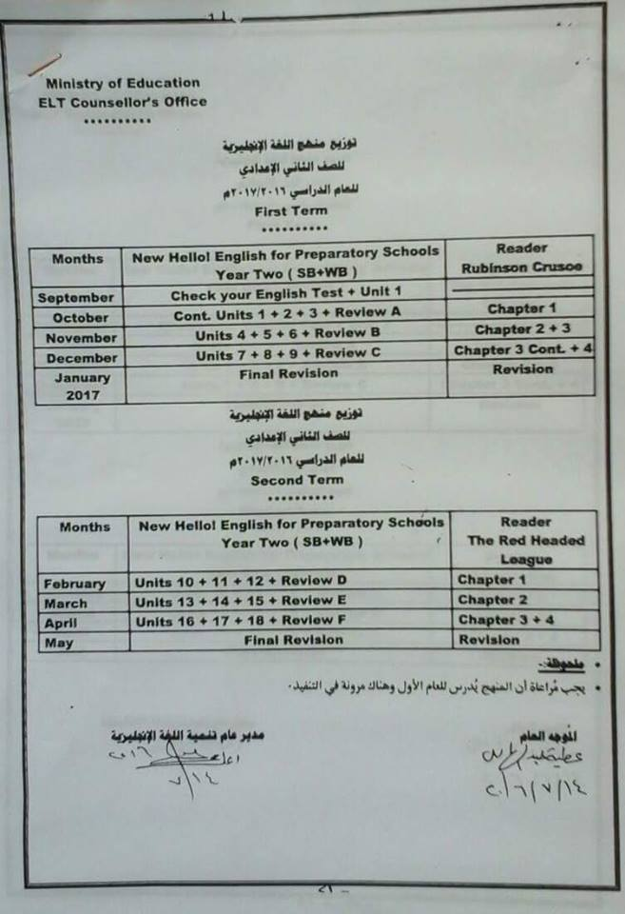

Ministry of Education
ELT Counsellor's Office
***********
توزيع منهج اللغة الإنجليزية
للصف الأول الإعدادى
للعام الدراسى 2016/2017
First Term
************

Reader  The Old Man and The Sea | New Hello For Preparatory Schools Year One (SB + WB) | Months
--------------------- | Check Your English Test + Unit 1 | September
Chapter 1 | Units 2 + 3 + Review A | October
Chapter 2 + 3 | Units 4 + 5 + 6 + Review B | November
Chapter 3 Con. +4 | Units 7 + 8 + 9 + Review C | December
Revision | Final Revision | January  2017

توزيع منهج اللغة الإنجليزية
للصف الأول الإعدادى
للعام الدراسى 2016/2017
Second Term
************
Reader  The Iron Man | New Hello For Preparatory Schools Year One (SB + WB) | Months
Chapter 1 | Units 10 + 11 + 12 + Review D | February
Chapter 2 | Units 13 + 14 + 15 + Review E | March
Chapter 3 + 4 | Units 16 + 17 + 18 + Review F | April
Revision | Final Revision | May

Ministry of Education
ELT Counsellor's Office
***********
توزيع منهج اللغة الإنجليزية
للصف الثالث الإعدادى
للعام الدراسى 2016/2017
First Term
************

Reader  Journey to the Center of the Earth | New Hello For Preparatory Schools Year Three (SB + WB) | Months
Chapter 1 | Unit 1 | September
Chapter 2 + 3 | Units 2 + 3 + Review A | October
Chapter 3 Contd.+4 | Units 4 + 5 + 6 + Review B | November
Chapter4 Contd.+5 | Units 7 + 8 + 9 + | December
Revision | Revision C + Practice Tests | January  2017

توزيع منهج اللغة الإنجليزية
للصف الثالث الإعدادى
للعام الدراسى 2016/2017
Second Term
************
Reader  Journey to the Center of the Earth | Hello! English For Preparatory Schools Year Three (SB + WB) | Months
Chapter6 | Units 10 + 11 | February
Chapter 7+ 8 | Units 12 + Review D 13 + 14 + 15 | March
Chapter 8 (Contd.) + 9 + 10 | Review E +Units 16 + 17 + 18 + | April
Revision | Revision F + Practice Test | May

