Robinson Crusoe

A] Put the events into the correct order:
Crusoe escaped from Morocco in a small fishing boat.
Crusoe’s ship sailed into a big storm and started to sink.
The captain of a passing ship rescued Crusoe and took him to Brazil.
Crusoe sailed with some friends to Guinea to sell more goods.

1- Who wrote Robinson Crusoe? Daniel Defoe
2- What did Crusoe do in Guinea before he went back to London? He sold his goods
3- Why do you think Crusoe was unhappy when he was a slave? As he had to work hard
4- Do you think Crusoe did the right thing by leaving home and sailing to Guinea? Why or why not? Yes, at first as he made a lot of money

B] Put the events into the correct order
Crusoe slept in a tree.
Pirates took Crusoe’s ship and sold him as a slave.
Crusoe became a farmer in Brazil.
Crusoe went to London and found a ship which was sailing to Guinea.
5-Who was Alexander Selkirk? a sailor who spent (four) years alone on an island
6-How do we know that Crusoe was a successful trader? He sold the goods for a lot of money
لأنه باع البضائع بمبلغ مالى كبير
7- Crusoe lived happily as a farmer in Brazil. Why do you think he wanted to be a trader again? As he was greedy / wanted to be rich .
8-Do you think he was able to fall asleep the first night in a tree? Why or why not? No , as he was afraid . / Yes , as he was very tiredمتعبا ً .

C ] Put the events into the correct order:
Crusoe lived alone on the island.
Crusoe’s ship sank.
Crusoe swam back to the ship before it sank and collected things from it.
After three years on the island, Crusoe spent four months building a big boat.
9-How does Crusoe take things from the ship to the beach? He used a raft.
10-What was the problem with the first boat Crusoe built? It was too big كان كبيراً جداً
11-Why do you think Crusoe taught the parrot some words? To make him a friend / To talk to him .
ليكون له صديقا / ليتحدث إليه
12- Why do you think that Crusoe wrote a diary? To know the days /To remember his life on the island
لكى يعرف الأيام / ليتذكر حياته على الجزيرة

D ] Put the events into the correct order:
Crusoe was afraid, so he made his fort stronger.
Crusoe cut down a very large tree and spent four months building a boat.
One day while walking along the beach, Crusoe saw a man’s footprint.
Crusoe learned to make clothes from animal skins
14 - What things did Crusoe first take from the ship and why? Food and drink, as he needed them most
19 - What did Crusoe hear while he was walking on the hill? He heard some guns.
20- Why do you think Crusoe taught Friday to speak English? To speak to him and become his friend .
21- Why do you think Crusoe found life difficult in England? As his wife died and he became alone again.

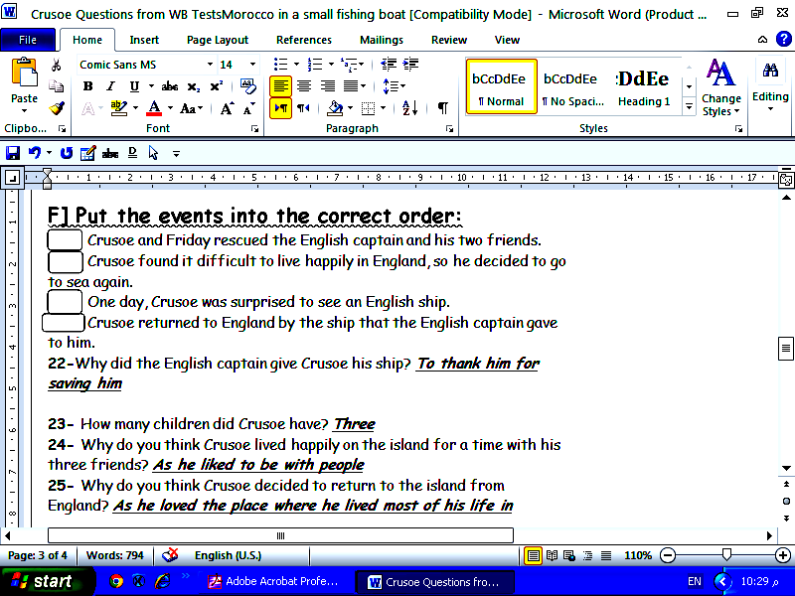
.

15 - Why did Crusoe make some pots? To cook and keep his food
16 - How do you think the compass helped Crusoe? He could know the places on the island
17 - Why do you think Crusoe wanted to sail around the island? To know if there were any people there

E ] Put the events into the correct order:
The dangerous men came to the island again with a prisoner who escaped.
With his telescope, Crusoe saw a large Spanish ship which was slowly sinking.
After Crusoe found the footprint on the beach, he didn’t feel safe.
Crusoe saw the dangerous men who quickly left the island.

18 - Why didn’t Crusoe want Friday to be his slave? He wanted to have a friend.

F] Put the events into the correct order:
Crusoe and Friday rescued the English captain and his two friends.
Crusoe found it difficult to live happily in England, so he decided to go to sea again.
One day, Crusoe was surprised to see an English ship.
Crusoe returned to England by the ship that the English captain gave to him.
22-Why did the English captain give Crusoe his ship? To thank him for saving him

23- How many children did Crusoe have? Three
24- Why do you think Crusoe lived happily on the island for a time with his three friends? As he liked to be with people
25- Why do you think Crusoe decided to return to the island from England? As he loved the place where he lived most of his life in

.

