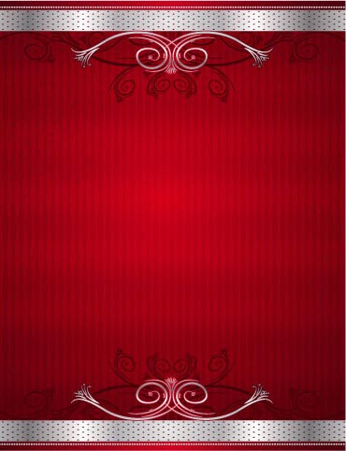
Science and Technology
Word | Meaning | Word | Meaning
STEM schools | مدارس المتفوقين للعلوم والتكنولوجيا | hardworking | مُجد – مجتهد
science | علوم | texts | نصوص
technology | تكنولوجـــيا | scientific | علمى
modern | حديث | need | يحتاج
interview | مقابله | skills | مهارات
essential | ضروري | exciting | مثير
e-mail | بريد الكترونى | attention | انتباة
jobs | وظائف | facts | حقائق
engineers | مهندسين | polluted | ملوث
engineering | هندسة | invention | اختراع
scientists | علماء | objects | أشياء
latest | الأحـــدث | achievements | انجازات
maths | رياضيات | laptop | لاتوب
develop | يطور | e-book | كتاب الكترونى
special | خاص – مميز | Smartphone | تلفون ذكى
focus on | يركز على | Wi-Fi | واي فاي
ability | قدرة | allow | يسمح
around | حول | connect to | يتصل بـــ
different to | مختلف | online | متصل بالانترنت
projects | مشروعات | forms of | أشكال من
usual | عادي | do quiz | يحل مسابقة – لغز
encourage | يشجع | ticket | تذكرة
space | فضاء | equipment | معدات
together | سويا – معاً | perhaps | ربما
solve | يحل | sure | متأكد
problems | مشاكل | academic | أكاديمى – تعليمى
fall | يسقط | electrician | كهربائي
air | هواء | powerful | قوي
data | معلومات – بيانات | rewarding | مجزي
graph | رسم بيانى | achieve | يحقق – ينجز
expert | خبير | cause | يسبب
through | عبر – خلال | pollution | تلوث
check | يفحص | healthy | صحى
results | نتائج | dirty | قذر – ملوث
future | المستقبل | fresh | نقي – طازج

Language Notes

1 – Know to (how to ) + مصدر
We should know how to use the internet.
2 – everyday + اسم يومي * every day كل يوم
I face everyday problems.
I go to school every day.
3 – the last الأخير * the latest الأحـــدث
Ali was the last boy to arrive.
Have you heard the latest news.
4 – Focus on = concentrate on يركز على
STEM schools focus on students’ abilities.
5 – encourage مفعول + to + مصدر
Teachers encourage students to study hard.
6 – do projects ينفذ مشروعات = carry out
Pupils do project and work together.
7 – have a problem عنده مشكله * solve a problem يحل مشكله
Do you have any problems?
He can solve his problems easily.
8 – How + صفة = What + اسم
How fast can the car go?
What speed can the car go?
9 – make a graph يطتب رسوم بيانية
He used data to make a graph.
10 – expert خبير * export صدر
Expert teachers help their students.
We export cotton to many countries.
11 – will be + P . P المبنى للمجهول في المستقبل
He will buy a car.
A car will be bought.
12 – hardworking مجد او مجتهد * work hard يعمل بجد
He is a hardworking boy.
He works hard.
13 – in English باللغة الأنجليزية
The lessons are in English.
14 – will be able to + مصدر تعبر عن القدرة او الاستطاعة في المستقبل
He will be able to study abroad.
15 – have special skills عنده مهارات خاصة او مميزة
An Expert should have special skills.
16 – Win an awardيفوز بجائزة
She won an award Last week.

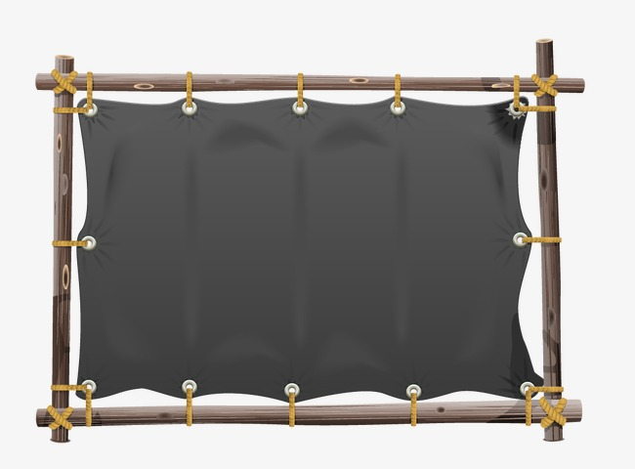
Book Text
STEM Schools
Today, knowing how to use modern technology is essential because people use it every day in schools, at home and at work. It can be easy if you don’t know how to use a computer or send an email. People with many different jobs, such as teachers, engineers and scientists all need to understand how to use the latest technology.
Students who are very good at STEM subjects (science, technology, engineering and maths) can also help develop the technology of the future. STEM schools are special schools which focus on developing students’ ability in these subjects. There are now STEM schools around the world where lessons are different to those in usual schools. Teachers encourage students to do projects where they work together to solve problems.
A lesson might be about how fast a ball falls through the air, or it might be about using data to make a graph. Expert teachers help the students through the projects and check their results.
In Egypt, there are now STEM schools around the country and more will be built in the future. STEM school students must be hardworking. All their lessons are in English, so that they can understand and use scientific texts from around the world while they study.
Experts say that there will be many more jobs in the future that need skills in STEM subjects, when they finish studying, STEM school students will be able to work in exciting jobs that will use the skills that they have learnt.

Listening text

Only students who are very good at maths and science can study at STEM Schools. They have to work hard when they get there. But spending time at the STEM school must be very rewarding. Today I have some students from STEM schools with me. They are going to tell us about amazing achievements. First Of All Azza is talking about an award she has won.
AZZA:
Hello! I won an award for a project that I did at my STEM school. First of All, our class studied the problems caused by polluted water around the world. People can’t stay healthy if they have to drink polluted water. We studied plants and realized that some of them can clean dirty water. I asked myself could it be a way to solve the problem.
I developed an invention that cleans polluted water using only plants. I am sure this can help people living in places that don’t have fresh water. After we check that the invention worked well, I entered the science competition in the USA.
I was very pleased to win an award. I think my invention might be important. Now, I want to take it around the World. There is a chance that it could help millions of people.

Grammar
Expressing Certainty and Uncertainty

(must – might – can’t) + be

must | I am sure – I am very certain متأكد في الاثبات
might (may) | I am not sure – perhaps – I don’t think so – I am uncertain
can’t | I am sure – I am certain متأكد في النفي
I am sure, he must be a doctor. أنا متأكد بنسبة 100% أنه دكتور
I am not sure, he might be a doctor. من المحتمل أن يكون دكتور ( لست متأكداً)
I am sure, he can’t be a doctor, he is an engineer.أنا متأكد 100% أنه ليس دكتور
The phone is ringing, it might be Mona, but I’m not sure.
He must be rich; he has a lot of money and cars.
That can’t be a real dinosaur, dinosaurs disappeared.
ملاحظات هامة
1 – عند التعبير عن المضارع نستخدم (must-might-can’t + be) كما في الأمثلة السابقة
2 – اذا كنا نعبر عن ماضي نستخدم : -
must – might – can’t + have + P. P

He must have been at school.
They might have escaped last night.
He can’t have killed the man, he was abroad.
3 – كلمة (perhaps ---------will) = might
Perhaps, they will visit Aswan.
They might visit Aswan.
Exercise Unit (4)
1 – Finish the following dialogue:
Tamer and Lobna are talking about STEM school.
Tamer: (1)-----------------------------------------------------?
Lobna: It is short for science, technology, engineering and maths.
Tamer: Are there STEM schools in Egypt?
Lobna: (2)-----------------------------------------------------------
Tamer: (3)--------------------------------------------------------?
Lobbna : No, the lessons are In English.
2 – Write what you would say:
1 –You are certain that he is an engineer.
2 – You meet your friend on the New Year day.
3 – Your friend’s father has had an accident.
3 – Read the following , then answer the questions:
Maha is a retired professor. She was born into a good family. She was born in 1940 her father was a great engineer who works in the Toshka valley project. When she was young, she had a dream of being a professor at university. She had some difficult situations at first. But with hard working and patience she achieved her dream and became a famous professor at the faculty of science. Because of her achievements, she was awarded the Nobel Prize last year. She had three daughters and no sons. Now she is leading a happy life.
A)Answer the following questions
1- How old is professor Maha now?
2- In which family was she born?
3- What was her dream?
B) Choose the correct answer from a, b, c or d :
4- Maha didn't have--------------------------------
a - three daughters b - sons c – father d - husband
5- Maha------------------- her goals and dreams.
a - achieved b – failed c – ate d - missed
4 – The Reader
A. Match

A | B
1. When the fire was bigger | a. softly and gently to the horses
2. John spoke | b. with a lantern
3. The man came | c. the building collapsed
4. The firefighters put out the fire | d. after many hours
 | e. After few hours
B – Answer the following questions
1 – Who saved Ginger and How?
2 – What happened to the building when the fire became bigger?
3 – Who came to put out the fire?
4 – Why do you think everyone was talking to John?
5 – In Gordon friend’s opinion, what is one of the hardest things in life?
5 – Choose the correct answer:
1. My father has many special skills, he is an -----------------------
a. import | b. export | c. expert | d. company
2. ----------------- means information or facts.
a. data | b. date | c. dates | d. dating
3. To ---------- is to make someone really like and do something.
a . hit | b. hurt | c. discourage | d. encourage
4. Essential means very --------------------------
a . important | b. unimportant | c. useless | d. bad
5. To ----------------- is to give all your attention to something.
a. focus | b. regret | c. neglect | d. leave
6. STEM school students must be ------------------
a – lazy | b. hardworking | c. helpless | d. stupid
7. That ----------be Ali. He has gone on holiday for two weeks.
a. must | b – can’t | c. might | d. is

8.In this photo, everyone is wearing warm clothes. It--- be very cold there.
a – can’t | b - must | c. may | d. might
9. Only students who are very good at maths and ------ can study at STEM
a - history | b. geography | c. Arabic | d. science
10. An -------- is a book that can be read online.
a. e-book | b. paper book | c. old book | d – history book
11. A mobile phone that can work like a computer .
a. Smartphone | b. laptop | c. lab | d. e-book
12. A -------- is a small computer that you can carry with you.
a. laptop | b. Smartphone | c. e-mail | d. e-book
13 – Something that allows mobile, computers and phones to connect to the internet is ---------------------------.
a – Wi-Fi | b. wi-hi | c. wi-lie | d. wi-bye
14. The students used the ---- from the experiment to draw a graph.
a. phones | b. books | c. program | d. data
15. My grandfather doesn’t want a/an-------- because he likes to buy books from the bookshop.
a. e-book | b. smart-phone | c. I-phone | d. I-pad
16. We can use the internet in this café because it has-----------
a. Wi-Fi | b. tea | c. books | d. newspaper
17. Manal --------- be at home. I am sure. The lights are on
a. can’t | b. may | c. might | d. must
18. He can’t speak Arabic, he ----------- be Egyptian.
a. must | b. can’t | c. may | d. might
19. The museum -------- be closed. There are no lights.
a. might | b. may | c. can’t | d. must
20. We are not sure how old this coin is. It -------hundreds of years old.
a. is | b. can’t | c. might | d. must
21. I am sure it is a British coin, it ------------ be Egyptian.
a. must | b. can’t | c. might | d. may
22. ------------- Asmaa will go to London, I am not certain.
a. Sure | b. Perhaps | c. Must | d. Should
23. Shehab----------- be happy. He has just won a gold medal.
a. may | b. can’t | c. might | d. must
24. I am ----------you did well, because you studied hard.
a. sure | b. must | d. not sure | d. uncertain
25. Scientists have ------------a new medicine to help fight heart disease.
a. done | b. dried | c. developed | d. dropped
26. Kenzy is studying ---------- at university.
a. engineer | b. engine | c. engineering | d. engineers

27. The students studied a ------- which showed the number of tourists who visited Cairo in different months.
a. goal | b. data | c. future | graph
28 – A/An ------ is a prize someone gets for something they have achieved
a. data | b. prize | c. price | d. flag
29 – Teachers ------------ STEM students to enter competitions.
a. encourage | b. discourage | c. deny | d. swim
30 – Omar won an amazing ------------------------- for his invention
a. award | b. present | c. data | d. STEM

6 – Rewrite the following sentences:
1 – I am sure he is an engineer. (must)
2 – Ali didn’t catch the train. (can’t)
3 – I am not sure she is at home. (might)
4 – Ayman has a lot of money. (must)
5 – Dina isn’t at school. (can’t)
6 – He can’t be Egyptian. (French)
7- Rana can’t have taken the money. (didn’t)
8 – He must be poor. (rich)
9 – He can’t be sad. (must)
10 – Perhaps, they will win the match. (might)
7 – Read and correct:
1 – I don’t talk much on my graph. I use it to send messages.
2 – Travelers want free data in airports because they need to send e-mails.
3 – I don’t like engines because I don’t enjoy reading novels online.
4 – I want to buy a book shop, it is easier to carry around than a computer.
5- The lessons are always by English.
6- STEM schools focus in Students’ abilities.
7 – I know how by speak English well.
8 – I go to school everyday.
9 – They used data to do a graph.
10 – How speed can this plane go?
8 – Write a paragraph of (7) sentences about one of the following:
- Modern Technology.
- STEM schools.

هذا العمل متاح للجميع لوجه الله دون استئذان وهو صدقة جارية على روح والدتى وموتى المسلمين
Mr Hamada Hashish
01287424004
وللمزيد تابعونا على

https://www.facebook.com/hamada.hashish.3

وهنا أيضا
https://www.facebook.com/groups/173244922885133/

