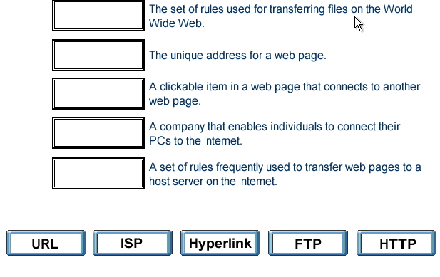
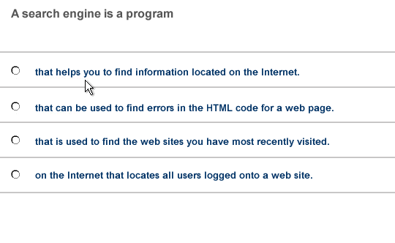
FTP

URL

Hyperlink

ISP

HTTP

- That helps you to find information located on the internet

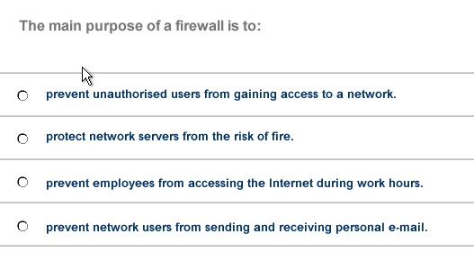
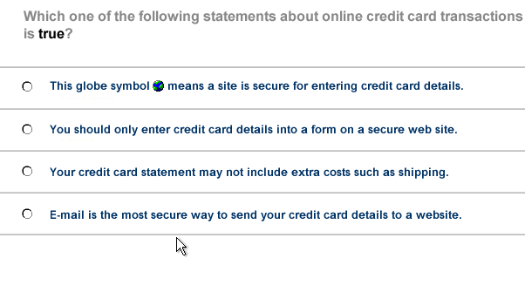

- Prevent unauthorized users from gaining access to a network

- You should only enter credit card details into a form on a secure web site
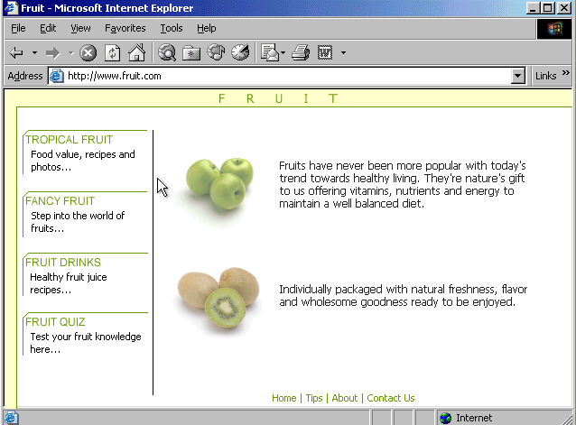
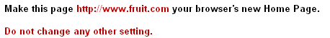

Tools → internet options → click on use current → ok

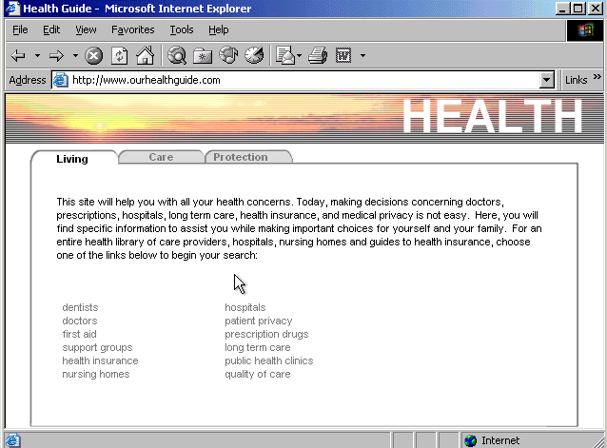
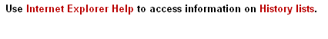

Help → contents and index→ type History lists → display

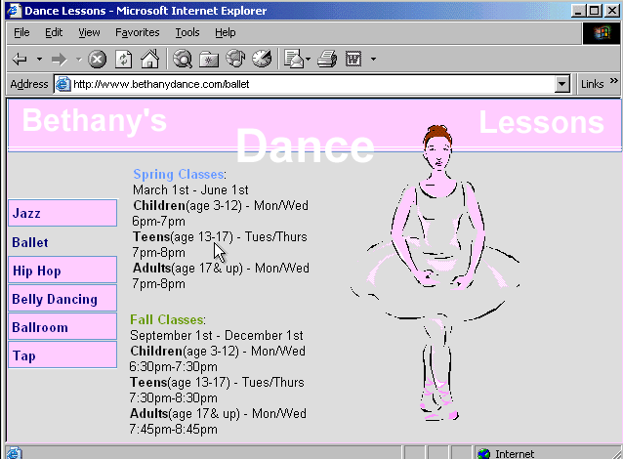
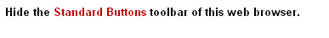

Right click on the menu bar → select the standard buttons

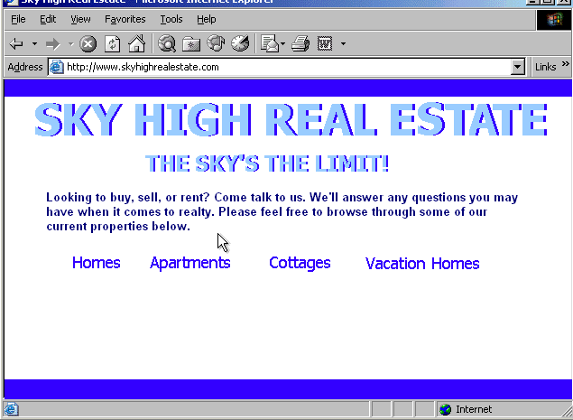
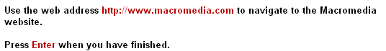

In the address box type http://www.macromedia .com → press enter from the keyboard

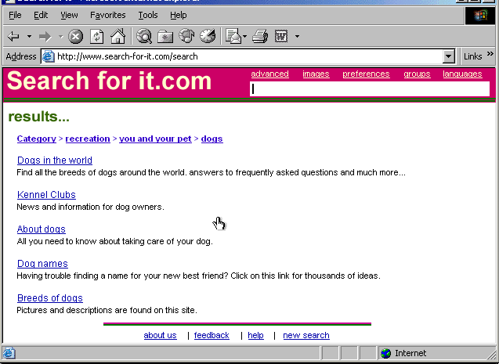
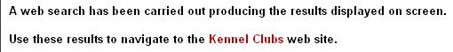

Click on the Kennel Clubs hyperlink

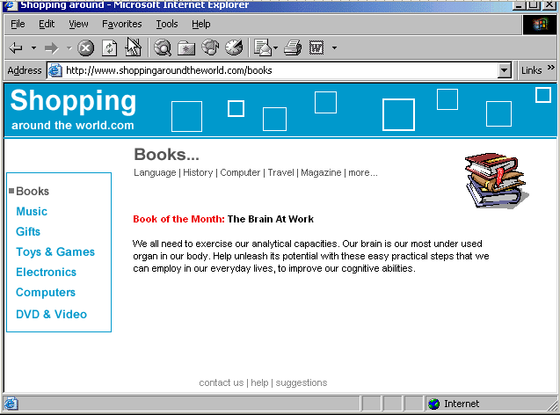
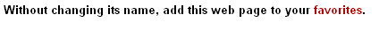

Favorites→ add to favorites → ok
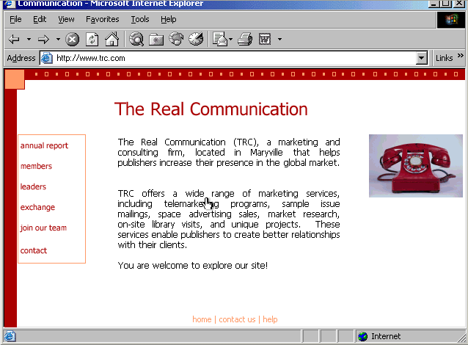
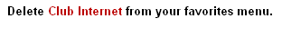

Favorites → organize favorites → select club internet → click on delete →yes
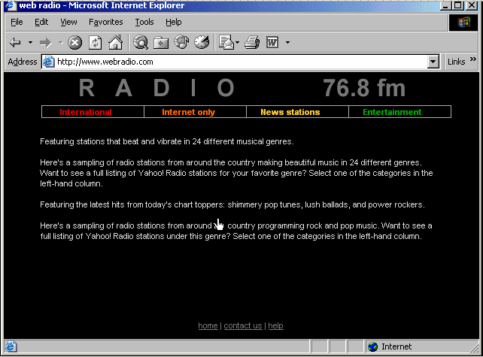
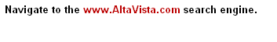

In the address box type www.AltaVista.com

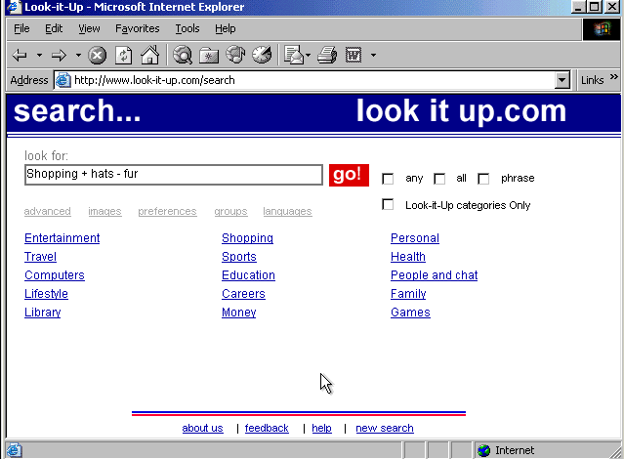
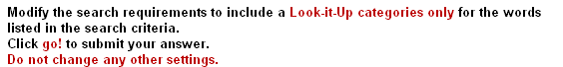

Check the look-it-up categories only → click on go
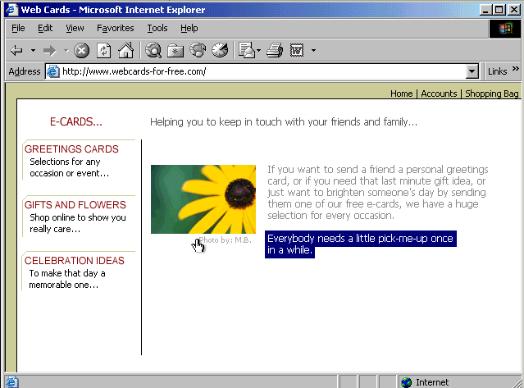
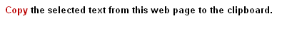

Right click on it and copy

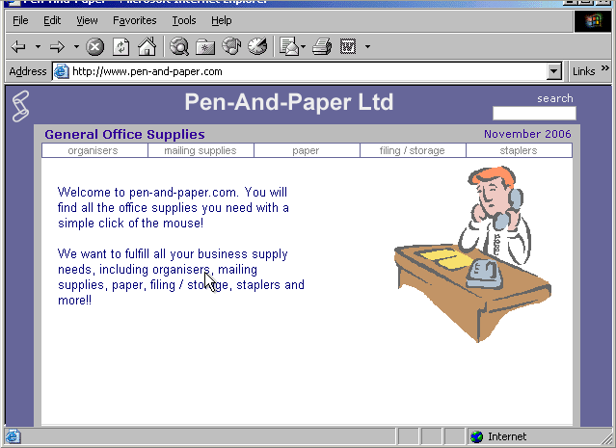
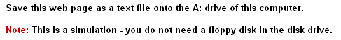

File → save as → in the save in box select drive A: → in the save as type select text file → click on save
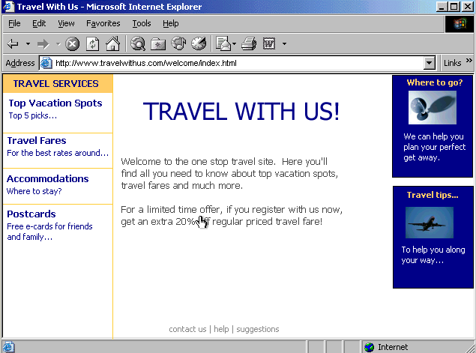
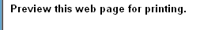

File → print preview
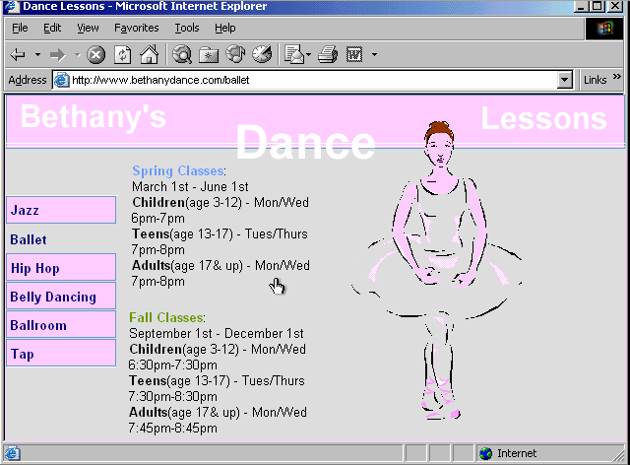
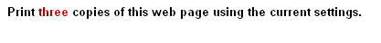

File → print → in the number of copies select 3 → click print
De
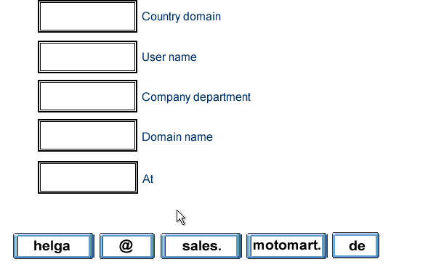
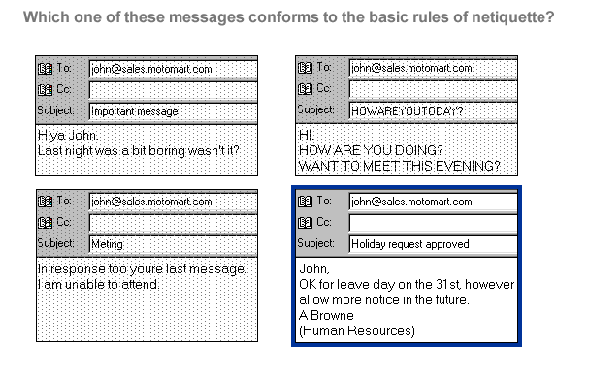

helga

Sales.

Motomart.

@

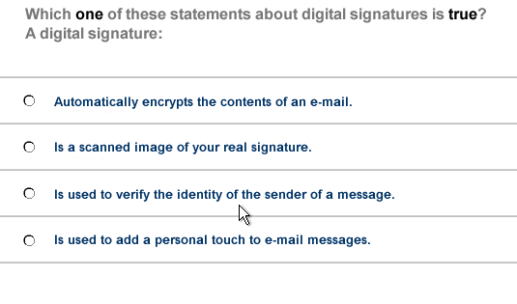
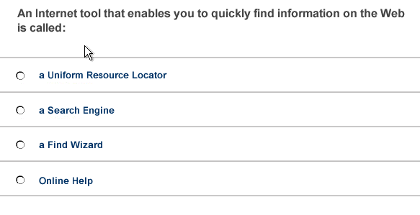

- Is used to verify the identity of the sender of a message

- A search Engine

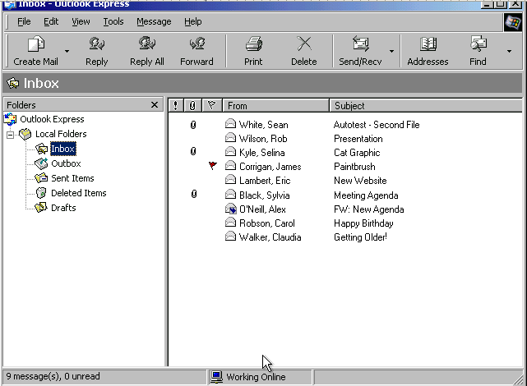
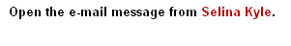

Double click on the Selina Kyle message

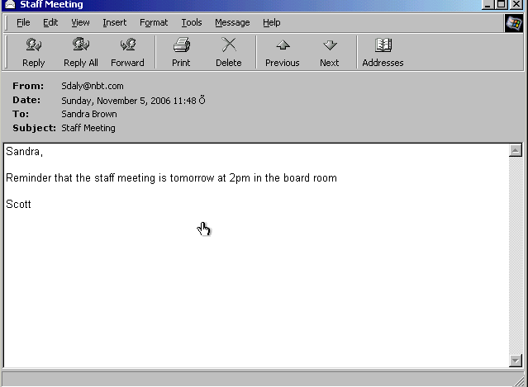
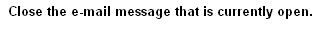

Click on close from the title bar

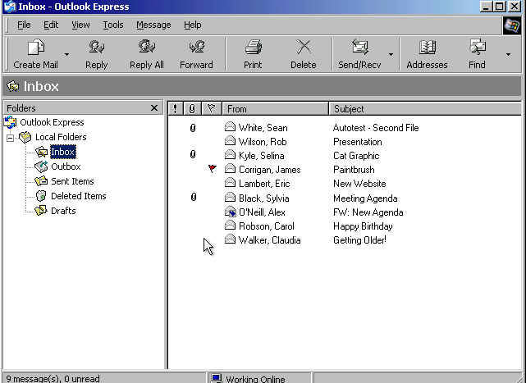
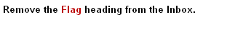

View → columns → uncheck flag → ok

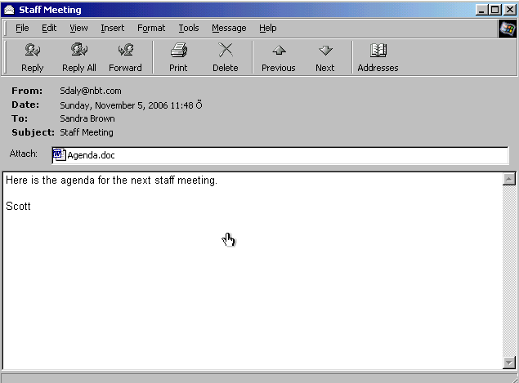
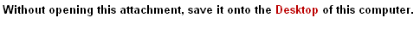

Right click on the Agenda.doc select save as → select desktop → save

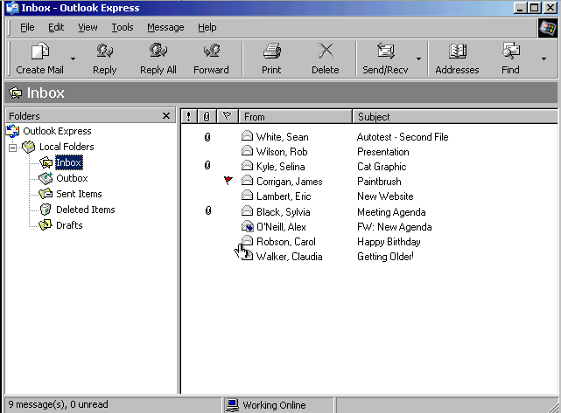

Tools → options → select send tab → uncheck the include message in reply → ok

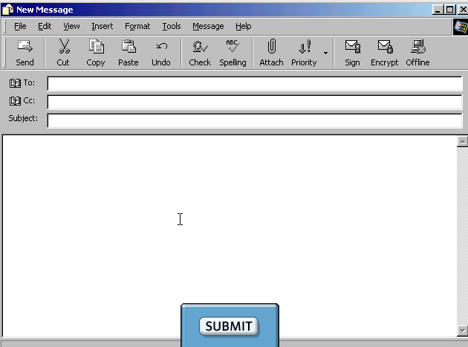
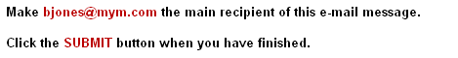

In the To box type bjones@mym.com → click submit

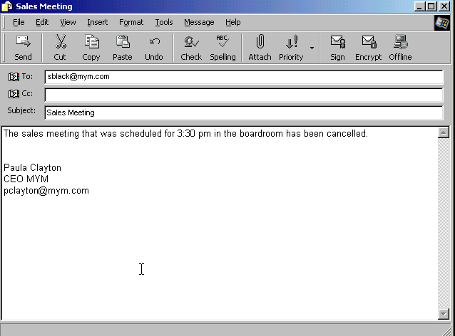
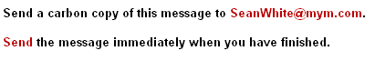

In the Cc box type Sean Whete@mym .com → click send

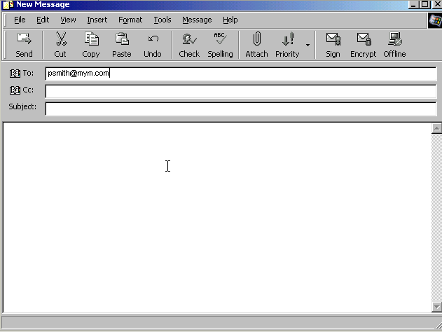
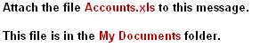

Click on the attach button → select my documents → select Accounts.xls → click attach
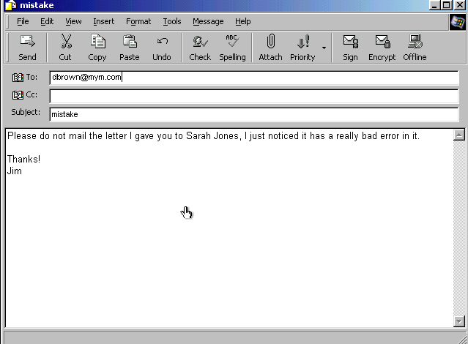
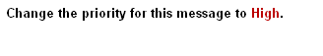

From the priority drop down list select high priority

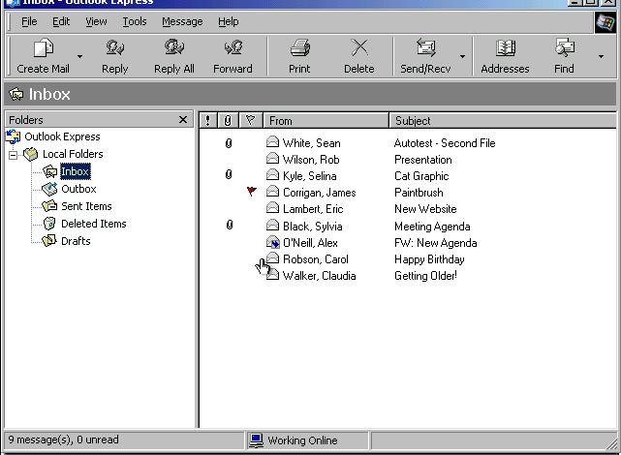
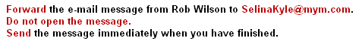

Select rob Wilson message → click on forward button → in the To box type SelinaKyle@mym.com → click send

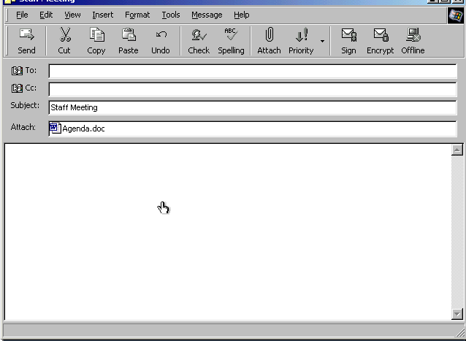
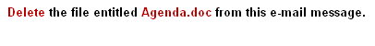

Select the file Agenda.doc → press delete from the keyboard

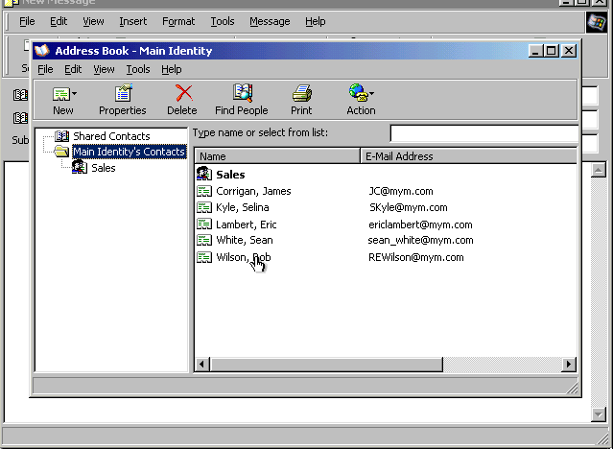

From the new drop down list select new group → in the Group name type Research Team → click on the select member button → select Rob Wilson click select → select Sean White click select → ok → ok

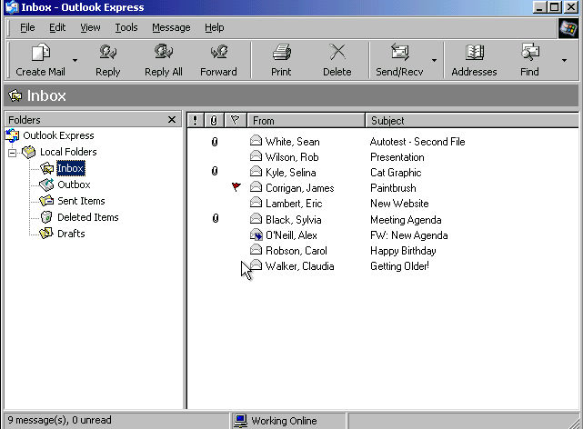
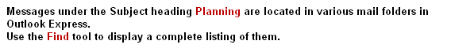

Edit → find → messages → in the subject box type Planning → click on find now
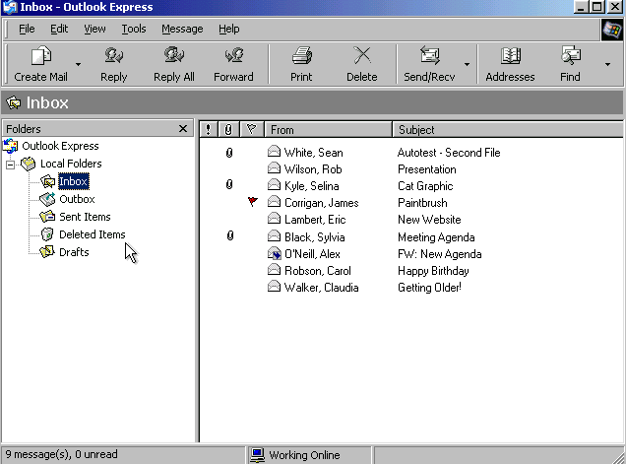
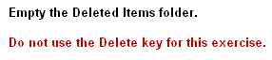

Right click on the deleted items → select empty 'deleted items' folder

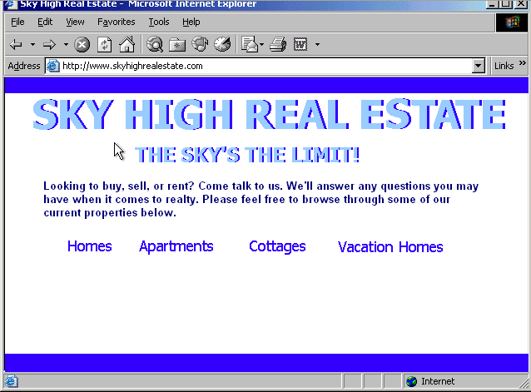
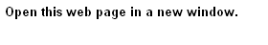

File → new → window

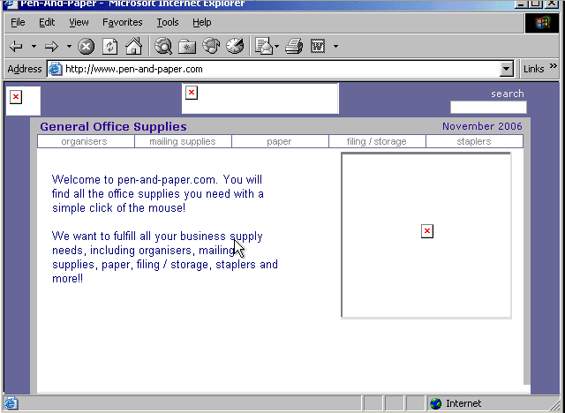
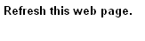

Click on the refresh button
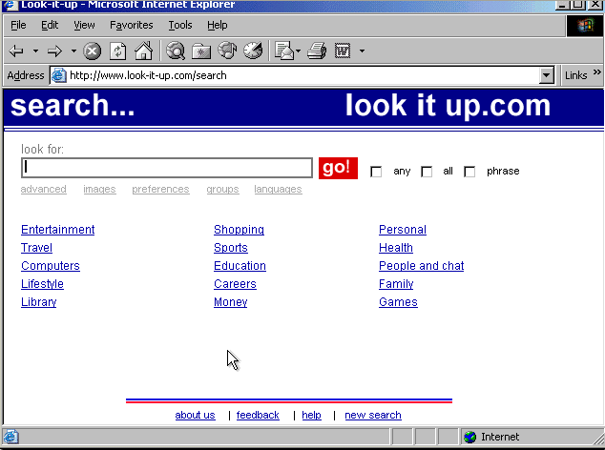
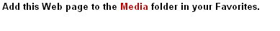

Favorites → add to favorites → select Media folder → ok

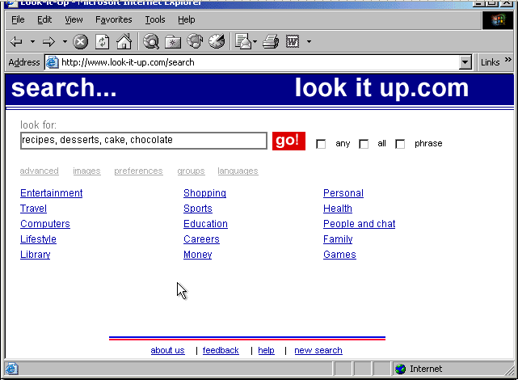

Check any and then click go
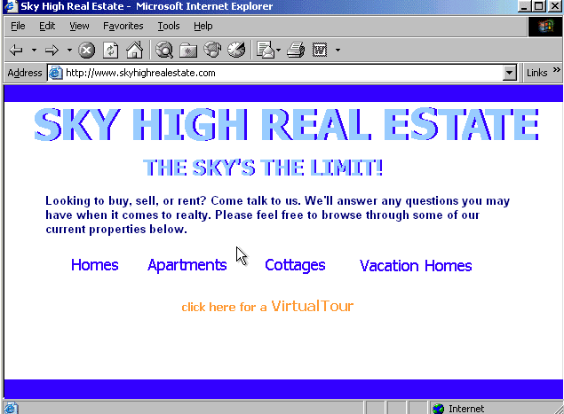
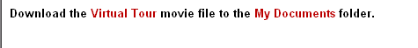

Click on the click here for a Virtual Tour → select my documents → save

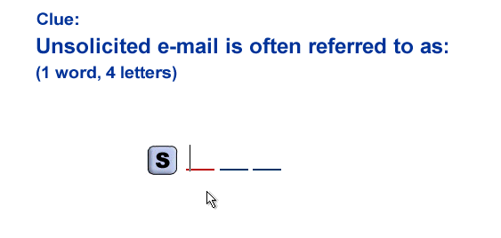
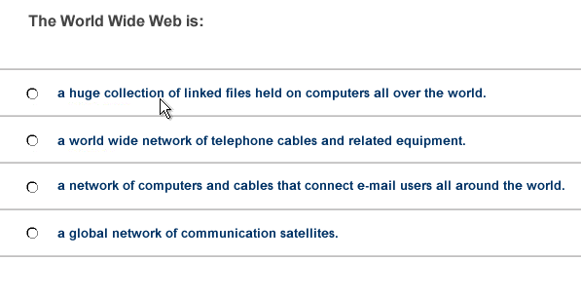

Spam

- A huge collection of linked files held on computers all over the world
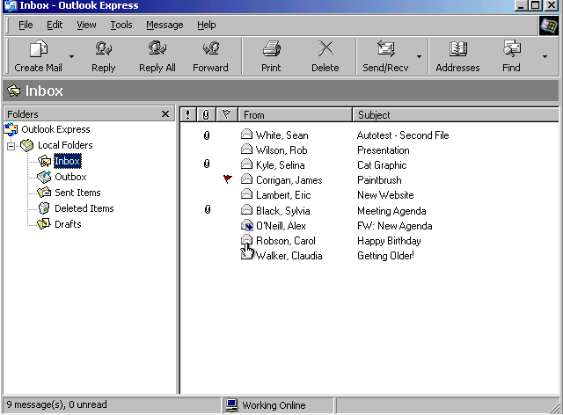

Help → contents and index → type unread messages → display

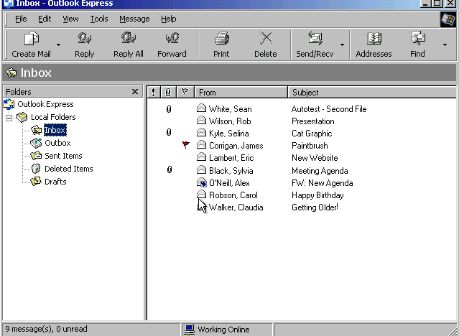
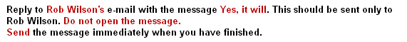

Select Rob Wilson message → click on reply button → click in the message body and type yes, it will → click send

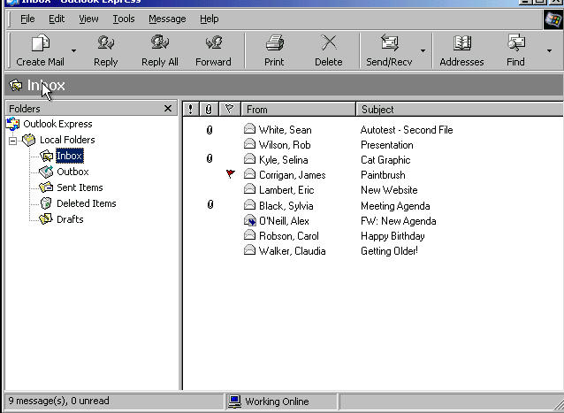
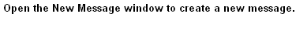

Click on create mail button
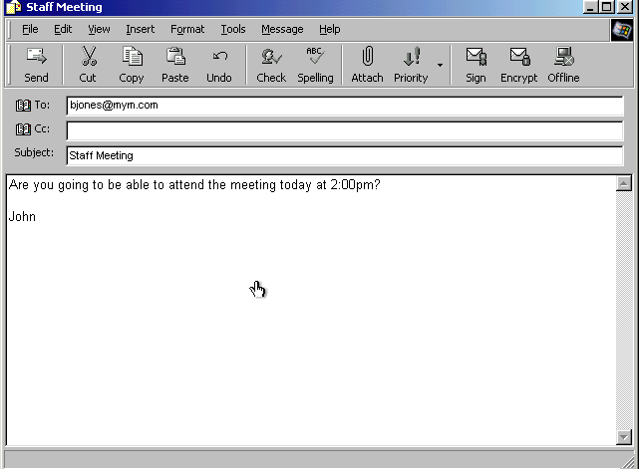
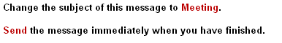

In the subject box delete the word staff → click send
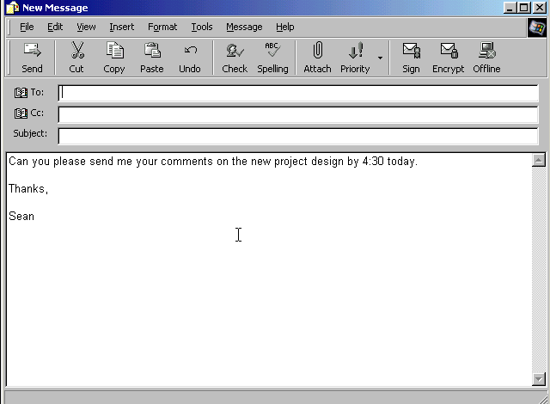
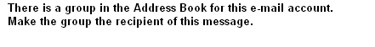

Click on the → select the Electric paper → click To → ok
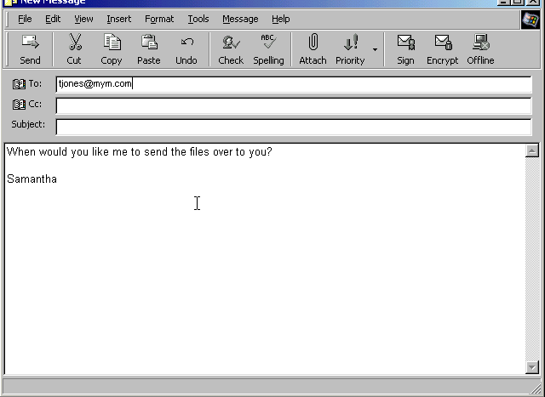

Right click in the subject box → select paste

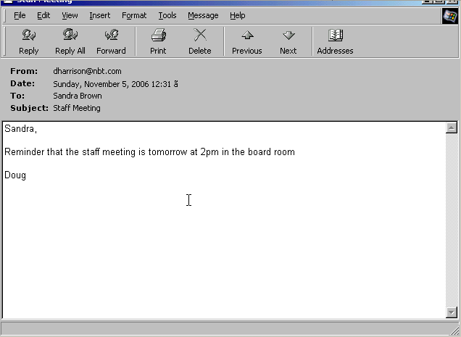

Right click on the email address in the from and select add to address book

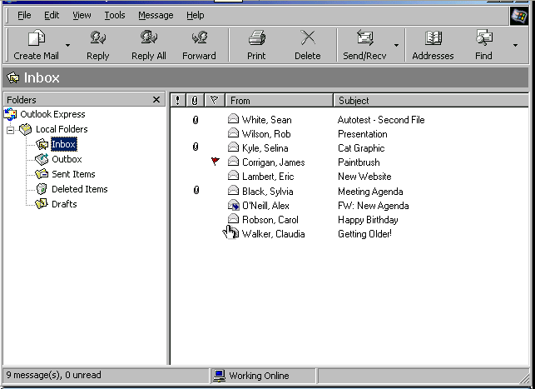

File → new → folder → in the folder name box type Personal → ok

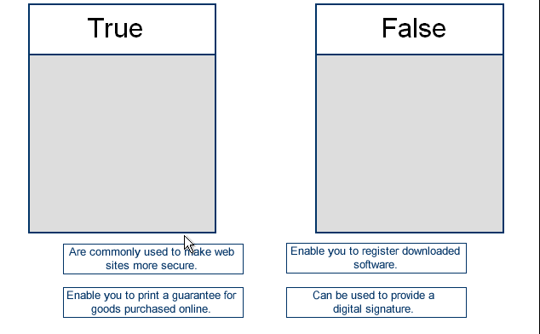

True
- are commonly used to make web sites more secure
- enable you to register downloaded software

False
- enable you to print a guarantee for goods purchased online
- can be used to provide a digital signature

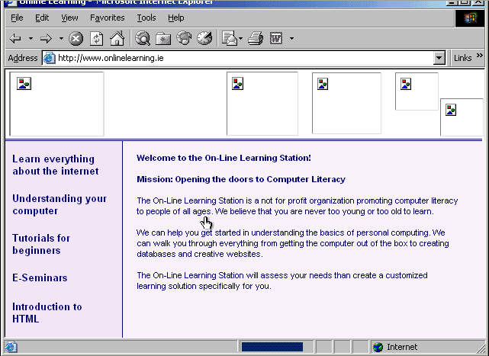

Click on the stop button
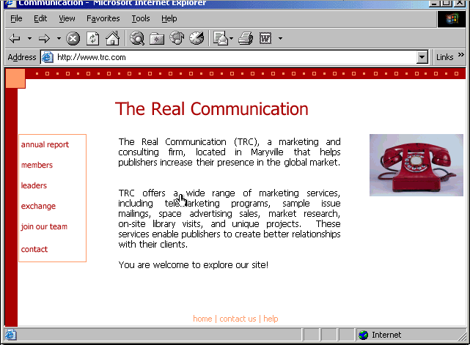

From the drop down list → select the first URL

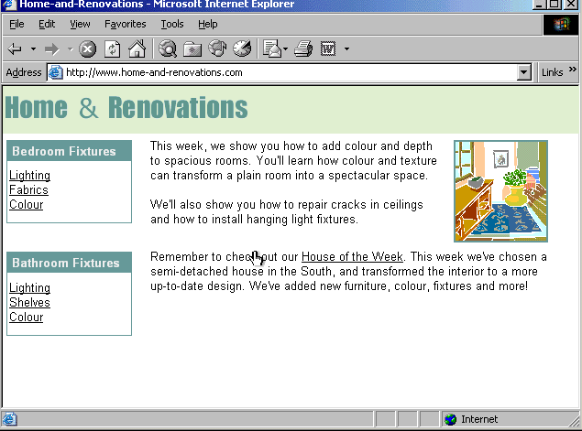
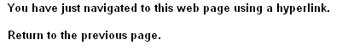

Click on the back button

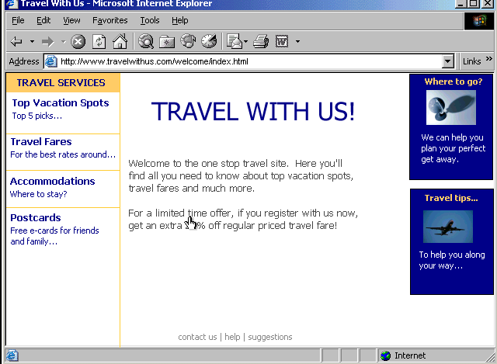
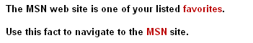

Favorites → select MSN

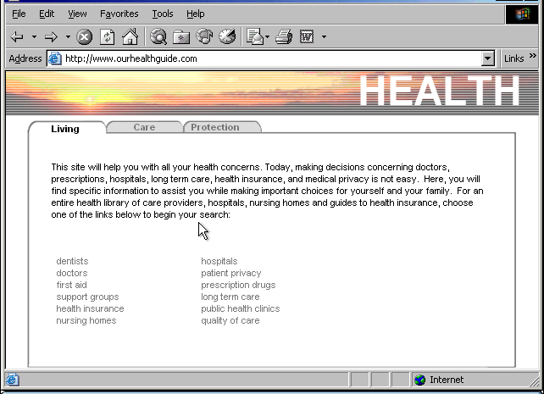
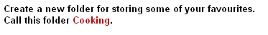

Favorites → organize favorites → create folder → type Cooking
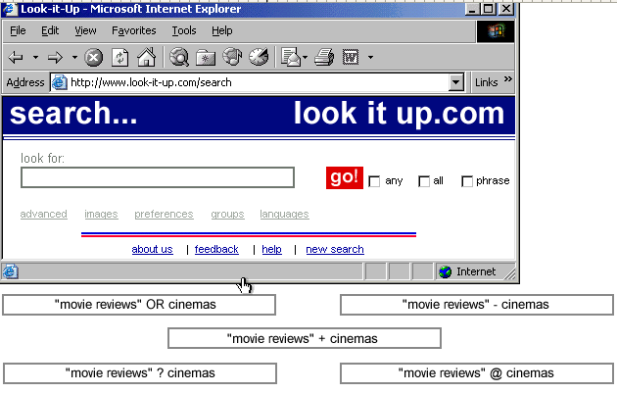

"Movie reviews" + cinemas

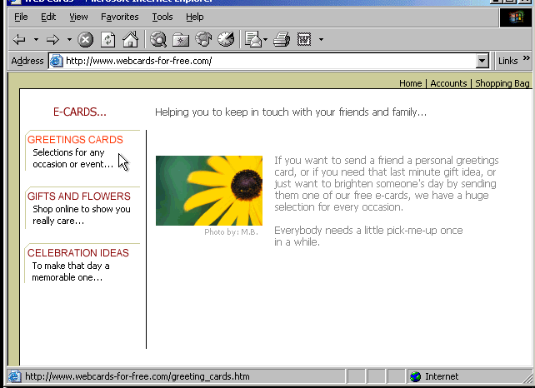
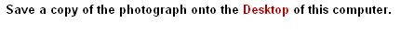

Right click on the photograph → select save picture as → select the desktop → save

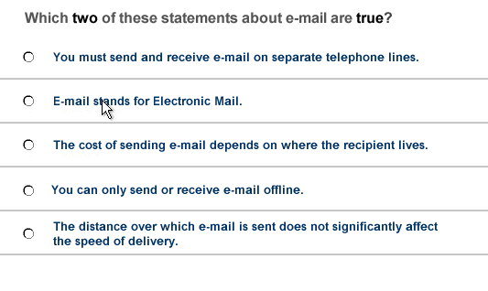
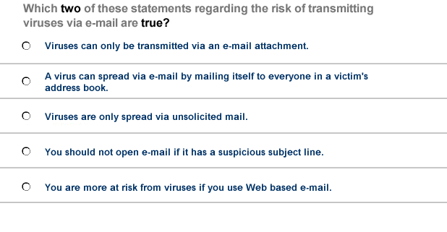

- E-mail stands for Electronic Mail
- The distance over which e-mail is sent does not significantly affect the speed of delivery

- A virus can spread via e-mail by mailing itself to everyone in a victim's address book
- You should not open e-mail if it has a suspicious subject line
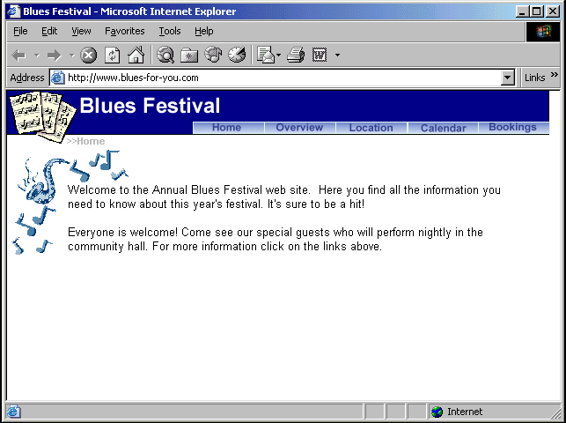
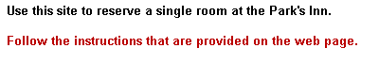

Click on Bookings → click on the rooms/Accommodation → from the first drop down list select Park's Inn → from the second drop down list select single room → click book now
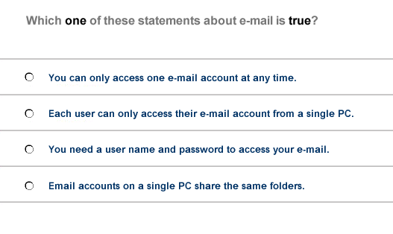
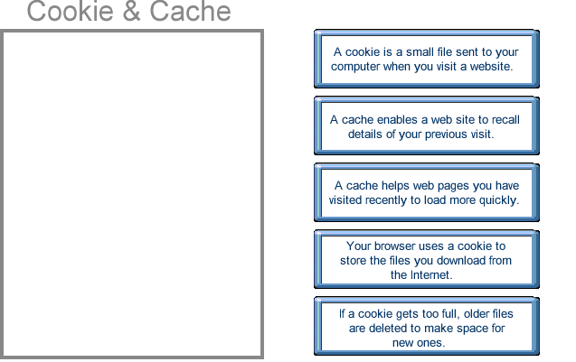

- You need a user name and password to access your e-mail

A cookie is a small file sent to
Your computer when you
Visit a website

A cache helps web pages you
Have visited recently to load
More quickly

If a cookie gets too full older
Files are deleted to make
Space for new ones

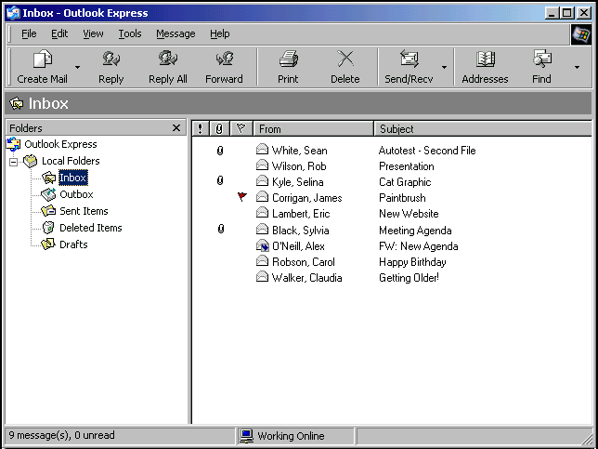
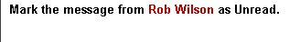

Right click on Rob Wilson → select mark as unread

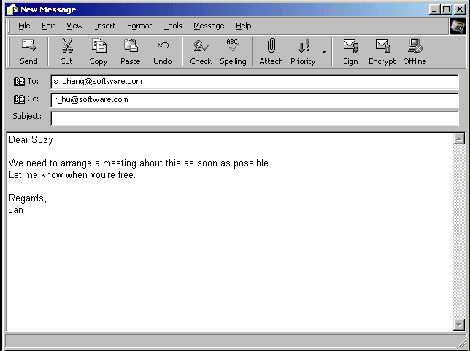
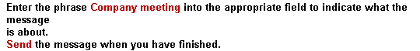

In the subject box type Company meeting → click send

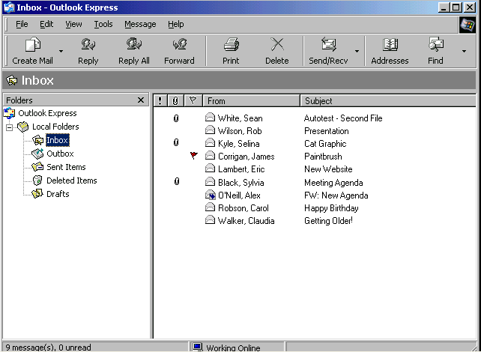
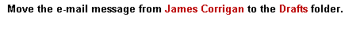

Select the message from James Corrigan and drag it to drafts
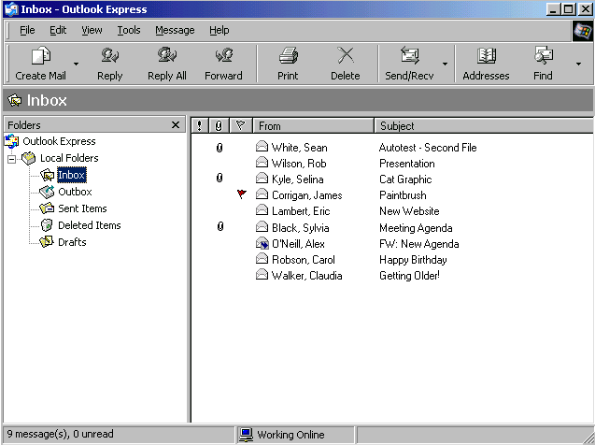
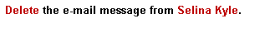

Right click on Selina Kyle message → select delete

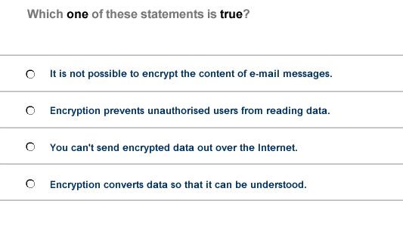
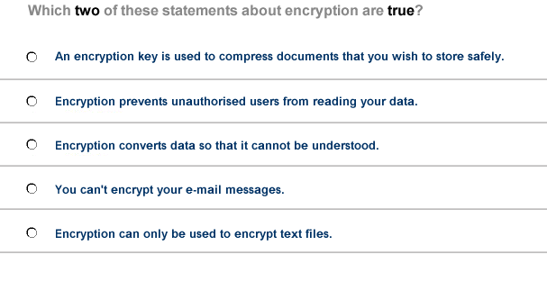

- Encryption prevents unauthorised users from reading data

- Encryption prevents unauthorised users from reading your data
- Encryption converts data so that it cannot be understood

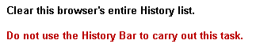

Tools → internet options → click on clear history
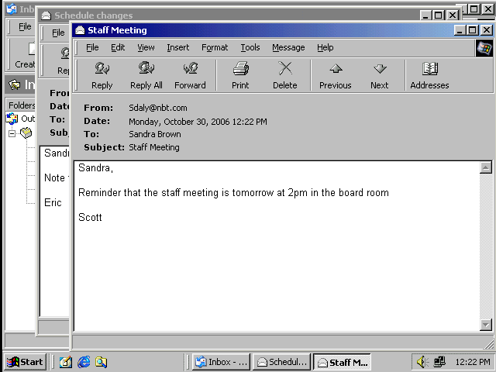

Select the Schedule changes from the task bar

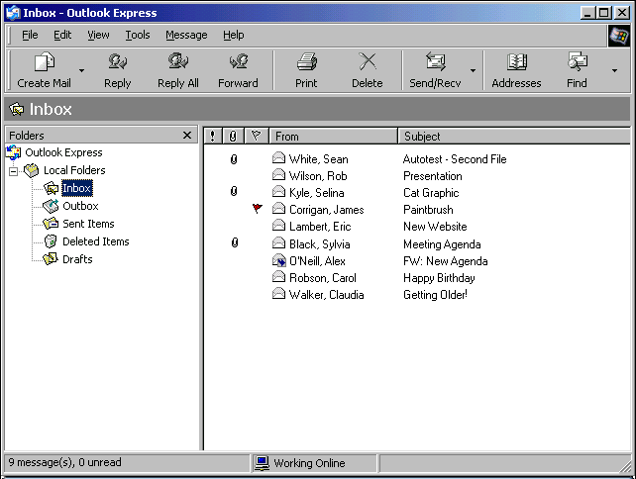
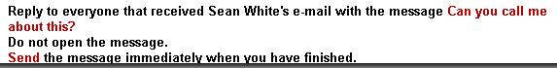

Select the Sean White's message → click on reply all → type Can you call me about this? → Click send

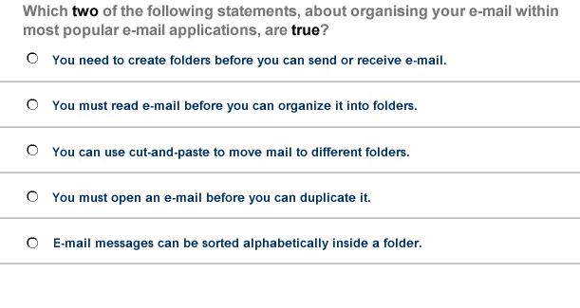
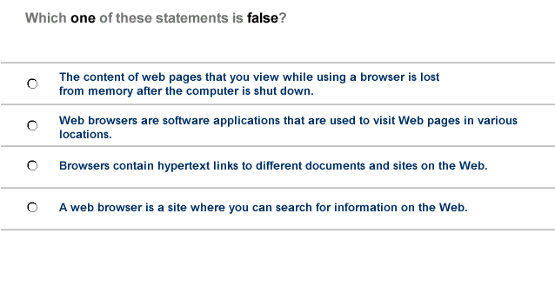

- You must read e-mail before you can organize it into folders
- E-mail messages can be sorted alphabetically inside a folder

- A web browser is a site where you can search for information on the web

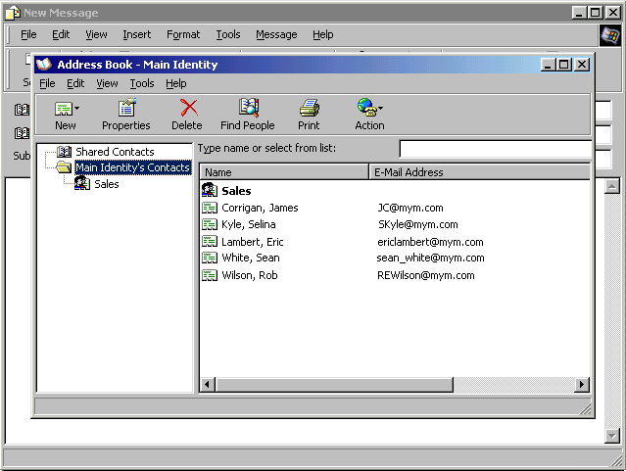
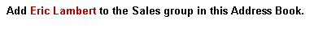

Select Sales → click properties → click select members → select Eric Lambert → ok → ok

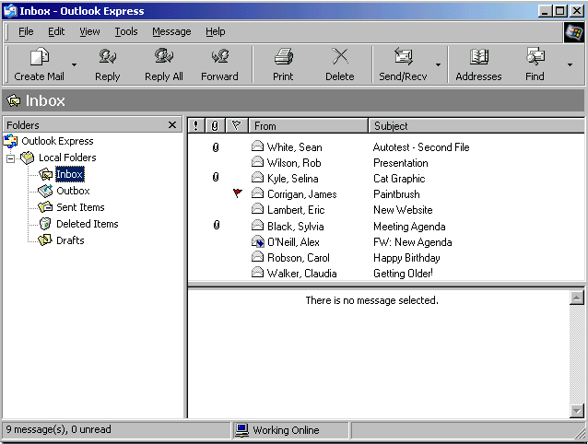

Select Selina Kyle message

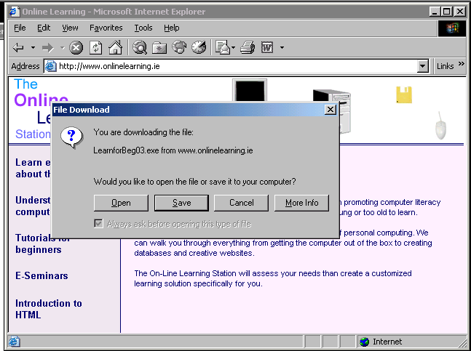
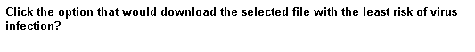

Click save

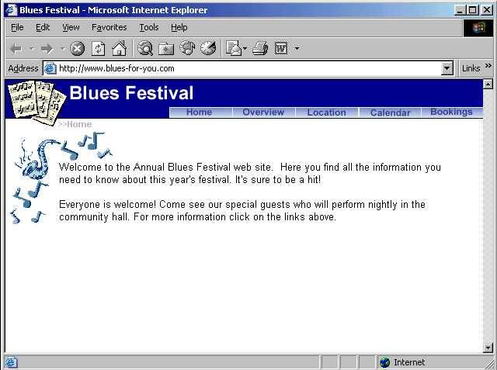
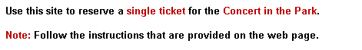

Click bookings → click Events and venues → from the first drop down list select Concert in the Park → from the second drop down list select single ticket → click book now
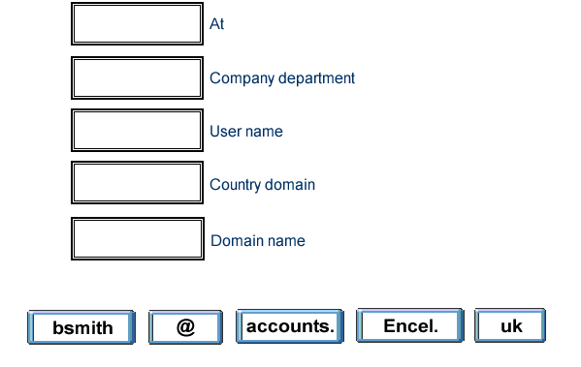
@

Accounts

Bsmith

uk

Encel

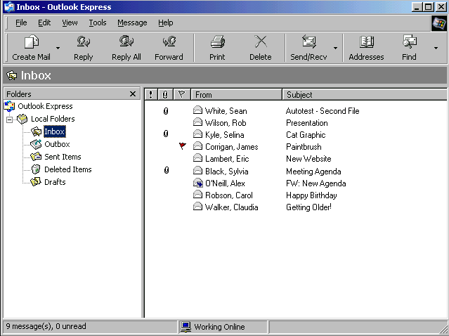
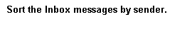

View → sort by → sent

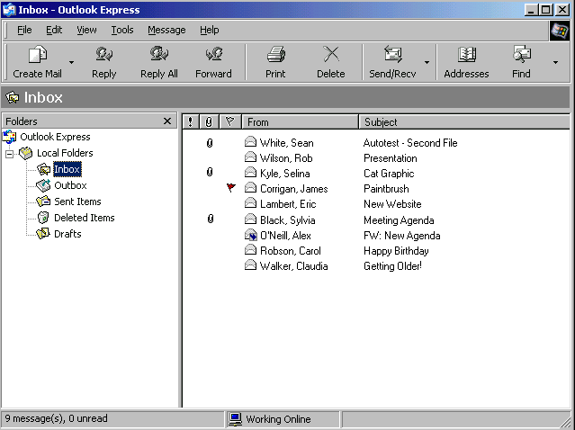
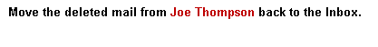

Select deleted Items → right click on Joe Thompson message → select move to folder → select inbox → ok

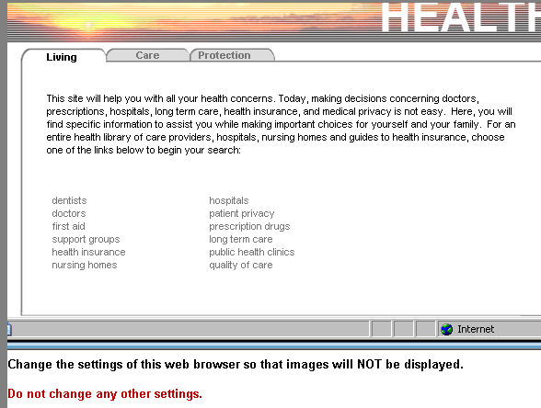

Tools → internet options → advanced tab → in the multimedia section uncheck the show pictures

