Which one of these devices can be uses to output data?
- Keyboard
- ear phone
- scanner
- mouse

Which one of the following statements about the use of teleworking is true?
- Requires less use of communications equipment.
- Increases commuting costs.
- Less emphasis on teamwork .
- Reduces flexibility of working hours

CBT has been used for on-line learning CBT stand for ?
- Computer based technology.
- Computer based training
- Computer based teaching
- Computer based text books

A megabytes is approximately.
- A hundred bytes
- A thousand bytes
- A million bytes
- A billion bytes

Which one of the following enables a computer to run application?
- Microsoft word
- Windows xp
- Access
- Internet explorer

Which one of the following statements is true about RAM ( random-access memory )
- Ram is used to temporarily store data that is being processed

Which one of these type of storage disks can save the amount large of data?
- Zip disk
- Floppy diskelte
- DVD
- CD-ROM

which one of the following statements about ………………………………
- A security policy protract
- Employees from lawsuits and bankruptcy
- The employee’s confidential information المعلومات السرية للموظفين
- The company’s revenue

Media player

Playing video clips

Internet Browser

Photo viewer

Displaying web pages

Presenting a window of vacation pictures

Word processing

FTP client

Uploading large files to a server

Creating letter and business documents

True
False

Purchases can be made 24 hours a day

You are guaranteed the best prices when making online purchases

Shipping of purchases is monnaily free

You are at risk from insecure payment methods

There a wide rang produces to choose from

Drag the statement that best describes the internet into the box.
Internet

الكبلات و اتصالات الاقمار الصناعية تربط انظمة الكمبيوتر حول العالم

All the linked documents that are held on a global network of computer system
The cable and communication satellites that connect computer systems all over the world

The programs that server up web pages to browsers

A local network of computers linked together or using communications equipment

Anti-virus software can
Anti-virus software can not

Protect your computer from all known viruses

Check your computer for viruses

Reduce the cupped of unsolicited e-mail received
Disinfect applications as well as files

True
False

Unformatted disks need operating system data which to learn before they can store files

Disks one automatically formatted when you save a file
Formatting a disk will erase all pre-existing data from the disks
A used floppy disk cannot be reformatted

Which one of these is computer hardware?
- An e-mail message.
- A database.
- A monitor
- An internet browser

Which one of these is computer types is the least powerful?
- Laptop computer.
- Personal digital assistant (PDA)
- Personal computer
- Network computer

Computer
Person

Calculating payroll for employees

Praising employees

Duplicating employee files

Luring employees

Motivating employees

EFT is commonly used payment method for E-commerce EST stands for ?
- Economic finance transit.
- Economic funds transfer تحويل الاموال الكترونيا
- E-mail finance transport.
- E-commerce fund transit

Which two of the following statements are good anti-virus practices?
- Opening unknown e-mail attachments.
- Installing software from unknown internet sites
- Deleting e-mail from unknown source
- Scheduling virus checks to run once a day
- Updating anti-virus software once a year

Which one of the following secure password?
- Your name.
- Your telephone number
- A word with both alpha and numeric characters
- A word with alpha characters only

Which one of the following statements about purchasing online is true ?
- You don’t need internet access
- Only business customers can shop safely online
- Customers can purchase goods from anywhere in the world
- Consumer rights are those that apply in your own country

The term GUI stands for اختصار الى ?
- Graphic user interchange
- Graphical user interface واجهة الرقائق الرسومية
- Graphical uniform infrastructure
- Graphical uniform images
Which one of the following noticeably affects a computer’s performance?
- Modifying the screen resolution to 640 × 480
- The number of printers installed on the computer
- The number of applications running .
- Modifying the brightness of your monitor.

Which one of the following traditional bonting on ………………….
- Checking an account
- Opening a new account
- Depositing a cheque
- Transferring funds
- Applying for loans

Which one of the following helps to create a good working environment for computer users ?
- Positioning monitors above eye level.
- Using energy efficient lighting
- Sitting one arms length from the monitor
- Sitting with your legs crossed at the knee

Operating systems
Other software

windows

Linux

Microsoft office

Mac os

Firefox

Dose not affect RSI
لا تؤثر
affect RSI
تؤثر

Sleeping patterns
نمط النوم

Repel live movement
الحركة المفاجئة

Stress
الاجهاد

Diet
الرجيم

Ergonomics
بيئة العمل

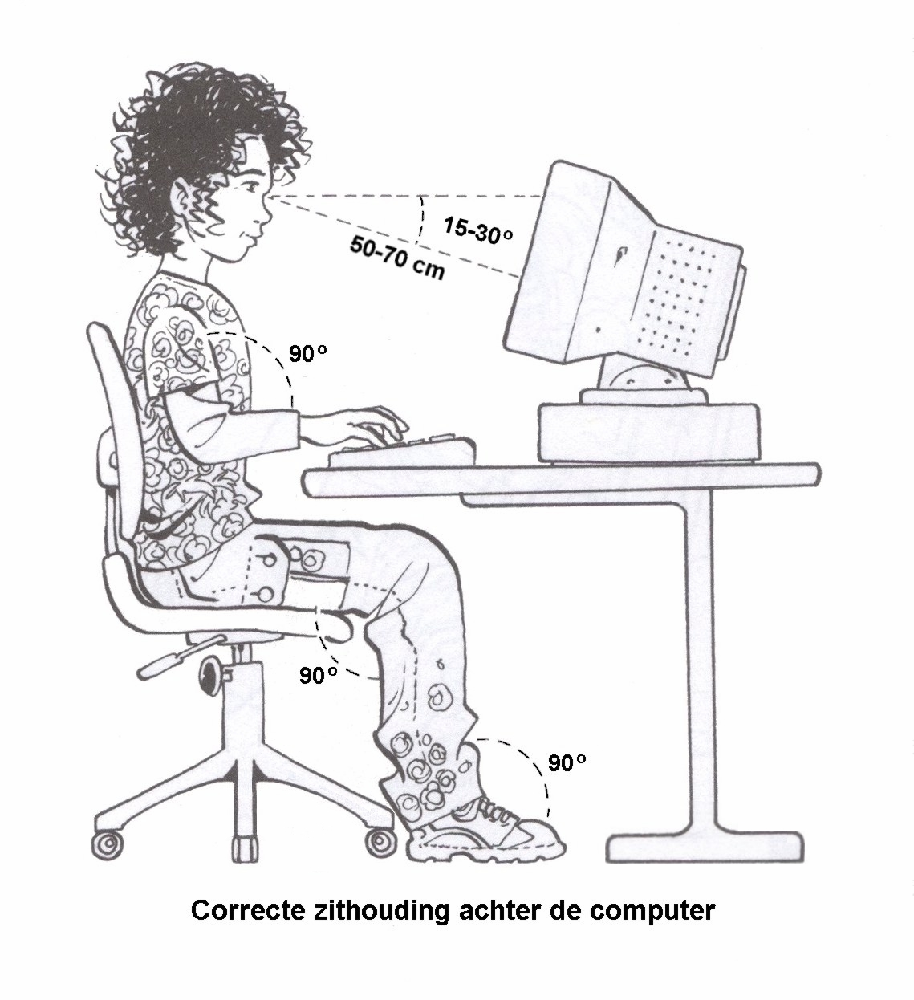
الخطأ في : - عدم وجود مسند للكرسي – ووجود الكابلات على الارض غير منظمة .

×

×

