Chapter One - Two Terms

Atomic structure - Summary

Atomic structure
- Atom: "A" means "no" and "tom" means "divide".
- Aristotle: Believed that all matters are composed of four componenets (water – air – dust – fire).
- Boyle define the element as "a pure simple substance that cannot be changed to simpler forms by the traditional chemical methods".
- Dalton's atomic theorys – the matter is composed of atoms which are undividable and each element have a certain type of atoms.
- Cathode rays: Consists of fine negative particles, move in straight lines, and have a thermal effect. They are affected by both electric and magnetic field. They do not differ in behavior or in nature if the material of the cathode or the used gas are changed. All element contain cathode rays.
- Thomson's model: the atom is a sphere of a uniform positive electricity and embedded in it equal number of –ve electrons. So, the atom is electrically neutral.
Rutherford's experiment:
1- The most of alpha)α) particles hit the same places, so, most of the atomic volume is empty sapce.
2- very small % of )α (particles did not penetrate the gold foil and reflected back, so, the atom contain high density nucleus.
3- A very small % of) α ( particles deflected, so the nucleus is positive charge.
Rutherford's Atom:
It is a vast space, its structure is similar to the solar system.
- The nucleus of the atom is very small, at the centre (positivly charged)
- The atom is electrically netural because the number of positive charges (protons) equals the No. of negative charges (electrons).
- The electrons never fall inside the nucleus because the electrons are affected by two equal forces in quanitity and oppose direction:
* The attractive force.
* The centrifugal force.
- Most of the atomic mass is concentrated in the nucleus because the mass of electrons can be neglected if it is compared to the mass of nucleus components.
- Maxwell's theory is the most important that contradicted RutherFord's theory, it states that when an electrically charged particle moves in an orbit around a fixed body of a different charge, it loses apart of its energy in the form of light radiations resulting a gradual decrease in the orbit radius.
- By applying this theory; the electron as a negative particle moves around the nucleus as a fixed positive particle, we would expect that the electron is in a state of continous emission to energy therefore the electron revolves in a spiral orbit until it fall in the nucleus causing removing of the atomic system.
Bhohr's atom:
- The atom is a positive nucleus, and negative electrons rotate around the nucleus in definite energy levels.
- Each level has a definite energy which increases as the distance from the nucleus increases, i.e the energy levels differ in energy from each other.
(K) energy level has a principle quantum no. equal (1) , and (L) level has a principle quantum no. equal (2) and so on until the seventh level.
- The electrons revolve around the nucleus in a number of energy levels which are constant and definite. So electrons can not be found at intermediate distances.
- The atom never emit radiations in the normal state, but emission is only produced from the excited atom.
- The difference in energy between the energy levels is not equal, and decreases gradually further from the nucleus.
- The electron does not leave its energy level to another unless the energy absorbed or emitted is equal to the energy difference between the two levels.
- The quantum: is the amount of energy absorbed or emmitted when the electron jumps from one energy level to another, and it differs according to the difference between the two levels.
- The quantum is neither divided nor doubled; i.e there is no half quantum or 2 quantums.
The advantages of Bohr's theory:
1- He explained the hydrogen atom spectrum.
2- He was the first who introduced the idea of quantized energy states for the electron in the atom.
3- He reconciliated between Ruhterford and Maxwell theories, that he considered that radiations are emited from the excited atom only.
The disadvantages of Bohr's Theory
1- He failed to explain the spectra of atoms of the heavier elements.
2- He postulated that both the speed and the location of the electron can be determined at the same time.
3- He did not consider the wave properties of the electron, he only considered the electron as a particle.
4- He considered the electron moving in a circular plannar orbit i.e The atom is planar. It is proved that the atom has the three dimensions in space x, y, z.
De Broglie Principle
Every moving body is associated with a wave motion which has some properties of light waves.
The Heisenberg uncertainty principle
: It is practically impossible to determine both position and velocity of the electron exactly at the same time, but it undergo to propabilities laws.
The electron cloud:
It is the propability of finding the electron in all direction and dimensions around the nucleus of the atom.
Quatum numbers:
They are numbers that define orbitals, their energy, their shapes, and their directions according to the atom axis.:
a- The principal quantum number)n)
b- The subsidiary quantum number (l)
c- The magnetic quantum number (m)
d- The spin quantum number (m_{s}(
Principal quantum number (n):
It defines the number of the main energy levels in the atom, the number of orbitals in each energy level from the role (n²), and the number of electrons in each energy level from the role )2n²(.
Subsidiary quantum numberl (l):
It defines the no. of energy sublevels in each principal energy level, its no. equals the no. of the principal energy level that it follows until the fourth principal level. For example (K) level contains one energy sublevel, (L) level contains two, (M) level contains three, and)N) level contains four energy sublevels.
Magnetic quantum number (m(:
It defines the no. of orbitals in the energy sublevels, and their space directions. They are odd numbers (1), (3), (5) or (7).
- Sublevel (s) has nonorbital ospsherical symmetrical shape.
- The sublevel (p) consists of three orbitals (x, y and z) each one is perpendicular to the other two.
- The electron could of each oritbtal take the form of two pears meeting head to head (dumb – bell. Shaped) at a node.
Spin quantum number (m_{s}):
It describes the type of the spin motion of an electron around its axis in either a clockwise or anti-clockwise.
- Sublevel (s) is saturated with two electrons, since it contains one orbital.
Sublevel (p) is saturated with six electrons, that it contains three orbitals.
- Sublevel (d) is filled with ten electrons because it has five orbtials.
- Sublevel (f) is filled with 14 electrons that it contains 7 orbitals.
Aufbaul (building-up) principle
Electrons must occupy sublevels which have the lowest energy at first then occypy sublevels which have higher energy.
[ 1S < 2s < 2p < 3p < 4s < 3d ]
Hund's Rule:
The electrons in sublevel preffered to occupy independent orbitals beofre its pairing.
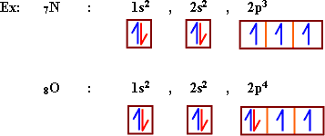

Chapter Two - Two Terms

Classification of Elements and the long periodic table
- The atomic number:
It is the number of protons or electrons in the atom.
Isotops
They are different forms of the same element, which have the same atomic number but different mass number as the number of neturons differs in the nuclei.
- The long periodic table
It is a system in which elements are arranged in an ascending order according to their atomic numbers. It depends on the building up principle (Auf-bau) which state that sublevels of low energy are filled at first.
- The periodic table is divided into four main blocks:
1) S-block elements
2) P- block elements
3) d- block elements
4) f- block elements
- Elements of S- block are located at the left of the table, it contains two groups (1A) and (2A).
The sublevel - S contains one orbital which is saturated with two electrons.
- Elements of P- block are found at the right of the table including (6) groups. This groups are 3A, 4A, 5A, 6A, 7A, and zeroth group.
- orbitals of d- block are filled with electrons frequantly through d- block elements. It includes ten vertical rows and eight groups of (B) groups . D- block is found in the middle of the table
- Element of d- block are called the main transition elements. They are divided into three horizontal chains which are 3d, 4d and 5d.
- The first transition series:
(3d) sublevel is frequantly filled with electrons. It is located in the long fourth period. It starts with scandium and ends with Zinc . The electronic configuration of this seris is: . where n = 4.
- The second main transition series:
(4d) sublevel is frequently filled with electrons. It is located in the long fifth period. It starts with
. The electronic configuration of this series is period. . The electronic , where n = 5 .
- The thrid main transition series:
(5d) sublevel is frequntly filled with electrons. It is located in the long sixth period. It starts with Lanthanum . The electronic configuration of this series is where n = 6.
- Elements of f- block:
- The orbitals of f- sublevel are filled freqauntly, it carries 14 electrons, and consists of two serieses (Lanthanides) in the sixth period after Lanthaum (₅₇La), and (Actinides) in the seventh period after Actinium (₈₉AC).
Mostly, f- block elements are separated under the periodic table to keep the general shape of it. F-block elements are called The inner transition elements.
- The lanthanides series elements (4F elements) have the electronic configuration
- The Actinides series elements ( 5 f elements) have the electronic structure
- Nobel gases
- They are the zeroth group, the electronic structure is (np⁶) except Helium (1s²) .
All energy levels of nobel gases are completely filled with electrons, so they are stable. Each element of this group is the end of a period in the periodic table.
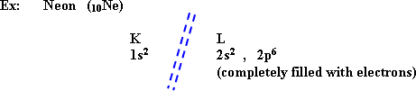
- The Representative elements:
The are elements of S-block and P-block, except the elements of zeroth group. All the energy levels are completely filled with electrons except the outer most energy level.
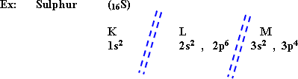
So, the main energy level (M) is not completely filled with electrons.
- The main transition elements:
They are elements of d-block, All energy levels are filled with electrons except the last two main energy levels.
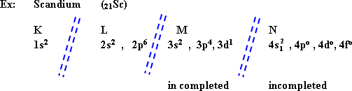
From the electronic structure of Scandium (a transition element), M, and N levels are not completely filled with electrons.
- The inner transition elements:
(F-block elements)
- All the energy levels are filled with electrons except the last three levels.
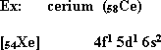
From this electronic structure of cerium (an inner transition element)
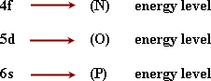
are not completely filled.
Description of the long form periodic table:
1- Contain 18 columns and 7 periods (horizontal).
2- Elements are arranged ascendingly of their atomic numbers.
3- The elements in the same group are indentical in the electron composition of the highest energy level.
4- Every new period begins by filling a new energy level of larger prinicpal quantum number with one.
- The atomic radius:
It is half the distance between centres of two similar atoms in a diatomic molecule.
The bond length = the distance between the nuclei of two bonded atoms.
- In the horizontal periods:
The atomic radius decreases gradually upon increasing in the atomic number. Because the (+ve) charges in the nucleus increases, and the attraction force of the nucleus for electrons increases, so the atomic radius decrease. i.e in the horizotnal periods, the biggest atoms in size are found in the first group (the period start), then it decreases gradually unitl it reaches the smallest size in the seventh group (the period end).
- In the vertical groups:
The atomic radius increases as the atomic no. increases due to the following reasons.
1- The no. of energy levels increases as the period no. increases
2- The repulsive forces between elelctrons increases which leads to increasing in distances between the levels.
3- The completely filled energy levels prevent the attraction force of the nucleus on electrons.
- The radius of the +ve ion (the metal ion) is less than the radius of its atom, due to the increase of the +ve charges. The metal atom tends to lose the electrons of the outer most energy level.
ex: Sodium ₁₁Na
The radius of (Na⁺) is smaller than that of (Naº) . The no. of +ve protons is bigger than no. of electrons as a result of the sodium atom ionization (lose one -ve electron).
- The radius of a negative ion is bigger than that of its atom, because of the increase of -ve charges, since the non-metals atom tends to gain some electrons in the outer most level.
The anionic radius is larger than the atom radius. The no. of electrons is bigger the no. of +ve charges.
- Ionization potential:
The amount of energy required to remove the smallest bounded electron completely from an isolated gaseous atom.
- In the horizontal periods:
The ionization potential values increase as the atomic no. increases, since the atomic radius decreases and the attraction force of the nucleus on electrons increases, ie. The ionization enegry is inversely proportional to the atomic radius.
- In the vertical groups:
The ionization energy decreases as the atomic no. increases , since the atomic radius increases and the no. of shells surrounding the nucleus increase, separating the nucleus charge from valence electrons, and so the binding between the electron and the atom becomes very weak and easy to separate the electron with low energy.
- Ionization energy increases in the case of (Be) and (Mg) elements, and other elements of (2A) group have big increase since the outer most sub-level (n_{s}) is completely filled with 2 electrons making the atom stable.
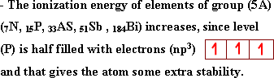
- The atom which has one electron in the outer most level, has first ionization potential when it loses this electron, and has second ionization potential upon breaking up a completely filled level such as sodium.
- The atom that has two electrons in the outermost energy level has first ionization enegy when it loses an electron and a second ionization energy when it loses the second electron and has third ionization energy when a completely filled level is breaked up such as in Magnessium.
- The ionization energy is very great in the case of breaking up a completely filled level, so the first ionization energy of inert gases is very high, the same with the second ionization energy of sodium and potassium.
- The electron affinity:
It is the amount of energy released when an extra electron is added to a neutral gaseous atom to form an anion (-ve ion).
- In the horizontal periods:
The electron affinity increases as the atomic no. increases. The atomic size decreases and the ability of the atom to attract a new electron increases.
- In the vertical groups:
The electron affinity decreases as the atomic no. increases, since the atomic size increases, the no. of energy levels increases and screen the attraction force of the nucleus on the valence electrons, so it is difficult to add an extra electron to them.
- The electron affinity of the atom increases if the added electron makes stability for the atom, and this occurs if the gained electron fill the energy sub-level.
- Fluorine has electron affinity less than that of chlorine, although the atomic radius of fluorine atom is smaller than that of chlorine because the gained electron is affected by a great repulsion force with nine electrons already existed around the nucleus.
- Electron affinity in noble gases = zero becaue the outer most energy level is completely filled, and this make the atom high stable.
- The electronegativity:
It is the tendency of an atom to attract the electrons of the chemical bond to itself.
- In the horizontal periods:
Electronegativity increases as the atomic no. increases due to the gradual decrease in the atomic radius and the increase in the attractive force of the nucleus to the electrons of the bond.
- In the vertical groups:
The electronegativity decreases as the atomic no increases, because the increase in the number of energy levels which increase the atomic size and decrease the attractive force of the nucleus to the electrons of the bond.
- The difference in the electronegativity between elements plays a very important role in determining the nature of the bond formed between them.
ex: If the difference in the electronegativity is more than 1.7 the compound is ionic compound and equal to zero in case of pure covalent bond, and less than 1.7 the compound is polar covalent.
- Fluorine is the highest electronegativity in the periodic table, due to its small atomic radius, while cesium has the smallest electronegativity, due to its big atomic radius.
- Characteristics of metals:
- The valence shell contains less than four (1, 2, or 3 electrons)
- electropositive elements
- big radii
- small ionization potentials
- easy motion of their electrons.
- Characteristics of non-metals:
- The valency shell contains more than four electrons (5, 6, or 7)
- electronegative elements.
- Small radii
- high vlaues of ionization energy and electron affinity
- bad conductivity of electricity.
- Metalloids:
They have metallic appearance, but non-metallic propeties
- valency shell contains 4 electrons (nearly half filled) ex: silicon (Si)₁₄
- Germanium (Ge)₃₂.
- In the horizontal periods:
Peiords start with the strongest metals, metallic properties decrease gradually as the atomic no. increases until the metalloids appear, then the non-metallic properties start to appear, it increases gradually until the period ends by the strongest non-metals.
- In the vertical groups:
The metallic properties increase and the non-metallic properties decrease gradually as the atomic no. increases. The strongest metals are located at bottom left of the table, so cesium is the strongest metal, while the strongest non-metal at top right of the table. So fluorine is the strongest non-metal.
- In horizontal period the basic character decreases, then the amphoteric character appears , then the acidic character appears with the end of the period.
- Acids and bases are considered as hydroxy compounds, with general formula (MOH)
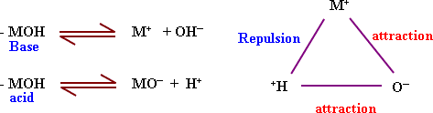
- when the two attractions are equal so, the substance is called amphoteric.
- The formula of oxygenated acid [MO_{n}(OH)_{n}]
- The strong acid is that which has more number of non bonded oxygen atoms.
- orthosiliconic acid H₄SiO₄ (Si(OH)₄ has no nonbinded oxygen with hydrogen so, it is weak acid.
- Perochloric acid HClO₄ [Cl O₃ (OH)] has three unbinded oxygen atoms with hydrogen, so, it is very strong acid.
- Oxidation number:
It is a number that referes to the electric charge (+ve or -ve) of the atom in the compound.
- The oxidation no. of Hydrogen in all compounds (+1) except in its hydrides like (NaH) = (-1).
- The oxidation no. of oxygen = (-2), but in
- The oxidation no. of oxygen in because the electronegativity of fluorine is greater than that of oxygen.
- The oxidation no. in the element molecule = zero whatever the no. of atoms in its molecule.
- The oxidation no. in the atomic group = the no. of charge on the group (ion)
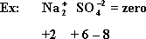
- Remarks on the periodic table:
- First period: contains S- block elements (hydrogon and Helium)
- The second and the third periods: involve S-block and P-block elements. S-block (two elements), while P-block contains six elements, so the two periods contain 8 elements.
- The fourth and the fifth periods they include S- block elements (two elements), P- block (six elements), and d- block (ten elements), so each period contains 18 elements.
- The sixth period include: S-block elements, P- block elements, d- block and f- block elements. So it contains 32 element

aChapter Three - Two Terms

Chemical Combination
- Chemical reaction: is a process by which chemical bonds between reactants are broken and new bonds between products are formed.
Chemical bonds: ionic, covalent, coordinate, hydrogen and metallic bond.
Ionic bond: It is an electrostatic attraction forces between +ve ion of metal element and -ve ion of non-metal element. It has no. materialistic existence.
It is formed when the difference in electronegativity between the two reactants atoms is more than 1.7.
- The difference in electro negativity increases as the distance between the two elements in the same period increases and so the ionic properties, the melting point, the boiling point and the electrical conductivity increase.
Covalent bond: It arises mostly between atoms of non-metal elements.
Types of covalent bonds:
- A pure covalent bond between atoms of two elements equal in electronegativity.
ex: The bond Cl₂ molecule:
- A polar covlent bond between atoms of difference in electronegativity less than 1.7. The atom of higher electron negativity has partial -ve charge , and the atom of lower electronegativity carry partial +ve charge .
Octet rule (Electronic of valency theory):
All elements except hydrogen , Lithium and Beryllium tend to reach the Octet structure.
Disadvantages of Octet rule:
It can not explain the binding in many molecules in which the number of electrons around the central atom is more or less than eight.
It is not sufficient to explain the properties of molecules such as the stereostructure and the angles between bonds:
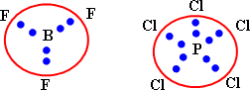
The valence bond theory:
It considers the covalent bond in the molecule is formed as a result of the overlap of half filled atomic orbital of one atom with another half filled atomic orbital of another.
Hybridization:
It is the combination between two different orbitals or more in the same atom to form new orbitals which are equivalent in shape and energy. The difference in energy between hybride orbitals is very small value. Ex: (2s, 2p) . The number of hybride orbitals = the number of pure orbitals
- Hybridized orbitals are more protrude to the outside than pure ones.
The molecular orbital theory:
- It considers the molecule as one unit or a big atom with multinuclei in which all the atomic orbital of the combined atoms are mixed forming molecular orbital.
- Sigma bond is a covalent chemical bond formed from overlaping of atomic orbital (head by head) when they are alone one line.
- Pi bond a chemical bond formed from overlaping of two atomic orbtials side by side when they are parallel.
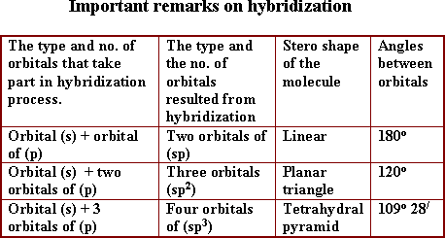
- Methane molecule (CH₄) tetra hydral pyramid in shape, the hybridization of (sp³) type, all bonds are sigma type, and the angles between orbitals are .
It takes the planar triangle shape, the hybridization of (sp²) type. Two covalent bonds exist between the two carbon atoms, one of them is sigma and the other is pi type. The angles between orbitals equal (120º).
Coordinate bond:
It is formed between two atoms, one of them (donar atom) having alone pair of electrons donated to the other atom (acceptor atom) having a vacant orbital.
- Hydronium ion has two covalent bonds and coordinate bond

aChapter Three - Two Terms

Chemical Combination
- Chemical reaction: is a process by which chemical bonds between reactants are broken and new bonds between products are formed.
Chemical bonds: ionic, covalent, coordinate, hydrogen and metallic bond.
Ionic bond: It is an electrostatic attraction forces between +ve ion of metal element and -ve ion of non-metal element. It has no. materialistic existence.
It is formed when the difference in electronegativity between the two reactants atoms is more than 1.7.
- The difference in electro negativity increases as the distance between the two elements in the same period increases and so the ionic properties, the melting point, the boiling point and the electrical conductivity increase.
Covalent bond: It arises mostly between atoms of non-metal elements.
Types of covalent bonds:
- A pure covalent bond between atoms of two elements equal in electronegativity.
ex: The bond Cl₂ molecule:
- A polar covlent bond between atoms of difference in electronegativity less than 1.7. The atom of higher electron negativity has partial -ve charge , and the atom of lower electronegativity carry partial +ve charge .
Octet rule (Electronic of valency theory):
All elements except hydrogen , Lithium and Beryllium tend to reach the Octet structure.
Disadvantages of Octet rule:
It can not explain the binding in many molecules in which the number of electrons around the central atom is more or less than eight.
It is not sufficient to explain the properties of molecules such as the stereostructure and the angles between bonds:
The valence bond theory:
It considers the covalent bond in the molecule is formed as a result of the overlap of half filled atomic orbital of one atom with another half filled atomic orbital of another.
Hybridization:
It is the combination between two different orbitals or more in the same atom to form new orbitals which are equivalent in shape and energy. The difference in energy between hybride orbitals is very small value. Ex: (2s, 2p) . The number of hybride orbitals = the number of pure orbitals
- Hybridized orbitals are more protrude to the outside than pure ones.
The molecular orbital theory:
- It considers the molecule as one unit or a big atom with multinuclei in which all the atomic orbital of the combined atoms are mixed forming molecular orbital.
- Sigma bond is a covalent chemical bond formed from overlaping of atomic orbital (head by head) when they are alone one line.
- Pi bond a chemical bond formed from overlaping of two atomic orbtials side by side when they are parallel.
- Methane molecule (CH₄) tetra hydral pyramid in shape, the hybridization of (sp³) type, all bonds are sigma type, and the angles between orbitals are .
It takes the planar triangle shape, the hybridization of (sp²) type. Two covalent bonds exist between the two carbon atoms, one of them is sigma and the other is pi type. The angles between orbitals equal (120º).
Coordinate bond:
It is formed between two atoms, one of them (donar atom) having alone pair of electrons donated to the other atom (acceptor atom) having a vacant orbital.
- Hydronium ion has two covalent bonds and coordinate bond

Chapter Four - Two Terms

The Representative Elments
- Elements of s-block:
They include elements of first group (1A), and second group (2A) in the long periodic table.
- Elements of group (1A):
They are known as alkaline metals (alkalies) such as sodium and potassium.
- Rock salt (NaCl) is from the most important ores of sodium while potassium chloride (KCl) is the most important ore of potassium element which exist in seas, water and in carnallite deposites .
- Elements of group (1A) have only one electron in the valence shell.
- Each element is located in the beginning of each new period in the periodic table.
- Each element of group (1A) [Li, Na, K, Rb, Cs, Fr] has (+1) oxidation number.
- They tend in all chemical reactions to lose the valence electron existing in the valence shell easily, so they are chemically very active elements.
- The first ionization energy is low while second ionization energy is high because the second ionization energy results from the breaking up of a completely filled shell.
- They tend to form ionic compounds. The ion of each element resembles the electronic structure of the preceding noble gas in the periodic table, so their salts properties depend mostly on the negative ionic radical.
Ex: 1- Sodium Cyanide salt is poisonous due to the presence of cyanide ion (CN⁻) which is poisonous.
2- Potassium permangante is an oxidizing agent due to the presence of permanganate ion which is an oxidizing agent.
- Elements of group (1A) are considered very strong reducing agents since the valence electron is lost easily.
- They are most malleable metals with low melting and boiling points due to the weakness of metallic bond since they have only one electron in the outermost energy level.
- They have a large atomic radius because each element occupies the beginning of its period.
They are used in photo-electric cells because the atoms of these elements are big in size and have low ionization energy, such as potassium and caesium, so when they expose to light, they lose the electrons from their outermost energy level easily.
- They have small elecronegativity and small electron affinity.
- Upon exciting, the electrons leave their atomic energy levels to the next energy levels, they give characteristic colours.
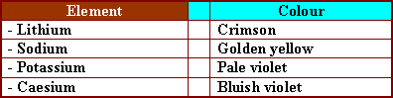
- They are kept insulated from air and humidity under the surface of kerosine (liquid hydrocarbon free from oxygen)
- They lose their metallic lustre as they expose to atomospheric air due to the formation of metal oxide.
- They react with dil. Acids. The metal atom replaces hydrogen atom in the acid in vigorausg reaction.
- They react with Hydrogen forming metal hydride.
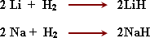
- They react with halogens vigorously to form a very stable ionic hlaides.
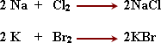
- Lithium carbonate decomposes by heat at (1000 º C) forming lithium oxide, and CO₂ gas
- Sodium and potassium carbonate do not decompose when heated inspite of its fusion when strongly heated.
- Sodium nitrate decomposes giving sodium nitrite releasing oxygen gas.
- Postassium nitrate decomposes making a great explosion, so it is used in the manufacture of bombs.
- Sodium nitrate is not used in the manufacture of bombs because it is deliqueseent.
- Davy prepared sodium and potassium metals by the electolysis of molten of theihalids salts. (NaCl, KCl)
- Sodium is chemically very active , so it reacts strongly with water releasing Hydrogen gas, and a large amount of energy which is enough to cause burning of Hydrogen over the water surface so it is kept under kerosene surface.
1) NaOH:
- Sodium hydroxide NaOH is prepared in industry by the electrolysis of sodium chloride solution.
Properties of NaOH:
- White hydgroscopic solid compound, and it has corrosive effect on skin, dissolves in water forming an alkaline solution, and it is exothermic dissolution.
- It reacts with acids forming sodium salts + water
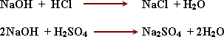
Uses of sodium hydroxide:
1- Soap - synethetic silk and paper industry.
2- Detection of copper (II) Cu⁺⁺ ion.
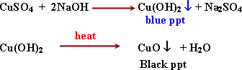
3- Detection of Aluminium Al³⁺:
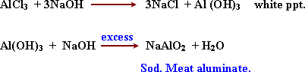
2) Sodium carbonate Na₂CO₃
- Na₂CO₃. 10H₂O hydrated sodium carbonate (washing soda).
Preparation: in Lab :
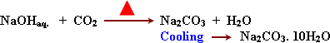
In industry (solvay process):
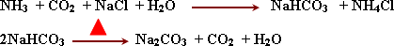
properties: white powder, easily dissolve in water, and has alkaline effect.
- not affected by heat.
Uses: Manufacture of glass - paper - textile industry - water softening.
The group 5 - A:
Elements of group 5-A are
Nitrogen - phosophrous - arsenic - Antimony and Bismuth. (N - P - As - Sb - Bi)
- Phosphorous is the most abundant element of group 5-A in the Earth's crust. It is found in the form of calcium phosphate .
and oppsite CaF₂. Ca₃(PO₄)₂ - Arsenic, Antimony and Bithmuth are found in the form of sulphides in their ores.
- Non-metallic nature is the main of these elements, the metallic properties increases as the atomic number increases (N, P) are non-metals while (As, Sb) are semi-metalic while (Bi) is a metal.
- The atomic radius increases in group 5 - A as the atomic number increases since a main energy level increases with each period.
- The potential energy decreases as the atomic number increases due to enlargement of atomic radius and weakness of the nucleus attraction force on electrons.
- They have several oxidation numbers which range from , and it is negative with hydrogen and positive with oxygen.
- They are characterized by allotripic phenomenon.
Allotorpy: is the presence of the solid non-metal element in more than one form, having the same chemical properties, but different in physical properties.
- Most of Nitrogen reactions take place in high temperature or by using electrical arc because nitrogen is chemically inactive due to the presence of three covalent bonds in which the strong sigma is present which some need very high amounts of energy to be broken up.
- Hydrogen reacts with nitrogen in the presence of electric arc to form ammonia.
- Oxygen reacts with nitrogen to form nitiric oxide, then nitrogen dioxide
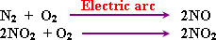
- Calcium cyanamide is formed from calcium carbid with nitrogen, CaCN₂ used as a fertilizer because it dissolves in water during irrigation.
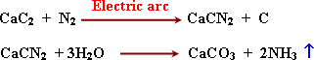
- Ammonia gas is prepared in lab by heating ammonium chloride (NH₄Cl) with slaked lime:
Ca(OH)₂.
- Ammonia dissolve easily in water. It's solution has alkaline effect on litmus paper due to the presence of (-ve) hydroxide group (OH) because ammonia has the ability to separate the water proton (H⁺).
- Ammonia gas dried by pasing it in quick lime (CaO) because quick lime does not react with ammonia gas.
- Ammonia is prepared in the industry (Haber's method)
Detection of ammonia gas:
The role of ammonia in the manufcture of feritilizers.
- Ammonium slats or urea dissolve in the irrigation water where it is absorbed by the plant root.
- Ammonia is considered the strating material for most of the nitrogenous fertilizers.
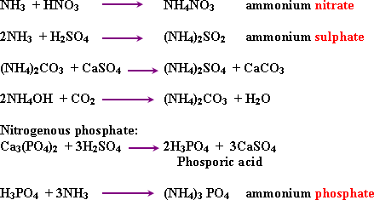
Notes on fertilizers:
1- Ammonium nitrate (35% nitrogen), the excess of it causes acidic effect on soil.
2- The continuous use of ammonium sulphate as a fertilizer increases acidity of the soil
3- Ammonium phospate is an important fertilizer because it contians nitrogen and phosporus.
4- Urea of 46% nitrogen is the most suitable fertilizer for hot arcas - because high tempeature release NH₃ and CO₂. Anhydrous liquid ammonia is the futare fertilizer because it has the highest nitrogen contentent, and supplied to the soil in a depth about 12 cm.
- Nitric acid (HNO₃)
is prepared in lab by heating potassium nitrate with conc. Sulphuric acid.
The temperature should not exceed more than 100 º C since nitric acid decomposes thermally.
- Conc. Nitric acid does not react with some metals such as iron, Aluienium or chromium since the acid oxidizes the metal forming a thin non - porous layer of metal oxide which prevent the metal from further reaction. This is called passivating effect.
- The hot conc. Nitric acid reacts with copper although (Cu) less active than hydrogen because the acid reacts with (Cu) as oxidizing agnet.
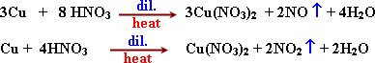
Detection of nitrate ion NO₃⁻
1) Black ring experiment:
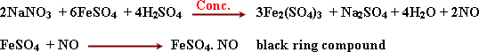
2) Differention between nitrite and nitrate salts:
Nitrate salts does not discharge the colour of permanganate.
- The economic importance of the 5th group elements.
1- Nitrogen:: It is used in the manufacture of ammonia gas, nitric acid, nitrogenous fertilizers and bombs (explosives).
2- Phosphorous: is used in the manufacture of matchs, rat poison, phosphorus bronz alloy used in ships, (Cu + Sn + P)
phosphorous fertilizers and incendiary bombs.
3- Antimony: is used with lead as an alloy in the manufacture of car battery plates, since this alloy is more harder than lead.
Antimony sulphide is used for dying (yellow).
Alloys of bismuth, lead, cadmium and tin have low melting points
Chapter Five - Two Terms

Transition Elements and Iron
- a) The main transition elements:
They are elements of d- block including three series which are located in periods 4, 5 and 6
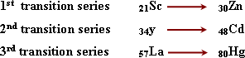
b) inner transition elements : Include f-block elements. Two series:
Lanthanides:Where sub-level (4f) is frequently filled. It is located in period - 6 after lanthanum; semi-colon ; it starts with cerium ₅₈Ce and ends with lutetium (₇₁Lu) and have the electronic structure
- Elements of Lanthanide series are similar in chemical and physical properties because the change in the number of electrons takes place in sub-level (4f) which exist deeply under 6s, 5d energy levels.
- They have oxidation number (+3) , since the valence electrons are located in sub-levels (5d¹ , 6s² ) by which the atom share in the reaction, while (4f) electrons donot take part in chemical reactions.
- Actinides series In which sub-level (5f) is frequently filled with electrons. It is located in period-7 after Actinium. It starts with Thorium (₉₀Th) and ends with Lawransium (₁₀₃Lr). They are radioactive elements as their unstable nuclie. They have electronic structure [Rn] 5 f ¹ ⁻ ¹⁴ 6 d¹ 7s².
The transition Element: It is the element in which orbitals of sub-level (d) or (f) are occupied with electrons but not completely filled either in the atomic state or oxide states.
- Coinagemtals (Cu, Ag, Au) are transition metals although orbitals of (d) are filled with electrons. Because in their higher oxidation states contain 9 or 8 electrons in d sublevel.
- ₃₀Zn, ₄₈Cd, ₈₀Hg are non-transition elements because the orbitals of (d) sublevel are completely filled with electrons in their free state or in their higher oxidation states.
- Chromium (₂₄Cr) and copper (₂₉Cu) are anomalous from the expected electronic configuration.
This make the atom has less energy and more stability.
- Iron II is easily oxidized to iron III.
Because iron III is more stable as the 3 d sublevel is half - filled, and it is difficult to reduce Iron III to Iron II for the same reason.
- Mn (II) is difficulty oxidized to Mn III. Because Mn (II) is more stable as the 3 d sublevel is half - filled , while Mn (III) is reduced easily to Mn (II) for the same reason.
- Transition elements atomic radie are nearly constant due to two opposite factors ; The first acts to increase the atomic radius, the second acts to decrease the atomic radius. So they are considered representatives for alloys manufacture.
- The densities of transition elements increase with the incresase of atomic number due to the increase of the atomic mass while the atomic radius is nearly constant.
- The transition elements have catalytic activity due to the presence of unpaired electrons in the orbitals of "d" sublevel which can be used in formation of bonds between the reacting molecules and the atoms on the metal surface therfore the concentration of reactants increases on the catalyst surface so the speed of reaction increases.
- Transition elements have high melting and boiling point because they have strong metallic bonds resulting from sharing of both the 4s and 3d electrons.
- Transition elements are considered paramagnetic substances due to the presence of unpaired electrons in orbitals of sublevel (d).
- The magnetic moment is equal to the number of unpaired electrons in (d) sublevel. Such as iron (Fe) the magnetic moment = the moment of (4) unpaired electrons in orbitals of (3d).
- The magnetic moment of zinc = zero. All electrons in (3d) are paired.
- The paramagnetic substance is the substance which is attracted to the magnetic field due to the presence of unpaired electrons in "d" orbitals.
- The diamagnetic substance is the substance which is repelled to the magnetic field due to the presence of electrons paired in all "d" atomic orbtials.
- Atoms or ions of transition elements are coloured due to the incompletly filled orbitals of "d" sub-level (from 1 to 9 electrons)
- Atoms or ions are uncoloured in the following cases:
a- When the orbtials of dº are empty. Ex : Sc ⁺³
b- When the orbtials of d¹⁰ are completely filled ex: Zn⁺²
c- When the unpaired electrons exist in orbtials of s, p such as in sodium or potassium since the normal light unable to excite s, p electrons.
" Cases of rational stability of atoms and ions
a- If sublevel dº is empty
b- If sublevel d¹⁰ is completely filled with electrons.
c- If sublevel d⁵ is half filled with electrons.
* Atoms or ions of a transition elements are coloured due to the presence of unpaired electrons in the orbitals of "d" which abosrb the amount of energy [equal to the energy of certain colour] sufficient to be excited and jump to higher energy level.
* Iron Ores:
The suitability of the ore for extraction of iron econmically depends on these factors.
1- The percentage of iron in the ore.
2- The composition of the impurities in the ore.
3- The type and presence of harmful elements mixed with the ore such as (S, P, As).
- Extraction of iron from the ores: it includes three stages.
1- Dressing of iron ore
2- Reduction of the iron ore
3- Production iron.
Dressing of the iron ores: It aimes to
a. Increase of percentage of iron in the resulted ore by separating the impurities from the ore.
b. Improvement of the physical properties of the ore.
- Crushing process: A process of converting the large size of the iron ore to small size to be easily reduced.
- Magnetic separartion: It aimes to separate impuriites from the ore by using a strong magnetic field.
Floating process:
It aims to separate impurities from the ore by carrying the iron ore coated with oil to form froth float on the surface and can be removed easily.

Roasting process:
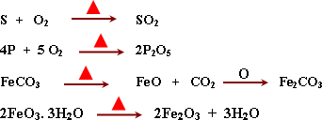
The Blast Furnace:
Its idea depends on the reduction of Haematite ore by (CO) gas to iron called pig iron
- Coke (C) and CO cycle in the blast furnace:
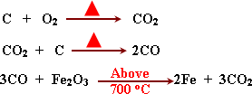
- The role of lime stone (CaCO₃) in blast furnace .
It decomposes by heat to CaO, CO₂ then CaO combine with impurities oxides to form slage.
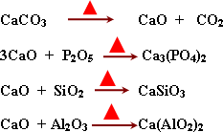
Slag:
a mixed of which prevent iron oxidation because it floats on the molten pig iron. It is used in brick industry, cement and road pavements.
Midrex Furnace
Its idea depends on reduction of Haematite ore by using (Co + H₂) to iron called spongy iron.
Natural gas (CH₄) combine with CO₂ and H₂O forming (CO + H₂)
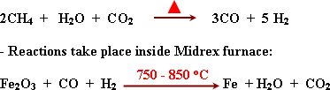
The oxygen converters:
Its idea depneds on blowing of oxygen rapidly under high pressure from the top of the converter oxidizing the impurities to acidic and alkaline oxides which combine together forming the slag. It floats on the surface of molten iron.
- The furnace is lined with dolomite .
It decomposes by heat forming CO₂ and basic oxides which react with acidic oxides of impurities to produce slag.
- Ferromanganese alloy prevents the formation of gas bubbles (O₂) steel since manganese combines with oxygen in steel.
Characteristies given to iron by the increase of carbon ratio are:
1- Its hardness increase
2- The melting point decreases.
3- It bears high pressure but not shocks.
4- It can't be hammereor pulled.
- Carbon in iron is either found separated in the intermolecular distances (inter stitional alloy), or combined in the form of Fe₃C (inter metalic alloy)
- 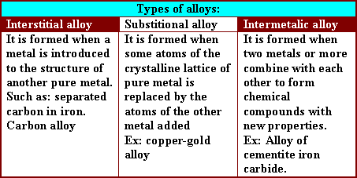
- 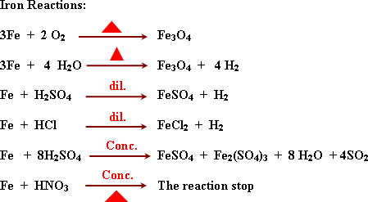
Due to formation of non-porous oxide layer the metal becomes chemically inactive.
FeCl₃ is formed because (Cl₂) is oxidizing agent.
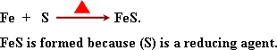
Iron oxides:
a) Iron II oxide
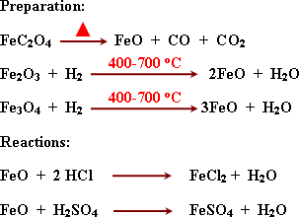
Iron II oxide is basic oxide because it reacts with acids forming salt and water.
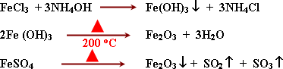
- Reactions:
Iron III oxide is basic because it reacts with acids giving salt and water. Its reactions take place with hot conc. acids because the oxidation number of iron in iron III oxide is (+3) , ie. It is rationally stable as it contains 5 electrons in orbital 3d.
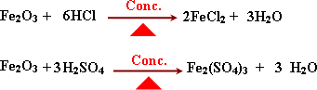
C) Magnetic Iron oxide Fe₃O₄
* Preparation:
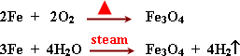
Reactions:
It reacts as a complex oxide that gives two kind of salts.
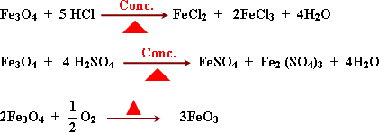
GR: Magnetic iron oxide reacts with conc. acids to give two kinds of salts.
Detection of Iron (II) and iron (III) cations:
1) Iron (II) cations Fe²⁺:
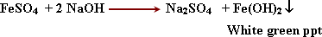
2) Iron (III) cation Fe³⁺:
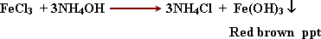

Chapter Six - Two Terms

Chemical calculation and quantitative analysis

1-The mole is the number of atoms or molecules or ions or electrons or concentration of various substances .
2- One mole of any substance contains a number of atoms or molecules or ions called Avogadro's number ; this number is 6.02×10 ²³ .
3- Gram - molecular volume or molecular volume : The molar mass expressed by gram of any gas , occupies a volume of 22.4 liters at a temperature of 273 º K and a pressure of 760 mm mercury (stp) .
4-The law of Gay - Lussac states that :
" The volumes of gases involved in a reaction and the gases produced are exist in fixed ratios "
5- One mole of any gas at (stp) occupies 22.4 liters .
6- 32 grams of oxygen or 2 grams of hydrogen or 44 grams of carbon dioxide occupy 22.4 liters .
7- The volume of any gas occupied by one mole contains 6.02×10 ²³ particles. .So, equal volumes of all gases measured under the same temperature and pressure contain equal numbers of molecules.
Volume of gas = Number of moles of the gas ×22.4 liters (stp)
8-The density of the gases is defined by gram / liter at (stp) , the relation between the molecular volume and molecular mass can be used to solve some problems .
9-The concentration of solutions is measured in grams / liter or moles / liter .
10- By dissolving 1 mole of a substance in water and completing the solution to 1 liter , the obtained concentration is 1 mole/liter .
11-Concentration (mole/liter) 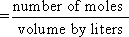
12-Number of moles = concentration(mole/liter) × volume of solution (liter)
13-Qualitative Analysis:
Determination of the concentration or quantity of the constituents of the sample .
14-Several ways are used to express the concentration , of these :
(1) Weight percent (w%) .
(2) Molar concentration (mole/liter).
(3) Parts per million (p.p.m).
15-Methods of quantitative chemical analysis are classified into :
1. Volumetric analysis.
2. Gravimetric analysis.
3. Instrumental analysis.
16-Volumetric Analysis : This method is based on measurement of the volumes of the substance to be analyzed.
17-Titration: It is based upon measuring the amount of a reagent of known concentration (standard solution) that is completely consumed by the analyte .
" Neutralization reactions which are used for determination of acids and bases.
" Oxidation - reduction reactions which are used for determination of redox substances .
" Precipitation reactions which are used for determination of substances that form sparingly soluble products.
18-To detect the point at which complete reaction takes place (end point), some indicators which change their colours in the reaction medium are used .
The following table shows some indicators used in the neutralization reactions .
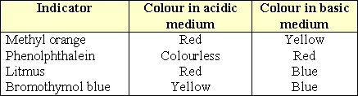
19-Mathematical equation:
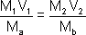
Where :
M₁ =concentration of the acid used (mole/liter).
V₁ =volume of acid used (ml).
M_{a} = number of moles of the acid shown in the chemical equation.
M₂ =concentration of the alkali used (mole / liter).
V₂ = volume of the alkali used (ml).
M_{b} =number of moles of alkali shown in the chemical equation.
20-Gravimetric Analysis: This method depends on the separation and determination of the mass of the analyte and by using chemical calculation ,the quantity of analyte can be measured .
(A)Volatilization method: based on the volatilization of the element or compound to be determined followed by its measurement either by collecting the volatile material and determining its mass or by measuring the amount lost from the original mass of the substance.
(B) Precipitation Method: This method is based on precipitation of the analyte in the form of pure sparingly soluble compound with constant and known chemical structure . The precipitate is isolated from the solution by filtration on an ashless filter paper

Chapter Seven - Two Terms

Chemical Equilibrium

1-The equilibrium system is apparently a stationary system but in reality dynamic .
2-Vapour pressure is the pressure due to water vapour in air at a certain temperature.
3-The vaporization process continues until the vapour pressure equals saturated water vapour pressure.
4- Saturated water vapour pressure is the maximum water vapour pressure in air at a certain temperature.
5- When the number of water molecules which evaporate from the liquid is equal to the number of water molecules in the condensed vapour, so there is a state of equilibrium.
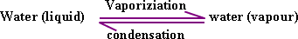
6- Chemical reactions can be divided into two types :
a-Complete (irreversible) reactions.
b-Reversible reactions.
7-Complete (irreversible) reactions: one of the products escape from the system, so the products cannot combined with each other once more reforming the reactants, under the conditions of the experiment.
8-Reversible reactions: The reaction proceed in both directions; forward and backward. So it does not proceed to completion towards the formation the products only and both the reactants and products are always found in the reaction medium.
9- Chemical equilibrium in reversible reactions : It is a dynamic system takes place when the forward reaction equals the rate of backward reaction .The concentrations of the reactants and products are not changed .
10-The equilibrium position remains unchanged since all reactants and products are still found in the system and as long as the reaction conditions are not changed .
11- Rate of chemical reactions: is the change in concentration of the reactants or products per unit time.
12-The concentration unit is expressed as mole / liter and the time unit is expressed as second or minute .
13- During the complete chemical reaction , the concentration of the reactants decrease and the concentration of the products increases .
14-In case of reversible reactions ,the increase in the concentration of the products and decrease in the concentration of the reactants proceed until an equilibrium state is established.
15-Factors affecting the rate of chemical reactions :
1- Nature of the reactants .
2- Concentration of the reactants .
3- Reaction temperature .
4- Pressure .
5- Catalysts .
6- Light .
16- Nature of the reactants :-
A-Type of bonding in the reactants:-
Ionic reactants undergo very fast reactions, while covalent bonded reactants undergo slow reactions.
B-Surface area exposed to the reaction :-
When the surface area exposed to the reaction increase the rate of the reaction increase.
17- Concentration of reactants :- the more concentration the more the reaction rate.
18- Waage and Guldberg established a law expressing the relationship between velocity of the chemical reaction and concentration of the reactants "the law of mass action" .
19- Low of mass action :- At a constant temperature, the rate of chemical reaction is directly proportional to the product of multiplication of the reactant concentrations , each is raised to the power of the number of molecules .
20- The small values of equilibrium constant (>1) mean that the concentration of the products are less than the concentration of the reactants which reveal that the reaction is not proceed well towards the formation of the products and that the reversible reaction has an effective role .
21- The high values of equilibrium constant indicate that the reaction proceeds almost to its end .This means that the forward reaction is the predominant reaction.
22- In general the concentration of water or solvent is considered as a constant because it does not significantly varied in the reaction .
23- Effect of temperature on the rate of reaction : the raise in temperature causes an increase the rate of chemical reaction.
24-Collision theory . This theory assumes that : to have a chemical reaction , molecules of the reactants must collide with each other . Only molecules of very high velocity can react, since their kinetic energy is high enough to break the bonds within the molecules so that the chemical reaction can take place .
25-Activation energy is defined as : The minimum amount (quantity) of energy that must be gained by a molecule to react at collision .
26-Activated molecules : Are those molecules which have kinetic energy that equals or exceeds the activation energy .
27-The rate of many chemical reactions is doubled by increasing the reaction temperature 10º C .
28-In case of an exothermic reaction in equilibrium state , decrease in temperature move the reaction to the forward direction.
29- In case of an endothermic reaction in equilibrium state , increase in temperature move the reaction to the forward direction.
30-Effect of pressure : If the reactants or products are in the gaseous state , the concentration is expressed by using their partial pressure.
31-The formation of ammonia gas is accompanied by a decrease in the number of molecules and reduction in the volume. It was found that by pressure and cooling , the rate of ammonia formation increases.
32-Increasing the pressure or cooling on a gaseous reaction under equilibrium , shift the direction of reducing the pressure.
33-In this case , the equilibrium constant is expressed by the symbol Kp to indicate that the concentrations of the substances are expressed by the partial pressure.
34-The equilibrium constant of the gaseous reactions can also be expressed in terms of molar concentration .
35- Le Chatelier's principle : Changes in any of the conditions of a chemical equilibrium such as concentration , pressure or temperature causes shift of the equilibrium in the direction which will oppose this change .
36- Catalysts are known as" substances that cause a change in the rate of chemical reaction without it self being changed". i.e. without affecting the position of equilibrium.
37-Catalysts are also used in catalytic converters used in modern cars to convert the gaseous combustion products, which cause air pollution , into safe products .
38-Catalysts are metals, metal oxides or compounds.
39-Enzymes : high molecular weight proteins produced in living cells act as catalysts for many biological and industrial processes .
40- Effect of light : Some chemical reactions are affected by light ,as the photosynthesis and Photographic films contain silver bromide in a gelatinous layer .When light falls on such films , silver ions accept electrons from bromide ions and converted into silver metal, bromine is absorbed in the gelatinous layer. The increase in light intensity is associated with an increase in the amount of silver formed .
41. Electrolyte Solutions : substances are dissolved in water and give(+ve) and (-ve) ions.
42- Ionization of hydrogen chloride is complete, but that of acetic acid is very limited .So, the acidic solution of HCl is a good conductor of electricity whereas the ethanoic solution is a bad conductor.
43- The extent of ionization of hydrochloric acid is not affected by dilution, but the extent of ionization of ethanoic acid increases by dilution.
44-Hydroxonium ion: No free hydrogen ion (protons) is present in aqueous of ionized acids .This ion is attract to the lone pair of electrons on the oxygen atom of the water molecule and connected to a water molecule by a co-ordinate bond. This proton is called hydrated proton or hydroxonium ion
[H₃O] ⁺.
45-Ionization : a process in which unionized molecules are changed into ions.
46-Complete Ionization : All unionized molecules are changed into ions, which happens in strong electrolytes.
47-Incomplete ( weak ) Ionization: A small fraction of molecules is ionized. This happens in weak electrolytes.
48- Ionic equilibrium: It is the equilibrium arising between molecules of a weak electrolyte and ions resulting from it.
Weak electrolyte Dissociated ions
49-The law of mass action can be applied only in the case of weak electrolyte solutions.
50-Strong electrolyte solutions do not contain un-dissociated molecules, since they are completely ionized.
51-In 1888 Ostwald described the relation between the extent of ionization - alpha (α ) and concentration ( C ) mole/litre for solution.
52- When one mole of a weak acid (HA)dissolves in (V) liter of the solution , then at equilibrium :
53- If the number of dissociated moles is (α ) mole then, the number of un dissociated moles from HA= (1-α) and the number of moles of (H⁺)and (A⁻) produced equals α mole.
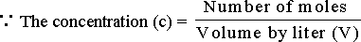
54- Ostwald's Law for dilution: The concentration of the substance (mole/ liter) at equilibrium is
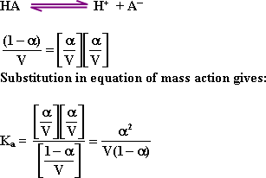
55- Ostwald's Law : At constant temperature, the degree of ionization (α) increases by dilution (so that K_{a} value remains constant ) .
56-In case of weak electrolytes , the degree of ionization (α) is small enough and can be neglected. Consequently the value (1-α) is considered approximately one and the relation becomes : 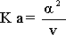Since the concentration of the weak acid 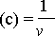male /liter. The above equation becomes:
57-This means that increasing dilution (decrease in concentration ) causes an increase in dissociation degree and vice versa .
58-Calculation of hydronium ion concentration of weak acids : when a weak acid such as acetic acid with a concentration (c) dissociates in water according to the equation :
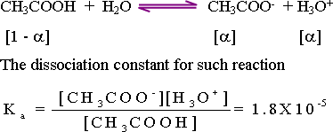
From the above equation , the quantity of acetate ion (CH₃COO-) released equals the quantity of hydronium ion (H₃O+) produced: [H₃O+] = [CH₃COO-]
The equilibrium constant is : 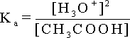
Since the acid is weak , the amount dissociated (α) is small and can be neglected. So , the concentration of acetic acid at equilibrium (C -α) equals the original acetic acid concentration (C) Consequently :
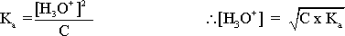
59-Calculation of the hydroxyl ion of weak bases "partially dissociated": when ammonia , a weak base , is dissolved in water the fallowing equilibrium reaction takes place :
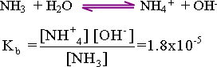
This equation reveals that one mole of both NH₃+ and OH- ions is formed.
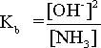
Since the dissociation constant of ammonia is small, a small portion of ammonia dissociates and at equilibrium , the concentration of the remaining ammonia [NH₃] equals the original concentration of ammonia (C_{b})
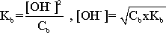
60-Pure water is a very poor conductor of electricity. 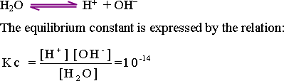
The number of unionized water molecules can be considered as a constant value. Therefore, the above relation can be rewritten as follows ;
Kw = [H⁺][OH⁻] = 10⁻¹⁴
Since the concentration of H⁺ equals the concentration of OH⁻ Then K_{w}
( ionic product of water ) = [10⁻⁷][ 10⁻⁷] = 10⁻¹⁴
61-The ionic product of water is the resultant of multiplying the concentration of the hydrogen ion [H⁺] times that of hydroxide ion
[OH⁻].It is a constant value equals 10⁻¹⁴ mole/liter.
62-If the concentration of hydrogen ion increases ,the concentration of hydroxyl ion decreases with the same amount and vise versa.
63-pH value : It is the negative logarithm of hydrogen ion concentration: pH = -log [H₃O⁺] , The symbol (p) means (-log) .
64- pK_{w}=pH + pOH= 14
65-In case of a neutral solution , the pH=7 and pOH =7.
66-For solution of pH 5 , the pOH=9 and for solution has a pH 8 , the pOH =6.
67- The pH value of the acidic solutions is < 7 and pOH is >7.
68-The and for basic solutions the pH is >7 and pOH is<7.
69-Hydrolysis of salt solutions :
a. The action of Na₂CO₃ solution ,it turns litmus blue so, it is alkaline solution
b- The action of CH₃COONH₄ solution ,it has no effect on litmus so, it is neutral solution.
c- The action of NH₄Cl solution ,it turns litmus red so, it is acidic solution.
d- The action of NaCl solution ,it has no effect on litmus so, it is neutral solution.
70- Hydrolysis of sodium carbonate: ( a salt of a weak acid and a strong base ) :
In this reaction carbonic acid, sodium and hydroxide ions are formed.Sodium hydroxide is not formed because it is a strong electrolyte, completely ionized. Carbonic acid is formed due to the reaction between hydrogen ions and carbonate ions in the solution to give carbonic acid ,it is a weak acid, almost not ionized. hydroxyl ions are formed and increased in concentration, than that of hydrogen ions. Thus the pH becomes >7, thus sodium carbonate solution is alkaline.
71. Hydrolysis of ammonium chloride : (a salt of a strong acid and a weak base ):
The hydrogen ions, chloride ions and ammonium hydroxide are formed. Hydrochloric acid is not formed, because it is a strong electrolyte, completely ionized ( H⁺, Cl⁻). The presence of chloride ions ( Cl⁻ ) doesn't affect water equilibrium .
But ammonium ions react with hydroxyl ions (OH⁻), to give ammonium hydroxide ( a weak electrolyte ). Consequently, hydrogen ions are formed , exceeds the concentration, of hydroxyl ions. Thus, ammonium chloride solution becomes acidic.
72. Hydrolysis of ammonium acetate ( a salt of a weak acid and a weak base ) :
Both acetic acid and ammonium hydroxide are formed. Both are weak electrolytes. The concentration of hydrogen ions formed from the ionization of the weak acid is very small, and equals the concentration of hydroxyl ions formed by ionization of the weak alkali. Thus ,the solution is neutral .
73. Hydrolysis of sodium chloride : ( Salt of a strong acid and a strong base ):
Both hydrochloric acid and sodium hydroxide are strong electrolytes and completely ionized. Therefore, hydrogen and hydroxyl ions resulting from ionization of water remain constant and the solution is neutral.
74- The hydrolysis process is opposite to the neutralization process. By dissolution of a salt in water, the acid and alkali from which the salt is derived are formed. The acidic or basic properly of the salt solution depends upon the respective strength of both the acid and the alkali formed due to the solution of the salt in water.
75- K_{sp} solubility product: solubility product for any sparingly soluble ionic compound is the product of multiplication of the concentration (expressed by mole / liter ) of its ions ,raised to the power of the number of ions, which exist in equilibrium with its saturated solution

Chapter Eight - Two Terms

Electro- Chemistry

1- Electrochemistry is studying the exchange conversion between chemical and electrical energy through oxidation and reduction reactions .
2- In oxidation and reduction reactions electrons are transferred from one of the reacting substances to other taking part with it in a chemical reaction .
3- On dipping a Zn-sheet in copper sulphate solution ( blue colour ) ,copper metal starts to deposit on the Zn-sheet surface , while Zn-metal starts to dissolve in the solution . (An spontaneous redox- reaction ).
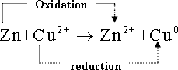
4- Oxidation reaction :
- In which , Zinc- atom (Znº) losses two electrons and converts to zinc ion (Zn²⁺ ) which leaves the surface of zinc sheet and dissolves in solution .
5-Reduction reaction :
in which each copper ion (Cu²⁺ ) in the solution accepts two electrons (coming from the Zn - half cell ) and converts to copper metal (Cu º ) which deposited at Zn- sheet surface.
6- Galvanic cells consists of the two half cells, salt bridge and the electrons are allowed to pass in a wire between the two half cells , thus we can obtain electric current resulted from the spontaneous oxidation - reduction reaction.
7- Electrolytic cells or electrolysis cells : in which an external electric energy is used ( e.g a battery ) to obtain oxidation - reduction reactions ( non - spontaneous ) .
8- Galvanic cells : it is used to obtain electric current as a result of spontaneous oxidation - reduction reaction as example the Daniel cell .
9- Daniel cell consists of plate of copper metal and other of zinc metal each of which is dipped in a solution of its salts in two separate compartments and the connection between the two solutions is via a salt bridge .
10- The copper plate in this cell is the cathode and it is the positive pole of the cell , while the zinc plate is the anode and it is the negative pole of the cell - the solution in each half cell is known as the electroyte.
11-When the two poles of the cell are connected by a conducting metal wire and the two solutions are connected via a salt bridge a flow of electric current occurs.
12-And the flow of electric current is stopped between the two half cells when all the zinc metal dissolves in the zinc half cell or the copper ions decreased because of its deposition as a copper atoms (Cu º) in the copper half cell .
13-The salt bridge in galvanic cells (e. g Daniel cell ) is a glass U- shaped tube filled with electrolyte solution (e. g Na₂SO₄) its ions do not react with the ions present in the two half cells as well as with the electrode materials of the galvanic cell .
14-The salt bridge connects between the solutions of the two halves , neutralize both the positive and negative charges in the two half cells as a result of the oxidation reduction reaction in the zinc and copper half cells , respectively .
15- The absence of the salt bridge in the galvanic cell leads to stopping the oxidation - reduction reaction consequently stop the flow of electric current in the external wire connecting between the two half cells .
16-Scientists had agreed to use the standard hydrogen electrode (S.H.E) ,its potential equals zero volt , the potentials of other electrodes can be measured .
17-The standard hydrogen electrode is consists of a platinum sheet (1cm²) covered by a layer of black spongy platinum over which a flow of hydrogen gas at constant pressure of one atmosphere passes and dipped in a strong acid solution of molar concentration (1M) .
18-The potential (S.H.E) changes by changing the hydrogen ion concentration in solution or by changing the potential pressure of the hydrogen gas or both .
19-The standard hydrogen half cell is represented by a diagram Pt + H₂ (1 atm.) /H⁺ (1M) and also in the case of gases half cells .
20- The standard electrode potentials ( Eº ) for all metals and nonmetals half cells relative to the standard hydrogen electrode.
21-Electromotive series of elements : If the standard potentials are descending arranged with respect to the reduction potentials and ascending relative to the positive reduction potentials , in which the more negative values are in the upper of the series and the more positive values are lower.
22- The most positive oxidation potential elements lie at the top of the series and are considered strong reducing agents .These metals which oxidize easily.
23- The most positive oxidation potential elements easily loss electrons when it react with ions of any element in a lower position in the electromotive series .
24- The most low positive oxidation potential elements which lie down in the series are strong oxidizing agents .
25- The most low positive oxidation potential elements has more ability to accept electrons when it reacts with any element lies above it in the electromotive series .
26-The elements lie above in the series replace the elements which lie down in its salt solution .
27- All elements lie above hydrogen in the electromotive series replace hydrogen ions in acidic solutions.
28-As the negative potential value increase , the affinity towards hydrogen ions substitution increases .
29-As the positive potential of element ,do not replace hydrogen ions in solutions .
30- The reduction potential (Eº ) of zinc half cell is equal - 0.76 volt , but the oxidation potential to this element has opposite sign since it represents here oxidation process .
31-The potential of the electromotive force of any galvanic cell can be calculated using the reduction or oxidation potential for the two half cells separate or both to obtain positive potential value for the galvanic cell .
32-The standard reduction potential for copper half cell = +0.34 volt
33- The standard oxidation potential for copper half cell = - 0.34 volt
34-The standard reduction potential of zinc half cell = + 0.76 volt
35- The standard oxidation potential of zinc half cell = - 0.76 volt
36- the electromotive force for the galvanic cell ( e.m.f ) = the reduction potentials difference for the two half cells . e.m.f = + 0.34 - ( - 0.76)= 1.1 volt or e.m.f = the oxidation potentials difference for the two half cells = 0.76- ( -0.34) = 1.1 volt
or e.m.f = summation of oxidation and reduction potentials of the two half cells e.m.f = + 0.76+0.34 = 1.1 volt
37-The galvanic cells are divided according to their nature to produce electrical energy to :
1- Primary cells .
2- Secondary cells .
38-These are a systems in the form of chemical energy can be converted to electrical energy through spontaneous irreversible oxidation reduction reaction .
39-Primary cells can not be recharged ,it is an irreversible cells as the dry cell.
40- The advantages of the dry cells:
a- Easley using in the mobile equipments.
b- It does not contain liquid .
c-Release a constant potential for long time working.
d- Possibility of its manufacture in small size
40-Dry cells: This cell consists of Zinc anode in the form of box containing the constituents of the cathode which is a wet paste of Manganese dioxide (oxidizing substance ) surrounded by a graphite rod
( as conductor ) and Ammonium chloride as an electrolyte .
N.B: In some cells the electrolyte is a mixture of ammonium and Zinc chlorides and in others Zinc chloride only is used as an electrolyte.
42-The total spontaneous reaction occuring in this cell is the summation of the two half cell reactions . This cell gives an electromotive force = 1.50 volt
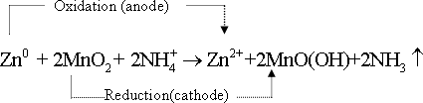
43-Mercury cell : This cell is in cylindrical in shape or as disk shape . It is characterized by its small volume . Thus it is commonly used in ear phones , clocks and cameras .
43- Mercury cell : the positive pole is zinc and the negative pole is from mercury oxide - potassium hydroxide is used as an electrolyte . total reaction occuring in this cell .
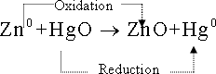
44-This cell gives electromotive force = 1.35 volt and it should get rid of this battery after using by a safe way since it contains mercury which is poison substance .
45- Secondary cells: are characterized by reversible chemical reactions and store the electrical energy as chemical energy .
46- Secondary cells :can be recharged by passing an electric current from external source between their poles in direction opposite to the discharge process.
47-Alkaline nickel - Cadmium battery : nickel ( cathode ) and Cadmium ( anode ) in presence of strong electrolyte (KOH) .
The total reaction occuring in this cell is :
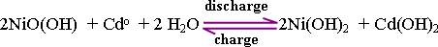
48- Alkaline nickel - Cadmium battery can be recharged by connecting it by an external current source to renew the constituents to its original state which may allow by its use another time .
49- Advantages of alkaline nickel - Cadmium battery: The life time of this battery is long It can be recharged for several years . It is light in mass and compact .It has no gases evolve from it and the potential of this cell = 1.3 volts
50-Lead - Acid Battery: used in cars ( so is known as car battery ) .It consists of six cells are connected in series . Each cell produces 2 volt and the total cell potential of the battery is 12 volts .
51- Lead - Acid Battery: the anode is network of lead filled with spongy lead (Pb) and the cathode is lead network filled with a paste of lead dioxide (PbO₂) and the plates are separated away a way from each other by insulting sheets and all of which are dipped in dilute sulphuric acid solution as solid materials ( polystyrene) which does not affect by acids.
52- Lead - Acid Battery: works as galvanic cell during its operation ( discharge) and consuming its energy , while in the case of recharging it is considered as an electrolytic cell .
53-Discharge reaction in car battery : these reactions occur during battery discharge :
a- At the anode :
( standard oxidation potential ) = + 0.36 volt
b- At the cathode :
( standard reduction potential ) = + 1.69 volt
The cell works here as a galvanic cell and at discharging the total battery reaction is :
54-The battery condition can be identified by measuring the density of the acid solution using the hydrometer( measuring liquids density) when the battery is completely charged .
55-The long period for using the battery leads to the dilution of sulphuric acid.
concentration as a result of increasing the quantity of water produced from the reaction and the conversion of cathode material (PbO₂) and anode (Pb) to lead (II) sulphate which led to decrease of the quantity of electric current produced from it .
56- Battery recharge: this is done by connecting the battery poles to an outside source of direct electric current whose potential is slightly higher than the potential produced from the battery , this will lead to the reversing of the spontaneous reaction
57-The battery is working during charging as an electrolytic cell , where a nonspontaneous chemical reaction has occurred by passing electric current. This is why the secondary cells are considered as storage batteries and in the car the dynamo in a continuous way is used in recharging the battery first by first .
58-Electrolytic cells: are electric cells in which the energy from an external source is used to make a nonspontaneous oxidation - reduction reaction to occur.
59- Electrolytic cell is a container contains electrolyte solution in which two electrodes of the same material or different material.
60- Anode : the electrode that connected by the positive pole of the battery , at which oxidation reactions occur.
61- Cathode : the electrode that connected by the negative pole of the battery and at which reduction reactions occur.
62- There are two kinds of liquid electrolytes .The first solutions of acids , bases or salts and the second is the molten of salts.
63-Cations: these are +ve ions (rich in electrons) that found in solution or molten, and move to anode and oxidized on passing the electric current.
64- Anions: these are -ve ions (poor in electrons) that found in solution or molten, and move to cathode and reduced on passing the electric current.
65-When the electrodes are connected with the applied potential on the cell slightly overcome the cell reversible potential an electric current in the electrolytic cell flows .
66- The negative value of the cell potential means non spontaneous reactions occurred, (electrolytic cell).
67- Faraday's First Law : The quantity of formed or consumed material at any electrode if it is gas or solid is directly proportional to the quantity of electricity that passes in the electrolytic solution .
68- Faraday's second Law : The masses of the different materials formed or consumed by the same amount of electricity are proportional to their equivalent masses.
69- Quantity of electricity (by coulomb )=current strength (in ampere)x time (in seconds).
70- Ampere: quantity of electricity passed for one second .(one coulomb in one second).
71- Coulomb : is the quantity of electricity on passing one ampere in one second. ( coulomb = 1ampere . second ).
72-General law of electrolysis: When one faraday (96500 coulomb ) is passed through an electrolyte ,this will led to dissolution or evolution or deposition of gram equivalent mass from the substance at any electrode .
73- The gram atom of the substance = the product of the equivalent gram mass x the valence of the atom ( or the number of charges of its ions ).
74- The equivalent gram mass= The gram atom of the substance ÷ number of charges of its ions.
75-the quantity of electricity necessary to deposit gram/atom of silver according to the reaction :
76-And the quantity of electricity necessary to deposit gram/ atom of copper according to the reaction :
77- The mass of deposited substance ( by gram )
78-Electroplating : It is a process of formation of thin layer of certain metal on the surface of another metal.
79- Uses of electroplating: to give the metal a nice shiny view , to protect it from corrosion and to increase the value of some cheap metals.
80- Electroplating of a jug by a layer of silver:
a- The surface should be completely cleaned.
b- dipping the jug in electrolyte solution contains silver ions.
c- Connect the jug with (-ve) pole of a battery (act as cathode).
d- A rod or plate of silver metal is put in the solution and connected with +ve pole of battery (act as anode).
81- Aluminum is electrically extracted from bauxite (Al₂O₃) which is dissolved in cryolite melt
(Na₃AlF₆ ) containing a little of fluorspar (CaF₂ ) to decrease the mixture melting point from 2045ºc to 950º c .
82-Now cryolite is substituted by using a mixture of fluoride salts of Aluminum , Sodium and Calcium where this mixture gives with bauxite a low melting point and a lower density value compared to the melt obtained from cryolite.
83- The lowering of the melt density facilitates the melted aluminum separation .
84-In Al extracting cell the cathode is body of the cell , is made of iron plated by layer of carbon (graphite) ,while the anode is carbon rods (graphite) .
85-When the electric current passes through Al extracting cell :

an oxidation - reduction reaction occurs :
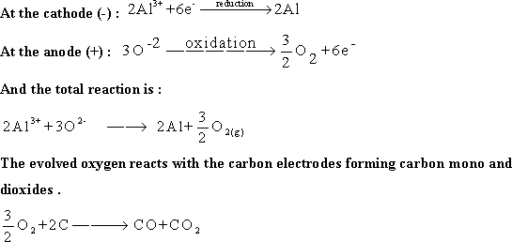
Then aluminum is withdrawn from the cell through a special opening .
86-Purification of impure copper metals:
a-The anode (positive pole) in the electrolysis cell is the impure copper metal.
b- The cathode (the negative pole) is from wires or fine copper sheets.
c- The electrolytic solution is an aqueous copper sulphate.[ (Cu²⁺) + (SO₄)²⁻)].
d-When electric current passes from the external battery at a potential slightly more than the standard potential of half copper cell , the ions are directed towards different charged electrodes .
e-At the anode : copper dissolves ( oxidizes ) and converts to copper ions (Cu²⁺) which spread in solution .
f-At cathode: and returns to deposit in the form of pure copper (99.95 purity) at the cathode.
g- The impurities in the anode material , some of it dissolves ( oxidizes ) in solution e.g. iron and zinc but do not deposit at the cathode because of the difficulty of its reduction compared to copper ions , while silver and gold impurities if it is present in the anode material it does not oxidize ( do not dissolve) at the oxidation potential of copper and failed down the anode and removed from the bottom of the cell
الاستاذ محمد الجمل
نسألكم الدعاء بظهر الغيب

