والقواميس متجدده ان شاء الله
قاموس Cambridge Advanced Learner's Dictionary انجليزى انجليزى لكل الجوالات
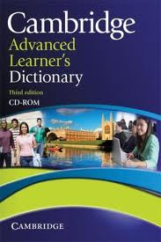
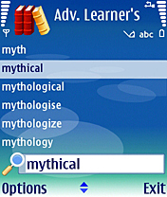
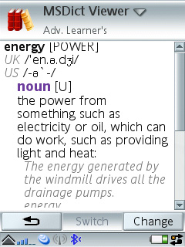
اكبر قاموس انجليزى انجليزى لكل الجوالات
القاموس بضيغة الجار
التحميل
http://www.mediafire.com/?5b1k234c864i0p0

آخر تعديل بواسطة hakimqwe ، 30-08-2012 الساعة 08:44 PM
#2
24-03-2012, 12:10 AM
 | hakimqwe  مشرف قسم المحمول و معلم ثانوي |  | تاريخ التسجيل: Mar 2010  الدولة: مصر  المشاركات: 308  معدل تقييم المستوى: 3

قاموس انجليزي عربى لنوكيا الجيل الثالث

قاموس انجليزي عربى لنوكيا الجيل الثالث
الملفات المرفقة
MOBIDICT.rar‏ (894.4 كيلوبايت, المشاهدات 4940)

#3
25-03-2012, 01:32 AM
أ/القاضى  عضو مجتهد |  | تاريخ التسجيل: Dec 2009  المشاركات: 67  معدل تقييم المستوى: 4

مشكوووووووووووووووووووووووووووووووورررررررررررر
#4
25-03-2012, 09:01 PM
donatila  عضو جديد |  | تاريخ التسجيل: Feb 2012  الدولة: egypt  المشاركات: 27  معدل تقييم المستوى: 0

شكرااااااااا

#5
12-05-2012, 08:15 AM
مستر اسامة محمد حسن(التل)  عضو مجتهد |  | تاريخ التسجيل: Jul 2010  الدولة: التل الكبير -الاسماعيلية  المشاركات: 108  معدل تقييم المستوى: 3

thanks a lot
__________________
اللهم اعنا علي ذكرك وشكرك وحسن عبادتك
#6
13-06-2012, 09:20 PM
اقوى واكبر قاموس انجليزي انجليزي لكل الموبايلات

MSDict Concise Oxford English Dictionary and Thesaurus.Jar
Click on image to view full size
- Description
- Details
Friends, this is the one of the best Java dictionary in the world
لتحميل
http://gallery.mobile9.com/f/2437991/?op=dpc&ref=2108
http://gallery.mobile9.com/f/2437991/?op=dpc&ref=2108

آخر تعديل بواسطة hakimqwe ، 09-08-2012 الساعة 10:51 PM

#7
22-06-2012, 10:40 PM
 | hakimqwe  مشرف قسم المحمول و معلم ثانوي |  | تاريخ التسجيل: Mar 2010  الدولة: مصر  المشاركات: 308  معدل تقييم المستوى: 3

للمتخصصين فاللغة الانجليزية قاموس slovoed

لمتخصصين فاللغة الانجليزية قاموس slovoed لكل الجوالات ولا يحتاج الى مفتاح
English-English
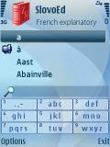
http://www.4shared.com/file/o7bSTD9e..._btlaqtv5.html

آخر تعديل بواسطة hakimqwe ، 09-08-2012 الساعة 10:54 PM
#8
21-07-2012, 04:34 PM
 | hakimqwe  مشرف قسم المحمول و معلم ثانوي |  | تاريخ التسجيل: Mar 2010  الدولة: مصر  المشاركات: 308  معدل تقييم المستوى: 3

مجموعة قواميس + القاموس الشامل الناطق UniDic عربي انجليزي انجليزي عربي بحجم ميجا 4

القاموس الشامل الناطق UniDicعربي انجليزي انجليزي عربي بحجم 4 ميجا
البرنامج للجيل الثالث
الخامس
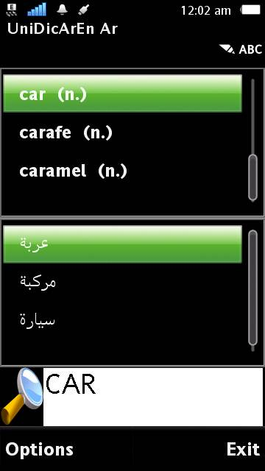
Description: ASGATech UniDic v1.00 English Arabic S60v3 &5 UniDic is a one of the most powerful and comprehensive multi-lingual dictionary. UniDic is one of the most powerful and comprehensive electtronic dictionaries. Muti-language (Arabic, English, Farsi, Urdu) with the ability to add any language of the translation languages. Main Features : * A huge number of words for each language, up to 100,000 words. * More than one meaning for the same word, ordered by commmon use. * English>Arabic & Arabic>English, English>Farsi & Farsi>English, English>Urdu & Urdu>English and other languages. * Fast access to the word needed, even if you don't know the right spelling. * Ability to search by the full word or a part of it. * Suitable for increasing the knowledge of words with the functionality for browsing to help you reading the sequence of words alphabetically ordered and the translation of these words. * Effective in your life and situations, it includes the commmon words in the daily life which you may not find in other dictionaries
تسجيل البرنامج 000000000000000
download
http://www.4shared.com/zip/es6vjIjk/_unidic.html
http://www.mediafire.com/?q6zijgtutmr722g

آخر تعديل بواسطة hakimqwe ، 02-09-2012 الساعة 02:43 PM
#10
30-07-2012, 04:00 AM

مجهود رائع

#11
30-07-2012, 04:33 AM

ممكن حضرتك ترفعه على الميديا فاير علشان فور شيرد لا يدعم الاستكمال وجزاك الله كل خير ورمضان كريييييييييييم
#12
30-07-2012, 05:08 AM

اقتباس:
المشاركة الأصلية كتبت بواسطة saadeden
ممكن حضرتك ترفعه على الميديا فاير علشان فور شيرد لا يدعم الاستكمال وجزاك الله كل خير ورمضان كريييييييييييم
تفضل يا اخي
http://www.mediafire.com/?15fdbl4b5cq9vax

#13
30-07-2012, 05:44 AM

اتمنى من حضرتك نفس البرنامج لموبايل نوكيا 5130 اكسبرس ميوزك ولك جزيل الشكر

#15
30-07-2012, 03:35 PM
 | hakimqwe  مشرف قسم المحمول و معلم ثانوي |  | تاريخ التسجيل: Mar 2010  الدولة: مصر  المشاركات: 308  معدل تقييم المستوى: 3

اقتباس:
المشاركة الأصلية كتبت بواسطة saadeden
ما ينفعش القاموس ده بصيغة جار علشان مو بايلات اكسبريس ميوزك ولك جزيل الشكر
للاسف
بس شوف ده
http://www.thanwya.com/vb/showthread.php?t=414996
اقوى واكبر قاموس متقدم كامل انجليزي انجليزي لكل الموبايلات

انا عدلت شويه فالقاموس علشان يكون كامل مش فترة تجربية ورفعتة الموقع المحبب للجميع ميديافاير
والقاموس من نوع جافا امتداد جار
يعنى لكل الموبايلات
Advanced English Dictionary:
Search all the English words, biographical and geographical information with Advanced English Dictionary. 196,000 entries, 1.4 million words and 250,000 relations make it the biggest dictionary available for mobile devices!
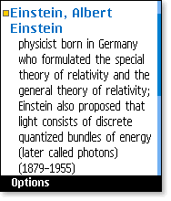
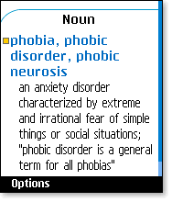

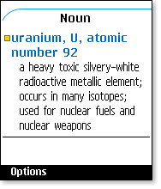
التحميل
http://www.mediafire.com/?3qxrjbovjmxmx4r

آخر تعديل بواسطة hakimqwe ، 31-07-2012 الساعة 12:12 AM
#19
31-07-2012, 01:17 AM

شكرااااااااااااااااااااااااااااااااااااااااااااا

#20
31-07-2012, 04:33 AM
قاموس انجليزي فرنسى والعكس لكل الموبايلات

قاموس انجليزي فرنسى والعكس لكل الموبايلات
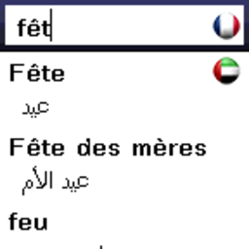
Y
- French
- 
- 
Arabic
Features
- • fully offline
- • easy to use
- • shows translations as you type
- • touch screen & qwerty & classic keyboard supported
- • thousands of entries
- • small file size (compressed, 358.5 k
- • instant boot up
- • 5 font sizes available

الملفات المرفقة
New WinRAR archive.rar‏ (343.4 كيلوبايت, المشاهدات 145)

#22
01-08-2012, 06:24 AM
 | sayededu  عضو مجتهد |  | تاريخ التسجيل: Jun 2008  المشاركات: 94  معدل تقييم المستوى: 5

اقتباس:
المشاركة الأصلية كتبت بواسطة sayededu
لدي قاموس
Camridge advanced learner's Dictionary
وكمان ناطق ..... بس حجمة اكتر من 100 ميجا ..... ايه رايك؟؟؟؟
http://www.thanwya.com/vb/showthread...=433369&page=5
http://www.thanwya.com/vb/showthread...=433369&page=6
قاموسmerriam-webster v3.20.signed الناطق (eng to spanish)(eng to eng)(eng to french
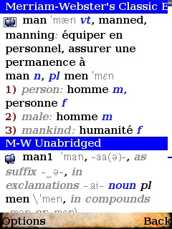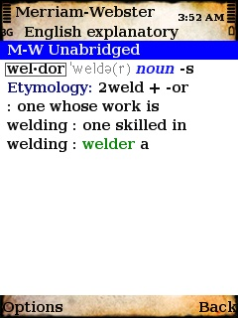
http://www.thanwya.com/vb/showthread...32#post4718832

آخر تعديل بواسطة hakimqwe ، 04-08-2012 الساعة 04:55 PM
#34
06-08-2012, 03:32 AM
 | hakimqwe  مشرف قسم المحمول و معلم ثانوي |  | تاريخ التسجيل: Mar 2010  الدولة: مصر  المشاركات: 308  معدل تقييم المستوى: 3

جديد قاموس سولفيد SLOVOED V3.20 cra ck by Pletar HOW TO UNLOCK ALL V3.20 SLOVOED DICT
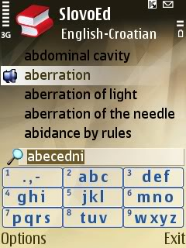
يعتبر من اجمل واروع القواميس للترجمة
THIS CRA CKING METHOD IS VERY SIMPLE:
YOU DON'T NEED TO INSTALL DICTIONARIES,JUST OPEN SIS FILE WITH extsis
PROGRAM AND EXTRACT DESIRABLE DICTIONARY
THEN INSIDE YOU HAVE FILE OR FILES WITH EXTENSION .prc
THIS FILES YOU MUST COPY TO: E/Resource/Apps/SlovoEdDicts
HOW TO INSTALL:
-DELETE ALL DICTIONARIES FROM YOUR PHONE
-UNINSTALL DICTIONARY ENGINE
START FRESH INSTALLATION
DOWNLOAD THIS FILE,YOU HAVE INSIDE 166 UNLOCKED DICTIONARIES (FOR MORE DETAILS SEE THE LIST BELOW)
للتحميــــــــــــــــــــــــل
http://rapidshare.com/files/260726939/SlovoEdDicts.rar
(THIS FILES YOU MUST COPY TO: E/Resource/Apps/SlovoEdDicts)
SOUND MODULES COPY TO : E/SlovoEd ( memory card )
DOWNLOAD THIS FILE WITH ALL SLOVOED SOUND MODULES (English,German,Spanish,French,Italian)
للتحميــــــــــــــــــــــــل
http://rapidshare.com/files/260664626/SlovoEd.rar
INSTALL SLOVOED DICTIONARY ENGINE V3.20 OR V3.10 (THERE IS NO DIFFERENCE)
للتحميــــــــــــــــــــــــل
http://rapidshare.com/files/26075248..._2_for_S60.sis
INSTALL HandyTools
للتحميــــــــــــــــــــــــل
http://rapidshare.com/files/26075293...ls_for_S60.sis
INSTALL Morphology_module
للتحميــــــــــــــــــــــــل

http://rapidshare.com/files/26075298...le_for_S60.sis
EXTRACT SLOVOED V3.20 cra ck
للتحميــــــــــــــــــــــــل
http://rapidshare.com/files/260753795/SLOVOED_V3.20_*****.rar
COPY ALL FILES FROM SLOVOED V3.20 ***** TO: C/Private/20001a58
DONE!!!
REMEMBER!!! DON'T INSTALL DICTIONARIES IF THEY ARE NOT ON THIS LIST!!! YOU CAN USE THEM ONLY IN DEMO MODE!
HOW YOU CAN CHECK IF DESIRABLE DICTIONARY IS REGISTERED:
CHOSE DICTIONARY/OPTIONS/DIRECTION/INFO IF THERE IS NO MESSAGE UNREGISTERED YOU HAVE FULL VERSION
HOW YOU CAN CHECK WHAT DICTIONARIES ARE UNREGISTERED:
GO TO OPTIONS/REGISTER DICTIONARY/AND IT WILL YOU SHOW WHAT DICTIONARY IS TRAIL,OR IF YOU DON'T HAVE THIS OPTION,YOU DON'T HAVE DEMO DICTIONARIES.
ALL DICTIONARIES FROM THIS TWO PACKAGE ARE UNLOCKED,****** KEYS ARE GENERATED INSIDE &quot;SLOVOED V3.20 cra ck .
IF YOU WANT MORE DICTIONARIES FOR FREE,SEND ME OLD ****** AND DICTIONARY WITH YOUR MAIL BY PM (ONLY FOR SYMBIAN)
IF YOU WANT TO DELETE SOME DICTIONARIES,JUST OPEN .prc FILE WITH SOME TEXT EDITOR (Notepad++,Hex Editor Neo...ETC) AND YOU WILL SEE NAME FOR DICTIONARY.
ALL CREDITS TO PLETAR
PASS: Code:
www.nokian958gb.bloger.hr
LIST OF UNLOCKED DICTIONARIES: 166
***ARABIC****************************************
SlovoEd Classic Arabic-English &amp; English-Arabic
SlovoEd Compact Arabic-Russian & Russian-Arabic
***BULGARIAN***********************************
SlovoEd Compact Bulgarian-Swedish & Swedish-Bulgarian
***CATALAN**************************************
Spanish talking SlovoEd Deluxe Catalan-Spanish & Spanish-Catalan
***CROATIAN*************************************
SlovoEd Compact Croatian-English & English-Croatian
SlovoEd Compact Croatian-Slovenian & Slovenian-Croatian
***CZECH*****************************************
English talking SlovoEd Deluxe Czech-English & English-Czech
French talking SlovoEd Deluxe Czech-French & French-Czech
German talking SlovoEd Deluxe Czech-German & German-Czech
SlovoEd Classic Czech-Italian & Italian-Czech
SlovoEd Compact Czech-Swedish & Swedish-Czech
***DANISH****************************************
SlovoEd Compact Danish-Swedish & Swedish-Danish
***DUTCH*****************************************
SlovoEd Deluxe Dutch explanatory
English talking SlovoEd Deluxe Dutch-English & English-Dutch
French talking SlovoEd Deluxe Dutch-French & French-Dutch
German talking SlovoEd Deluxe Dutch-German & German-Dutch
SlovoEd Compact Greek-Dutch
SlovoEd Classic Dutch-Italian & Italian-Dutch
SlovoEd Compact Dutch-Portuguese & Portuguese-Dutch
Spanish talking SlovoEd Deluxe Dutch-Spanish & Spanish-Dutch
SlovoEd Compact Dutch-Swedish & Swedish-Dutch
***ENGLISH***************************************
Talking SlovoEd Deluxe English explanatory
SlovoEd Classic Arabic-English & English-Arabic
SlovoEd Compact Croatian-English & English-Croatian
English talking SlovoEd Deluxe Czech-English & English-Czech
English talking SlovoEd Deluxe Dutch-English & English-Dutch
SlovoEd Classic English-Estonian & Estonian-English
Talking SlovoEd Deluxe English-French & French-English
Talking SlovoEd Deluxe English-German & German-English
English talking SlovoEd Deluxe English-Greek & Greek-English
SlovoEd Classic English-Hebrew & Hebrew-English
SlovoEd Compact English-Hungarian & Hungarian-English
Talking SlovoEd Classic English-Italian & Italian-English
SlovoEd Classic English-Latin & Latin-English
SlovoEd Classic English-Latvian
English talking SlovoEd Deluxe English-Lithuanian&Lithuanian-English
SlovoEd Classic English-Polish & Polish-English
SlovoEd Classic English-Portuguese & Portuguese-English
SlovoEd Compact English-Romanian
English talking SlovoEd Deluxe English-Russian & Russian-English
SlovoEd Compact English-Serbian & Serbian-English
SlovoEd Compact English-Slovenian & Slovenian-English
Talking SlovoEd Deluxe English-Spanish & Spanish-English
SlovoEd Compact English-Swedish & Swedish-English
SlovoEd Classic English-Turkish & Turkish-English
SlovoEd Compact English-Ukrainian & Ukrainian-English
***ESTONIAN*************************************
SlovoEd Classic English-Estonian & Estonian-English
***FRENCH****************************************
French talking SlovoEd Deluxe Czech-French & French-Czech
French talking SlovoEd Deluxe Dutch-French & French-Dutch
Talking SlovoEd Deluxe English-French & French-English
Talking SlovoEd Deluxe French explanatory
Talking SlovoEd Deluxe French-German & German-French
SlovoEd Compact French-Greek & Greek-French
SlovoEd Classic French-Italian & Italian-French
SlovoEd Compact French-Polish & Polish-French
SlovoEd Compact French-Portuguese & Portuguese-French
SlovoEd Compact French-Romanian
SlovoEd Compact French-Slovenian & Slovenian-French
Talking SlovoEd Deluxe French-Spanish & Spanish-French
SlovoEd Compact French-Swedish & Swedish-French
***GERMAN***************************************
German talking SlovoEd Deluxe Czech-German & German-Czech
German talking SlovoEd Deluxe Dutch-German & German-Dutch
Talking SlovoEd Deluxe English-German & German-English
Talking SlovoEd Deluxe French-German & German-French
SlovoEd Compact German-Greek & Greek-German
Talking SlovoEd Deluxe German-Italian & Italian-German
SlovoEd Compact German-Latin & Latin-German
SlovoEd Compact German-Lithuanian & Lithuanian-German
SlovoEd Compact German-Polish & Polish-German
SlovoEd Compact German-Portuguese & Portuguese-German
German talking SlovoEd Deluxe German-Russian & Russian-German
SlovoEd Compact German-Slovenian & Slovenian-German
Talking SlovoEd Deluxe German-Spanish & Spanish-German
SlovoEd Compact German-Swedish & Swedish-German
***GREEK******************************************
SlovoEd Compact Greek-Dutch
English talking SlovoEd Deluxe English-Greek & Greek-English
SlovoEd Compact French-Greek & Greek-French
SlovoEd Compact German-Greek & Greek-German
SlovoEd Compact Greek-Italian & Italian-Greek
SlovoEd Compact Greek-Portuguese & Portuguese-Greek
SlovoEd Compact Greek-Russian & Russian-Greek
SlovoEd Compact Greek-Spanish & Spanish-Greek
***HEBREW***************************************
SlovoEd Classic English-Hebrew & Hebrew-English
SlovoEd Compact Hebrew-Russian & Russian-Hebrew
***HUNGARIAN***********************************
SlovoEd Compact English-Hungarian & Hungarian-English
***ITALIAN****************************************
SlovoEd Classic Czech-Italian & Italian-Czech
SlovoEd Classic Dutch-Italian & Italian-Dutch
Talking SlovoEd Classic English-Italian & Italian-English
SlovoEd Classic French-Italian & Italian-French
Talking SlovoEd Deluxe German-Italian & Italian-German
SlovoEd Compact Greek-Italian & Italian-Greek
SlovoEd Compact Italian-Lithuanian & Lithuanian-Italian
SlovoEd Compact Italian-Portuguese & Portuguese-Italian
Italian talking SlovoEd Deluxe Italian-Russian
SlovoEd Compact Italian-Slovenian & Slovenian-Italian
Talking SlovoEd Deluxe Italian-Spanish & Spanish-Italian
SlovoEd Compact Italian-Swedish & Swedish-Italian
SlovoEd Compact Italian-Turkish & Turkish-Italian
***LATIN******************************************
SlovoEd Classic English-Latin & Latin-English
SlovoEd Compact German-Latin & Latin-German
***LATVIAN***************************************
SlovoEd Classic English-Latvian
***LITHUANIAN***********************************
English talking SlovoEd Deluxe English-Lithuanian&Lithuanian-English
SlovoEd Compact German-Lithuanian & Lithuanian-German
SlovoEd Compact Italian-Lithuanian & Lithuanian-Italian
***NORWEGIAN***********************************
SlovoEd Compact Norwegian-Swedish & Swedish-Norwegian
***POLISH***************************************** *
SlovoEd Classic English-Polish & Polish-English
SlovoEd Compact French-Polish & Polish-French
SlovoEd Compact German-Polish & Polish-German
SlovoEd Compact Greek-Polish & Polish-Greek
SlovoEd Compact Italian-Polish & Polish-Italian
SlovoEd Compact Polish-Portuguese & Portuguese-Polish
SlovoEd Compact Polish-Russian & Russian-Polish
SlovoEd Compact Polish-Spanish & Spanish-Polish
***PORTUGESE************************************
SlovoEd Compact Dutch-Portuguese & Portuguese-Dutch
SlovoEd Classic English-Portuguese & Portuguese-English
SlovoEd Compact French-Portuguese & Portuguese-French
SlovoEd Compact German-Portuguese & Portuguese-German
SlovoEd Compact Greek-Portuguese & Portuguese-Greek
SlovoEd Compact Italian-Portuguese & Portuguese-Italian
SlovoEd Compact Polish-Portuguese & Portuguese-Polish
SlovoEd Compact Portuguese-Slovenian & Slovenian-Portuguese
SlovoEd Compact Portuguese-Swedish & Swedish-Portuguese
***ROMANIAN************************************
SlovoEd Classic Romanian explanatory
SlovoEd Compact English-Romanian
SlovoEd Compact French-Romanian
SlovoEd Compact Romanian-Swedish & Swedish-Romanian
***RUSSIAN***************************************
SlovoEd Compact Arabic-Russian & Russian-Arabic
English talking SlovoEd Deluxe English-Russian & Russian-English
French talking SlovoEd Deluxe French-Russian & Russian-French
German talking SlovoEd Deluxe German-Russian & Russian-German
SlovoEd Compact Greek-Russian & Russian-Greek
SlovoEd Compact Hebrew-Russian & Russian-Hebrew
Italian talking SlovoEd Deluxe Italian-Russian
SlovoEd Compact Polish-Russian & Russian-Polish
Spanish Talking SlovoEd Deluxe Russian-Spanish & Spanish-Russian
SlovoEd Compact Russian-Swedish & Swedish-Russian
SlovoEd Compact Turkish-Russian
SlovoEd Compact Russian-Ukrainian & Ukrainian-Russian
***SERBIAN***************************************
SlovoEd Compact English-Serbian & Serbian-English
***SLOVENIAN************************************
SlovoEd Compact Croatian-Slovenian & Slovenian-Croatian
SlovoEd Compact English-Slovenian & Slovenian-English
SlovoEd Compact French-Slovenian & Slovenian-French
SlovoEd Compact German-Slovenian & Slovenian-German
SlovoEd Compact Italian-Slovenian & Slovenian-Italian
SlovoEd Compact Portuguese-Slovenian & Slovenian-Portuguese
SlovoEd Compact Slovenian-Spanish & Spanish-Slovenian
***SPANISH***************************************
Talking SlovoEd Deluxe Spanish explanatory
Spanish talking SlovoEd Deluxe Catalan-Spanish & Spanish-Catalan
Spanish talking SlovoEd Deluxe Dutch-Spanish & Spanish-Dutch
Talking SlovoEd Deluxe English-Spanish & Spanish-English
Talking SlovoEd Deluxe French-Spanish & Spanish-French
Talking SlovoEd Deluxe German-Spanish & Spanish-German
SlovoEd Compact Greek-Spanish & Spanish-Greek
Talking SlovoEd Deluxe Italian-Spanish & Spanish-Italian
SlovoEd Compact Polish-Spanish & Spanish-Polish
SlovoEd Compact Portuguese-Spanish & Spanish-Portuguese
Spanish Talking SlovoEd Deluxe Russian-Spanish & Spanish-Russian
SlovoEd Compact Slovenian-Spanish & Spanish-Slovenian
SlovoEd Compact Spanish-Swedish & Swedish-Spanish
***SWEDISH***************************************
SlovoEd Compact Bulgarian-Swedish & Swedish-Bulgarian
SlovoEd Compact Czech-Swedish & Swedish-Czech
SlovoEd Compact Danish-Swedish & Swedish-Danish
SlovoEd Compact Dutch-Swedish & Swedish-Dutch
SlovoEd Compact English-Swedish & Swedish-English
SlovoEd Compact French-Swedish & Swedish-French
SlovoEd Compact German-Swedish & Swedish-German
SlovoEd Compact Italian-Swedish & Swedish-Italian
SlovoEd Compact Norwegian-Swedish & Swedish-Norwegian
SlovoEd Compact Portuguese-Swedish & Swedish-Portuguese
SlovoEd Compact Romanian-Swedish & Swedish-Romanian
SlovoEd Compact Russian-Swedish & Swedish-Russian
SlovoEd Compact Spanish-Swedish & Swedish-Spanish
***TURKISH***************************************
SlovoEd Classic English-Turkish & Turkish-English
SlovoEd Compact Italian-Turkish & Turkish-Italian
SlovoEd Compact Turkish-Russian
***UKRAINIAN************************************
SlovoEd Compact English-Ukrainian & Ukrainian-English
SlovoEd Compact Russian-Ukrainian & Ukrainian-Russian

#35
06-08-2012, 08:08 PM
Mr/zain  عضو جديد |  | تاريخ التسجيل: Aug 2012  المشاركات: 4  معدل تقييم المستوى: 0

#37
07-08-2012, 09:19 PM
 | hakimqwe  مشرف قسم المحمول و معلم ثانوي |  | تاريخ التسجيل: Mar 2010  الدولة: مصر  المشاركات: 308  معدل تقييم المستوى: 3

اقتباس:
المشاركة الأصلية كتبت بواسطة mr.mahmod morad
يا ريت والله وجزاك الله خيرا
ده الموقع الرسمى حمل ماشئت من القواميس وارقام التفعيل مقدور عليها
http://www.penreader.com/s60-3rd-edi...tionaries.html
#38
08-08-2012, 09:10 PM
 | hakimqwe  مشرف قسم المحمول و معلم ثانوي |  | تاريخ التسجيل: Mar 2010  الدولة: مصر  المشاركات: 308  معدل تقييم المستوى: 3

القاموس الشامل
لنوكيا الجيل الثاني
عربي انجليزى -انجليزي عربي
الملفات المرفقة unidicaren_oiw8c936.ra

آخر تعديل بواسطة hakimqwe ، 09-08-2012 الساعة 09:26 PM

sloved
عربي-انجليزي
انجليزي-عربي
جيل ثالث
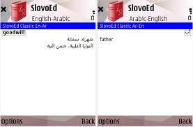
http://www.mediafire.com/?xd69u3k36py777c
http://www.tops-stars.com/download.p...2655619051.zip
الملفات المرفقة
قاموس -عربى انجليزى.rar‏ (426.3 كيلوبايت, المشاهدات 141)
#48
12-08-2012, 05:12 PM

قاموس المورد الناطق لنوكيا الجيل الخامس
انجليزي عربي -عربي انجليزي
وصوت واضح
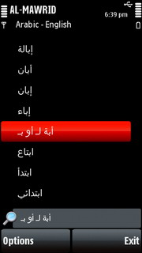
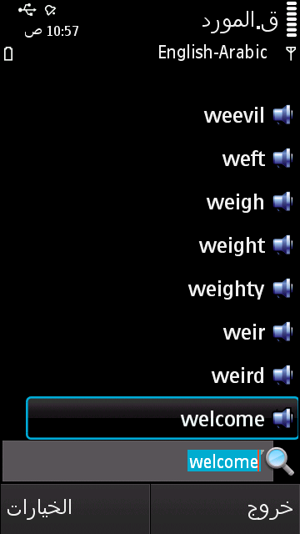
الحجم 95 ميجا
http://www.mediafire.com/?mjyytcztmuh

آخر تعديل بواسطة hakimqwe ، 12-08-2012 الساعة 05:18 PM

#49
12-08-2012, 06:53 PM

قاموس الثقافة البريطانية والامريكية
Oxford Guide to British and American Culture
كل ما يخص الادب الامريكي والانجليزي من قصص وروايات مسرحيات وكتاب
القاموس من نوع الجافا لكل الموبايلات
الملفات المرفقة
Oxford Guide to British and American Culture.rar‏ (1.53 ميجابايت, المشاهدات 1108)

Oxford Dictionary of Idioms..
قاموس Oxford للمصطلحات كامل
القاموس جافا لكل الموبايلات
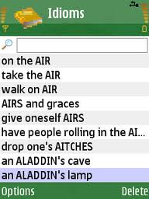
Containing more than 5,000 entries, this dictionary covers metaphorical phrases, similes, familiar sayings, and proverbs, providing illustrative quotations from sources as varied as the Bible, the Spectator, and Agatha Christie. It explains meanings and provides historical information for well-known idioms such as cost an arm and a leg, knocks spots off, once in a blue moon, the tip of the iceberg, and many more. Full of fascinating facts, this dictionary is ideal for anyone with interest in the origins of the colloquial, quirky byways of the English language.
Idioms are arranged alphabetically by key word for easy reference. Sayings in British English are supplemented by American English and other expressions.
الملفات المرفقة Oxford Dictionary of Idioms.rar‏ (583.8 كيلوبايت, المشاهدات 0)

#51
14-08-2012, 02:17 AM

اقتباس:
المشاركة الأصلية كتبت بواسطة theprof1
فين القاموس اللى طلبته يا مستر
http://www.thanwya.com/vb/showthread.php?t=414996

#57
21-08-2012, 09:28 PM

اقتباس:

22-08-2012, 12:03 PM
bkarlovestory
هذه الرسالة حذفت بواسطة hakimqwe.
#59
28-08-2012, 02:35 AM
theprof1  عضو مجتهد |  | تاريخ التسجيل: Mar 2012  الدولة: مصر  المشاركات: 88  معدل تقييم المستوى: 1

فيه قاموس انا شوفته على موقع واب تريك مزدوج وشامل كلمات كتير اسمهdictionary English to Arabic بس الموقع ده مش بيحمل ايه السبب وهو شغال تمام مع واحد صاحبى وبصيغة الجار

#60
28-08-2012, 02:55 AM
theprof1  عضو مجتهد |  | تاريخ التسجيل: Mar 2012  الدولة: مصر  المشاركات: 88  معدل تقييم المستوى: 1

هذا هو الرابطhttp://www.mediafire.com/?3qxrjbovjmxmx4r
قاموس اوكسفورد الطبى الرائع Oxford Concise Medical Dictionary
قاموس اوكسفورد الطبى الرائع Oxford Concise Medical Dictionary
لكل الجوالات
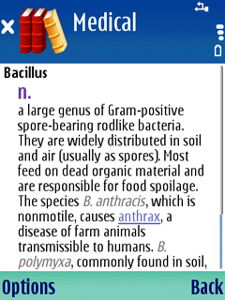
الملفات المرفقة Oxford Concise Medical Dictionary by hakim.rar‏ (1.10 ميجابايت, المشاهدات 80)
#67
31-08-2012, 06:38 PM

اقتباس:
http://www.4shared.com/zip/es6vjIjk/_unidic.html
#69
02-09-2012, 11:16 AM

#70
02-09-2012, 02:40 PM

اقتباس:
المشاركة الأصلية كتبت بواسطة Awatef Esmat
معلش بس الموقع ده لازم اشترك فيه عشان احمل حاجه
مفيش علي موقع تاني؟
http://www.mediafire.com/?q6zijgtutmr722g
#71
09-10-2012, 08:05 PM
#73
14-10-2012, 01:49 AM

اقتباس:
المشاركة الأصلية كتبت بواسطة البلبيسى الكبير
مفيش قاموس فرنسى بعد اذنكم
http://www.asgatechshop.com/demo/app...20Fr-Ar-Fr_S60

