1- AXEL
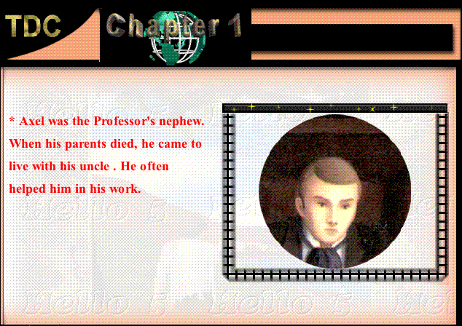
The narrator of the story الشخص الذى يسرد لنا القصة
Axel was a young man. He tells usthe story how he and his uncle made a journey to the centre of the earth .
After the death of his parents بعد وفاة والديه he came to live with his uncle Professor Lidenbrock.He was proud to be his uncl's assistant.كان فخورا بكونه معاونا لعمه
His cleverness]
Axel was clever enough to break the secret code يفك الشفرة السرية
of the message written on the parchement للرسالة المكتوبة فى المخطوطة(قطعة من الجلد مكتوب عليها بخط اليد)the Professor found in the old book.The message was about a journey to the centre of the earth[/align]
His Faithulness To His Uncle
[color=#CC6699]-Axel refused to tell his uncle his discovery of the secrt code because he was sure he would decide to make that journey which he believed was dangerous.خطرة
When he found his uncle suffering a lot because his failure in breaking the secrt code he changed his mind.غير رأيه
-He was worried قلقwhen they used half the water and did not find any sprigs
طاعته لعمهHis Obedience]
He obeyed his uncle to make the journey although he objected to it as he believed it was dangerous
قوى الملاحظة Being Observant
He obseved plants and animals preserved in the rock which proved they were walking in the wrong path.
مواجهة المصاعب How He Faced Hardships
When he became thirsty عطشان ،he fell to the ground and his uncle gave him the last drops of water they had.
Walking in front of the group he lost his way.When he walked into a wall of rock he fell down and broke his torch.In the darkness he ran agaist the rock cut himself and fainted جرح وأغمى عليه
.
2-PROFESSOR LIDENBROK
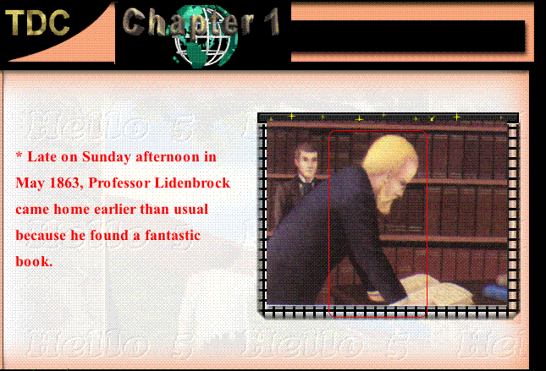

A Famous Scientist عالم مشهور
He was a famous scientist and geologist.He gave lectures at the university of Humburg.He knew more about earth than any other scientist .Other geologists came from all over the world to learn from him

INSISTING ON HIS DECISSIONS
الاصرار على قراراته

When he found a parchment with a message written in a secret code , he couldn't eat or sleep as he insisted on breaking the secret code .
When Axel told him the contents of the message, he insisted on making the journey to the centre of the earth at once.Axel's objections were of no use.اعتراض اكسل كان بلا جدوى

BEING IMPATIENT عديم الصبر
He was angry when they were delayed three days because there were no sun to get the shadow of the mountain Scartaris on one of the three chimneys.
What He Did As A Scientist During The Journey
He examined the rocks during the journey and became sure that the centre of the earth was not hot.
He was sure they would find water after getting through lava rocks.
After finding the water , he calculated their position and knew they were under Atlantic ocean.

The Mistake He Made الخطأ الذى فعله
When they reached the end of the passage عندما وصلوا لنهاية الطريق ,
he choose the eastern path اختار الطريق الشرقى
It tooke them five days to reach its end and find it was blockedمسدود
So, they returned back to the western path.
3-HANS هانز
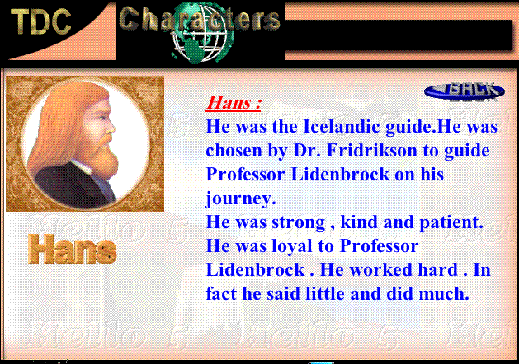
He was a guide.مرشد He was choosen by Sr Fridrikson to guide them in their journey.He knew that area well.In their journey to Sneffels, he helped them to cross the inlets.He also knew about tide (المد والجزر) and had to wait until the tide was out.

A Hard Working Man
He moved slowly and didn'tsay much and worked silently
He was obedient مطيع
. He put all the suppliesinabag and tied them to a rope to lower them down the chimney.
He took an hour of hard work to make a hole in the rock to get water.

وبهذا نكون قدانتهينامن الشخصيات الثلاثة الرئيسية
ويبقى MARTHA مديرة منزل ليدن بروك
Sr Fridrikson صديق برفوسور ليدنبروك من ايسلاند الذى أمدهم بهانز
Arne Saknussem مالك الكتاب الذى قام برحلة لمركز الأرض وهو الذى كتب المخطوطة

